

Fleetwood’s Charity Primary School

**Homework Menu**

Oak Class – Autumn 1

Please bring your homework in to show to the class on the last week of half term so that we can share and celebrate all of your hard work!

|  |  |
| --- | --- |
| **Weekly Activities** | |
| Reading | Read to an adult or independently for 10 minutes each day; this could be a story book, newspaper, recipe or even a comic! |
| Phonics | Practise the sounds which you have been learning in phonics each week. This will help to support your reading and writing too. Practise the spelling list attached to homework. |
| Times  Tables | Times tables are set on Times Tables Rockstars weekly; practise for 10 minutes, at least once a week. |

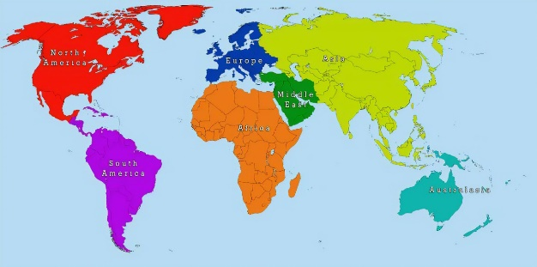

Science

Choose an animal and design a poster to show what they need to survive. I am looking for bright colours and lots of pictures/drawings/facts!



English

Design a new front cover for our English book ‘Lask stop on Market Street’ and write a small description of what the book is about.

**The front cover of your new homework menu book needs decorating. Design a front cover to make yours stand out!**

Geography / art

Can you paint (draw/colour if you don’t have paint) your own world map showing how many continents there are. There is one above to help you.

RE

Can you make your own Jewisk Sukkah (hut). This can be made in any form. Some examples being outdoors (take a picture!), Lego, paint, cardboard – use your imagination!