Please bring your homework in to show to the class on the last week of half term so that we can share and celebrate all of your hard work!
Fleetwood’s Charity Primary School
Homework Menu
Oak Class – Autumn 1

Weekly Activities
Reading | Read to an adult or independently for 10 minutes each day; this could be a story book, newspaper, recipe or even a comic!
Phonics | Practise the sounds which you have been learning in phonics each week. This will help to support your reading and writing too.
Times  Tables | Times tables will be set on Times Tables Rockstars weekly; practise for 10 minutes, at least once a week.
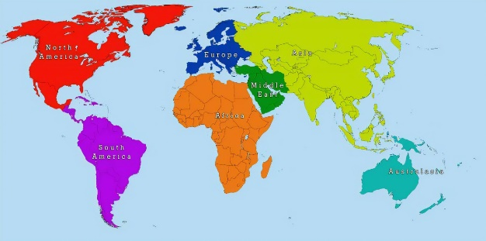

Science
Go for a walk around the garden/outdoors, write down what you smell, see, hear, taste, and touch. Write and draw about your walk.

Show us how you have promoted the Christian values ‘kindness and courage’. Send a photo, draw a picture with labels or a sentence showing what you did.
For example, helped someone at home.

The front cover of your new homework menu book needs decorating. Design a front cover to make yours stand out!
Geography
Find out some facts about one of the continents. Draw pictures and write labels or sentences to show what have you learnt. This can be shared with the class.

Our class library would love some photos – so send a photo on Dojo of you reading your favourite book or comic in your favourite place.

