
Please bring your homework in to show the class/school by the last week of half term and earn plenty of Dojo points and stickers!
Fleetwood’s Charity Primary School
Homework Menu
Ash Class – Autumn 1

Weekly Activities
Reading | Read to an adult or independently for 5-10 minutes each day; this could be a story book, newspaper, recipe or even a comic!
Phonics | Practise phase 2 and 3 sounds that are sent home. Can you recognise them in words? Say the sounds to your family.  Receptions – practise reading words with s, a, t, p, i, n, g, o, c, k.
Maths (Y1) | Practise writing your numbers correctly. Show me and you get extra dojos! (Receptions are welcome to do this too if they want)

Create a collage with any materials at home.
Some examples could be newspaper, leaves, paper, food wrappers.

Geography
Could you draw or create the world. Show me where the land and sea is.
This could be painted, lego, drawing (the more creative, the better)
R.E
Design a front cover for a bible.
What is on it? Crosses, Jesus, sheep are some examples.

PSHE
Draw/paint/make a picture of the people who are important to you.

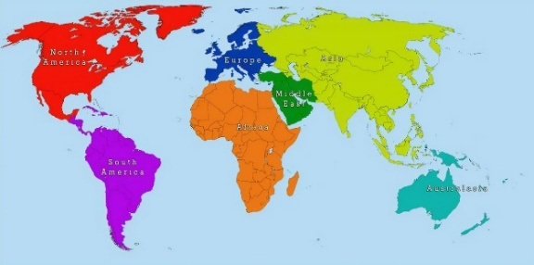
Science: A senses hunt.
In your home/outside, what can you smell? Taste? See? Hear? Feel?

