

Please bring your homework in to show the class/school by the last week of half term and earn plenty of Dojo points and stickers!

Fleetwood’s Charity Primary School

**Homework Menu**

Ash Class – Autumn 1

|  |  |
| --- | --- |
| **Weekly Activities** | |
| Reading | Read to an adult or independently for 5-10 minutes each day; this could be a story book, newspaper, recipe or even a comic! |
| Phonics | Practise phase 2 and 3 sounds that are sent home. Can you recognise them in words? Say the sounds to your family.  Receptions – practise reading words with s, a, t, p, i, n, g, o, c, k. |
| Maths (Y1) | Practise writing your numbers correctly. Show me and you get extra dojos! (Receptions are welcome to do this too if they want) |

**Create a collage with any materials at home.**

**Some examples could be newspaper, leaves, paper, food wrappers.**

Geography

Could you draw or create the world. Show me where the land and sea is.

This could be painted, lego, drawing (the more creative, the better)

**R.E**

Design a front cover for a bible.

What is on it? Crosses, Jesus, sheep are some examples.

PSHE

Draw/paint/make a picture of the people who are important to you.

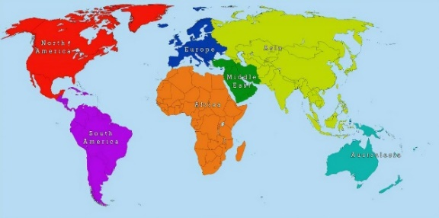

Science: A senses hunt.

In your home/outside, what can you smell? Taste? See? Hear? Feel?