Welcome to Oak Class
Welcome back, we hope that you have all had a lovely Summer break. We have a busy half term ahead which is detailed below. Please support your child at home by asking questions about their school day, listening to your child read, reading to your child and assisting with any homework.
Reading through this together will help to prepare your child for their learning this half term.
If you have any concerns, please come in to see us or contact us via email or Dojo, noxley@fleetwoods.lancs.sch.uk m.wells@fleetwoods.lancs.sch.uk
Kind regards
Oak Class team
English  The Queen’s Hat  We will use the structure of this story to write our own versions. Our focus will be on sentence structure, basic punctuation and exciting vocabulary.  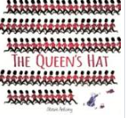  Phonics/Spelling  This year the school is introducing a new Phonics Scheme which will help to further develop the children’s phonic knowledge. | Oak Class  Newsletter Autumn 1 |  | Maths  This half term we will cover place value to further develop their understanding of number. They will use lots of practical resources and enjoy learning outdoors too.  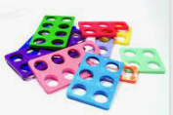  The children will also cover addition and subtraction, which will build on their growing understanding of place value.
RE
The Bible
During this unit children will be looking at the structure of the Bible and some of the most important stories. This will develop an understanding of the importance of the Bible to Christians around the world.

Science  Changing Materials  The children will be reinforcing their knowledge of the materials around them and how these materials can be changed in a variety of ways. Also, how some changes are reversible, and others are not. | Computing  The children will be developing and improving the coding skills using the BeeBot App.  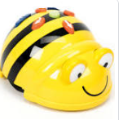 |  | PE  Gymnastics/Games  PE lessons will be on Thursdays and Fridays. If your child wears earrings please ensure they are removed for the said days. If your child can remove their own prior to the lesson this is acceptable.  The children will be developing their athletics skills.
Topic  In history this half term we will be learning about The Great fire of London. We will enjoy a virtual visitor and will learn about how London has changed since 1666.  We also be learning about the different countries in the UK, including some of the landmarks in each of these countries. Our art and DT will link with these units too. | PSHCE  The children will be thinking about how we make friends and accept other people. |  | Music  This half term the children in Oak Class will be learning to play the recorder.  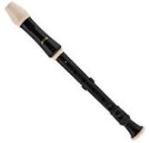
Class Dojo  Class Dojo is a great way for us to keep you updated with day to day classroom life and also for you to send messages and pictures to share.  If you have an urgent message or a message regarding attendance, please ring the office as we may not be available to check the Dojo messages during the school day. |  | Reading  Your child will soon bring a reading book home which is to be enjoyed together. Each time that your child has completed their reading book, they can bring them into school to be changed-so every school day if you choose. Reading at home will support your child’s learning and will help to reinforce their phonics knowledge too.

