Welcome to Willow Class!
I hope that you have all had a great Summer holidays and are ready for a busy half term!
We have had a good few days, settling back in and getting to know our new classroom, adults and classmates. We have Mr Walsh joining us this term, working with me, alongside Miss Bramwell, Mr Nicholls and Miss Gemma.
Throughout the year, please support your child at home by asking questions about their school day, listening to your child read, reading to your child and assisting with any homework.
If you have any questions or worries, please come in to see me or contact me via email or Dojo, mpotter@fleetwoods.lancs.sch.uk
Many thanks, Mrs Potter
English  Our focus this half will be poetry. During this unit we will look at different poetry features as well as developing our descriptive language and punctuation.  Spelling  We will continue to develop our phonics knowledge and will continue learning different spelling patterns, applying these in our writing.  Reading  This half term we will be reading a range of different texts. We will be developing our inference and retrieval skills as well as vocabulary knowledge.  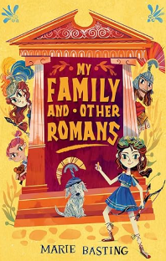  Our first class novel will be  ‘My family and Other Romans’, which will support our history topic, as well as bring different aspect of Roman life to life.  Ask your child about our reading reward system and please support them by listening to them regularly. | Willow Class  Newsletter Autumn 1  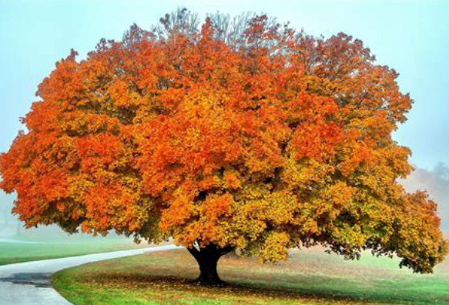 |  | Maths  In maths this half term we will focus on Place Value.  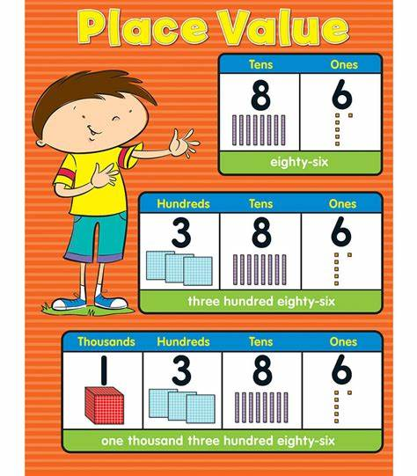  Times Tables  We will have a great focus on tables this year. The national expectation is for children to have quick recall of their tables up to 12x12 by the end of Year 4.  We work towards this by using Time Tables Rockstars as a learning aid, as well as teaching children number patterns and relationships.  Your child’s TTRS login is stuck inside the front cover of their reading record.  
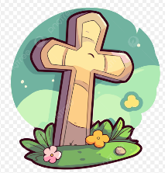
R.E.
This half term our RE focus will be based on the unit ‘Called by God’. We will give children an opportunity to consider what it means to be called by God, as well as consider the responses people have made in the past, and still do today, when they hear a call from God.

Science  In our science lessons this half term we will be learning about  Rocks.  We will identify different rocks and their properties, group rocks, learn to carry out a fair test and complete a local rock survey.  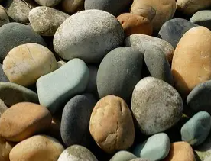 | Computing  During Autumn 1 we will focusing on coding as well as keeping safe online.  We will hone our ipad skills and also work on laptops. |  | PE  Willow will have two PE lessons each week.  One of the PE sessions will be on a Thursday, when the class will have swimming lessons at Poulton YMCA.  The other lesson will be gymnastics on a Wednesday, which will be led by Fleetwood Town.  
History  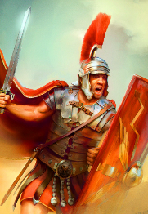  In history this half term we will be learning all about the Romans! We have an exciting visitor booked in for the end of September… | 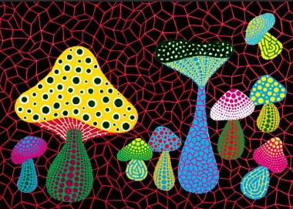  Art  This half term in art we are learning about Yayoi Kusama, and her techniques.  We will be creating our own art and holding a special art exhibition to show our work. |  | PSHE  The unit is ‘Me and My Relationships, in which we will focus on healthy relationships, strategies for standing up to peer pressure, as well as looking at ourselves and our feelings.  Year 4 pupils have some SRE content, about which a separate letter has been sent.
Class Dojo  Class Dojo is a great way for us to keep you updated with day to day classroom life and also for you to send messages and pictures to share.    If you have an urgent message or a message regarding attendance, please ring the office as we may not be available to check the Dojo messages during the school day. |  | Please continue to listen to your child reading regularly. (3-4 times a week for 5-10 minutes would be ideal.) At this stage in their reading journey, we are hoping to embed their phonics ability as well as developing their fluency and expression. Reading regularly will help this to develop.  Please also remember to discuss your child’s reading with them. Question them about what has happened, why characters have behaved in certain ways, characters’ feelings etc.

