Welcome to Willow Class
We hope that you have all had a great Summer holidays and feel rested and ready for an action packed half term.
To the Year 3 pupils-welcome to your new class, you’re now a junior in Year 3!
To the Year 4 pupils-welcome back, we look forward to seeing you work hard and act as super role-models to the younger pupils in Willow!
Throughout the year, please support your child at home by asking questions about their school day, listening to your child read, reading to your child and assisting with any homework.
Reading through this together will help to prepare your child for their learning this half term. ☺
If you have any concerns, please come in to see us or contact us via email or Dojo, noxley@fleetwoods.lancs.sch.uk will be in class on Monday, Tuesday, Wednesday
mpotter@fleetwoods.lancs.sch.uk will be in class on Thursday and Friday.
Kind regards
Mrs Oxley and Mrs Potter
English  Our focus this half will be a poetry text called ‘Autumn is here’. During this unit we will look at different poetry features as well as developing our descriptive language and punctuation.  Spelling  We will continue to develop our phonics knowledge and will continue learning different spelling patterns, applying these in our writing.  Reading  This half term we will be reading a range of different texts. We will be developing our inference and retrieval skills as well as vocabulary knowledge when reading further texts based on our end of week class novel, The Firework Maker’s Daughter by Phillip Pullman. | Willow Class  Newsletter Autumn 1  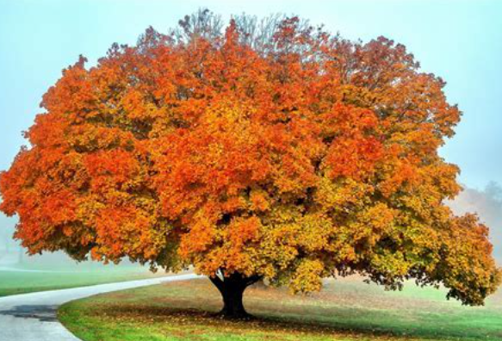 |  | Maths  In maths this half term we will focus on two different areas of maths.  With Mrs Oxley (on a Monday, Tuesday and Wednesday) we will be learning all about place value before moving on to addition and subtraction.  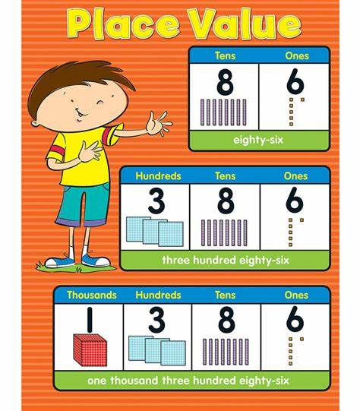  With Mrs Potter (on a Thursday and Friday) we will be learning about statistics before moving on to a topic on shape which focuses on different 2D and 3D shapes, angles and turns.
RE
This half term our RE focus will be based on David and the Psalms. We will explore the Story of David and his strengths and qualities. We will read the Psalms and use them to discover more about the nature of God. We will identify the values that the pupils consider to be particularly important.

Science  In our science lessons this half term we will be learning about  Earth and Space.  We will learn about the different planets, how day and night are created as well as lots of new vocabulary.  .  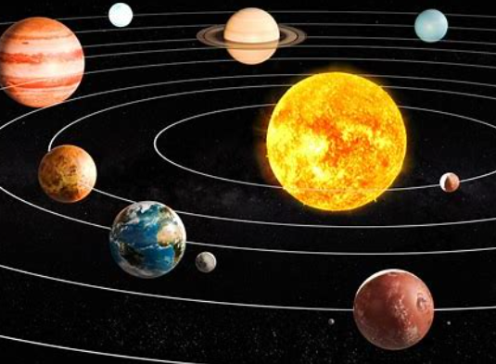 | Computing  During Autumn 1 we will focusing on coding as well as keeping safe online. |  | PE  Willow will have two PE lessons each week.  One of the PE sessions will be on a Wednesday when the class will have swimming lessons at Poulton YMCA baths.  The second lesson will be gymnastics on a  
History  In history this half term we will be learning all about Ancient Greece! 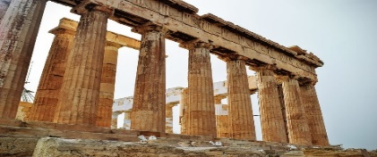 | Art  This half term in art we are learning about clay.  We will learn how to sculpt clay and use tools precisely when creating our own clay creations, inspired by the Greeks. |  | Music  In music this half term, we will look at the unit ‘Different Musical Styles’. This will help us learn to sing in parts, to use instruments to accompany us and practise performing and gaining confidence in doing so.
Class Dojo  Class Dojo is a great way for us to keep you updated with day to day classroom life and also for you to send messages and pictures to share.    If you have an urgent message or a message regarding attendance, please ring the office as we may not be available to check the Dojo messages during the school day. |  | Reading  Please continue to listen to your child reading regularly. (3-4 times a week for 5-10 minutes would be ideal.)  At this stage in their reading journey, we are hoping to embed their phonics ability as well as developing their fluency and expression. Reading regularly will help this to develop.  Please also remember to discuss your child’s reading with them. Question them about what has happened, why characters have behaved in certain ways, characters’ feelings etc.

