Welcome to Oak Class
Welcome to Oak Class’s Autumn 2 Newsletter, I hope you had a great half term and ready to be back! We have a busy and exciting half term ahead full of Christmas activities. Please continue to support your child at home by asking questions about their school day, listening to your child read daily and assisting with any homework.
Miss Shatford will be teaching Oak Class every day, and Miss Reeves on a Tuesday afternoon. Throughout the week, we have Mrs Grundy, Mr Nicholls and Mrs Bramwell supporting Oak Class.
Reading through this together will help to prepare your child for their learning this half term.
If you have any concerns, please come in to see us or contact us via email or Dojo. cshatford@fleetwoods.lancs.sch.uk mpotter@fleetwoods.lancs.sch.uk cbrakewell@fleetwoods.lancs.sch.uk
Kind regards
Oak Class team
English  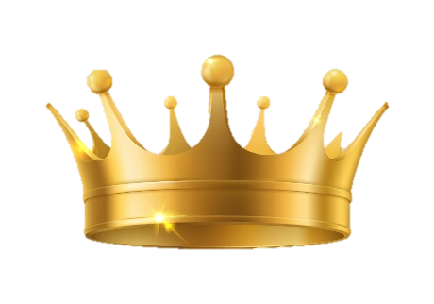  We will be continuing our poetry unit on ‘If I were in charge of the world’. Children will be writing what they would like to cancel and change to make the world their own. We have had some great ideas so far! At the end of the unit, we will be writing our own poem on ‘If we were in charge of the adults/teachers’.  We will be starting a fiction topic based around the advert ‘My Christmas Star’ by the BBC. We will be writing the events taking place in the Christmas advert and continue the plot independently.  Phonics  Year 1s and some Year 2 will be continuing to learn new Phase 5 sounds. Year 2 will be looking at spelling patterns and starting to complete reading comprehensions, answering and discussing questions based on a text. | Oak Class  Newsletter  Autumn 2  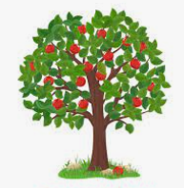 |  | Maths  Addition and subtraction:  We will be continuing our unit on addition and subtraction for both Year 1s and Year 2s. We will be using part-whole models, bar models and fact families to help children understand the numbers and symbols used in calculations.  We will also be using numbers lines to help us add or subtract and knowing our number bonds to 10 (Year 1s), 20 and 100 (Year 2s)  Our last unit this half term will be shape looking at the key features and characteristics of 2D and 3D shapes. Year 1 will be learning the names and their key features of 2D and 3D shapes. Year 2 will be learning shape’s vertices, edges, sides and faces to compare and understand the differences.  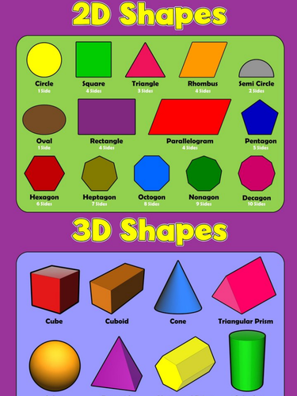
RE

During this half term, we will be comparing Jesus’s world to ours, looking at the main differences. The children will know that Jesus celebrated Passover and link bible stories to their understanding on his world.

We will also be looking at the Christmas story and why it is such a significant event in the Christian calendar.

Worship:
Worship over this half term will be based around our values respect and peace. There will be 3 class worships and 2 whole-school worships a week. The ‘VIP award’ will be awarded every Friday for a pupil who has shown they can promote our school values and achieved the VIP goal of the week.
Science  During science this half term, children will be learning about different materials, and what objects are made of. We will be looking at objects and suggesting different materials they can be made from.  We will be completing different investigations weekly such as the absorbency of materials, waterproofness, properties of metal and learning about Charlie Macintosh. | Computing  With Miss Reeves, children will be spending the next 8 week learning about coding. They will understand what an algorithm is and how to create a code on Purple Mash to complete different tasks.  DT  On the last week, Oak Class are having a DT day, creating a moving Christmas scene using sliders. We will design our Christmas scene and slider and understand how a slider works. |  | PE  1 x PE lesson on a Tuesday with Miss Reeves doing team activities and ball games.  1 x PE lesson on dance, focusing on the secret garden and the circus. This will be on a Thursday.  
History  Our first history topic on local and past/present farming. We will be looking at farming in the past and how/why it has changed to the present. We will be trying out ways farmers used to complete their jobs in the past and how they are completed now.  We will be visiting a local farm on Wednesday 13th November. | PSHE  We will be looking at our ourselves and relationships with others, focusing on feelings. It is important for children to know what to do when they have different feelings (both positive and negative feelings), so children will learn what to do when they experience different feelings in school and at home. |  | Nativity  We will be starting to practice the nativity from early on this half term. We will be learning the songs and our roles to ensure we give family and friends the best performance  Please practise at home so everyone knows their lines off by heart. Thank you in advance for your support with this!
Class Dojo  Class Dojo is a great way for us to keep you updated with day-to-day classroom life and also for you to send messages and pictures to share.  If you have an urgent message or a message regarding attendance, please ring the office as we may not be available to check the Dojo messages during the school day.  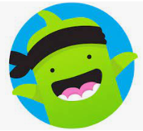 |  | Reading  Reading remains such an important part of your child’s education. We want every child to have a love for reading!  Please continue to listen to your child reading regularly this half term too- reading at home will support your child’s learning and will help to reinforce their phonics knowledge too.  

