Welcome to Oak Class
Welcome back, we hope that you have all had a great October break. We have a busy half term ahead, including lots of preparations for this year’s nativity. Please continue to support your child at home by asking questions about their school day, listening to your child read, reading to your child and assisting with any homework.
Reading through this together will help to prepare your child for their learning this half term.
If you have any concerns, please come in to see us or contact us via email or Dojo, noxley@fleetwoods.lancs.sch.uk m.wells@fleetwoods.lancs.sch.uk
Kind regards
Oak Class team
English  The Queen’s Hat  Seasons  We will spend the first few weeks of Autumn 2 finishing off our own stories before moving on to our new text; Seasons. During our writing topic of seasons, we will look at the features of non-fiction writing before writing our own text based on one of the seasons.  Phonics  We have made a great start with phonics this year and have successfully implemented a new phonics scheme. Each week most children will be learning several new sounds, some with be consolidating the sounds which they learnt in Reception and Year 1, developing their ability to choose the correct sound when spelling. | Oak Class  Newsletter Autumn 2  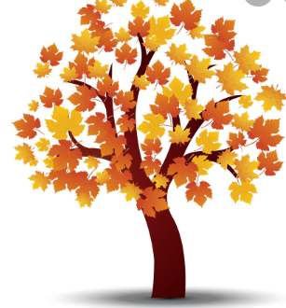 |  | Maths  This half term we will continue to develop our understanding of place value. We will also be further developing our ability to add and subtract numbers with Year Ones using their number bonds to create number families and the Year Twos beginning to look at adding and subtracting numbers up to 100.  Following this we will learn all about shape-we will learn the properties of different shapes, we will make our own and will go on shape hunts too!  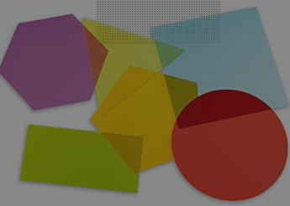
RE
For the first three weeks we will following on from our work on The Bible to look at the sacred books of other religions.
As we get nearer to Christmas we be thinking about the good news of Christmas.

Science  This half term we will be looking at the basic needs that all humans have to survive, including a good diet and exercise. | Computing  In Computing we will be looking at how we can safely find information on the Internet. |  | PE  In PE we will be having fortnightly forest sessions for each year group as well as continuing to develop our gymnastic routines.
Topic  We will continue learning about the different countries in the UK this half term and will extend our knowledge by reading maps and then creating our won maps. In DT we will work together to create our own ‘Houses of Parliament’ whilst learning about Guy Fawkes. We will also enjoy making pop-up Christmas cards.  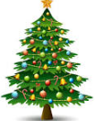 | PSHE  This half term we will be learning about keeping safe online.  We will also be learning and thinking about others and how we can show other people ‘kindness’. |  | Music  This half term the children in Oak Class will continue to learn to play the recorder.  We will also be learning the songs for the Nativity.  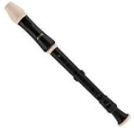
Class Dojo  Class Dojo is a great way for us to keep you updated with day to day classroom life and also for you to send messages and pictures to share.  If you have an urgent message or a message regarding attendance, please ring the office as we may not be available to check the Dojo messages during the school day. |  | Reading  Reading remains such an important part of your child’s education. So many children in Oak class are reading regularly and this is great to see!  Please continue to listen to your child reading regularly this half term too- reading at home will support your child’s learning and will help to reinforce their phonics knowledge too.

