Willow Class Newsletter Autumn Term 2 2025
Dear Parents / Carers,
I hope that you have all had a great half term holidays and are ready for another busy half term. Throughout the year, please support your child at home by asking questions about their school day, listening to your child read, reading to your child and assisting with any homework.
Reading through this together will help to prepare your child for their learning this half term.
Mr Walsh will continue with our class until the end of term.
If you have any concerns, please come in to see us or contact me via email or Dojo,
mpotter@fleetwoods.lancs.sch.uk
Kind regards
Mrs Potter
English  This half term we will be learning how to write a story.  We will be focusing on a book called ‘The Flood’. We will work together to look at the structure and language of a story. Children will then build up to writing their own.  Spelling  We will continue to develop our phonics knowledge and will continue learning different spelling patterns, applying these in our writing.  Reading  This half term we will be reading a range of different texts. We will be developing our inference and retrieval skills as well as vocabulary knowledge when reading a range of different texts.  Reading at home builds up towards our prize box! | Willow Class  Newsletter Autumn 2   |  | Maths  In maths this half term we will focus on Multiplication & Division.  on to multiplication and division.  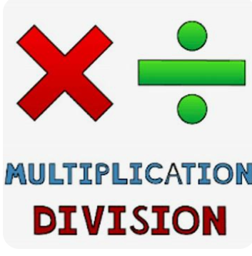  Multiplication tables will be a focus, as the Year 4 pupils are working towards the Multiplication Check. This is a government given assessment that gives the pupils 6 seconds to answer and input into the inline box.  This requires practise and will be highlighted to parents at parents’ evening.  Year 3 pupils can only benefit from practise. They are tested uptp 12x12.
RE
This half term our RE focus will be based on
Christmas: How does the birth of Jesus fit into God’s Big Story?
The aim of the unit is to give children a Biblical perspective on the nativity story. The children will deepen their understanding of what Christians believe to be the true meaning of Christmas. Pupils will increase their knowledge and understanding of the place of the incarnation in God’s Big Story.
Science  In our science lessons this half term we will be learning about  Soil & Fossils  We will be exploring fossils, understand fossil formation, explore soil and understand the importance of soil in our world.  We will plan, carry out and conclude a fair test  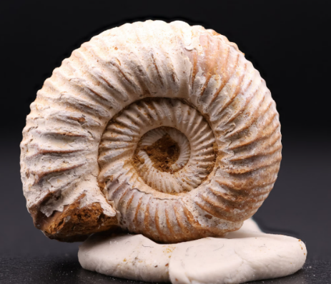 | Computing  During Autumn 2 we will focusing on Online Safety and Spreadsheets. These units will provide life skills; in keeping children safe and their information safe on the internet, and introduce spreadsheets.   |  | PE  This half term, Willow will have PE on a Wednesday with Fleetwood Town and swimming on a Thursday.  Our PE lesson on a Wednesday will be linked to the skills of Dodgeball, building up playing games within the rules and accepting when you are out.  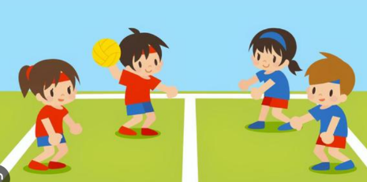
Geography  We will be looking at Earthquakes and Volcanoes with Mr Walsh. We will also cover Extreme Weather briefly within this unit.   | DT  This half term in art we are learning about food technology.    We will be focussing on chocolate and are looking forward to some product research and making some tasty treats! |  | PSHE  Valuing Difference  A unit of work looking at the differences between people and the value this holds. We will be exploring how to be your own person, standing up to peer pressure, defining different types of relationships and highlighting respect.
Class Dojo  Class Dojo is a great way for us to keep you updated with day-to-day classroom life and for you to send messages and pictures to share.    If you have an urgent message or a message regarding attendance, please ring the office as I may not be available to check the Dojo messages during the school day. |  | Reading  Please continue to listen to your child reading regularly. (3-4 times a week for 5-10 minutes would be ideal.)  At this stage in their reading journey, we are hoping to embed their phonics ability as well as developing their fluency and expression. Reading regularly will help this to develop.  Please also remember to discuss your child’s reading with them. Question them about what has happened, why characters have behaved in certain ways, characters’ feelings etc.

