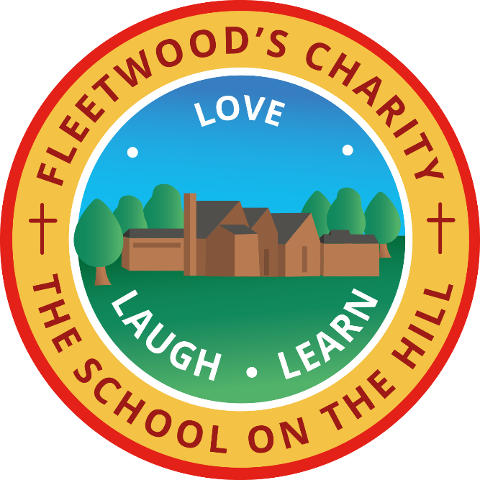
In His Light We Flourish
Enrichment and Spirituality Curriculum Overview
Reception and Year 1
You are the Light of the world. A school that stands upon a hill cannot be hidden. (Matthew 5:14 adapted)

Love Laugh Learn in God's World

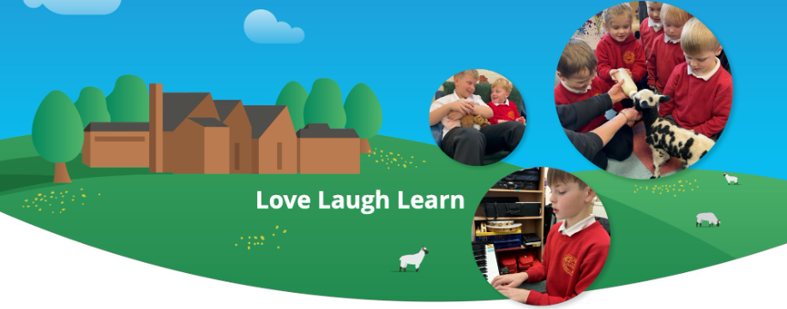
 | Term One | Term Two | Term Three | Term Four | Term Five | Term Six
Themes (EYFS) | Marvellous me! | Healthy me and celebrations! | Winter and the world around us! | Castles  My natural world | Into the jungle | Pirates
Computing (Y1) | Introduction to Purple Mash  Creative computing | Data explorers | Animated stories | Coding | Technology around us. | Making beats
History |  | Florence Nightingale and Mary Seacole |  | Kings, queens and castles. |  | Schools in the past
Geography | Map explorers (UK) |  | UK and Antarctica |  | World adventurers
Science | My clever body | Seasonal change Materials | Seasonal change  Animals habitats | Plants | Animal classifications with lifecycles | Seasonal change  Investigations
Art | Printing |  | Drawing |  | Painting
DT |  | Healthy eating – fruit kebabs for Santa |  | Mechanisms – dragons |  | Structures – boats
Music | Blackpool Music Service | My stories  Christmas Nativity | Everyone! | Our World | In the groove | Hey you!
PE | Fundamental motor skills. | Dance | Gymnastics | Invasion games | Athletics | Net and wall games
PSHE | Me and my relationships | Valuing difference | Keeping myself safe | Rights and responsibilities | Being my best | Growing and changing
RE | Harvest and being thankful. | Christmas | What made Jesus special? | Why did Jesus tell stories?  Easter | Why are we all different and special? | What makes a place holy or special?
Class stories | Marvellous Me! | Festivals and celebrations | Poetry | Traditional Tales | Animals | Seasons
Visits/Visitors | Blackpool Music Service  Reverend Naomi | Christmas Nativity  Santa visit | Local walk |  | Eggs to chicks (lifecycles)

Term One
Spirituality | British Values | Christian Value: Respect | Christian Value: Thankfulness
Children will develop a sense of wonder and awe as they explore their local village and the wider UK. This can be through observing landscapes on our local walk, looking at natural features and appreciating the beauty of the world around them.  During our music unit with Blackpool music service, children will develop connection with other by group signing, participating in action songs and making music together to help children experience belonging. | During our unit on why those of faith are thankful during harvest, children are encouraged to be thankful for the food, people and resources they have, whilst developing respect, generosity and a sense of community. They will learn how their actions can help their wider community.  During our first EYFS theme on Marvellous me, children develop confidence to express their feelings and make choices, whilst learning to listen to others, respect opinion and celebrate uniqueness. This promotes individual liberty, mutual respect and tolerance. | During our computing unit, children learn to use technology respectfully, taking care of equipment and valuing other people’s ideas and creations. They develop an understanding of respect when working and sharing with others.  The children will deepen their understanding on respect using the continuous provision effectively, learning how to look after resources and the importance of tidying up after themselves. | ‘My clever body’ can be explored through the value, thankfulness. Children learn about their five senses and the different parts of the body, developing and understanding of each part of there is special and helps them experience the world around them.  Our Harvest unit is fully revolved around thankfulness and why those of faith give thanks during this incredible time. Children will deepen their understanding on what they are thankful for and why others from all around the world say thanks to God.

