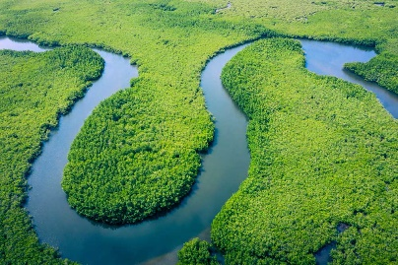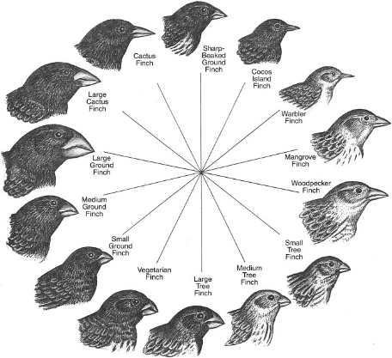**ELM CLASS NEWSLETTER**

**Autumn TERM 2**

*Our curriculum for this half-term is as follows:*

**English:** We will be looking at a novel called ‘Kensuke’s Kingdom’ by Michael Morpurgo. The children will work towards writing a fiction text based on this novel. In lessons we will be exploring different language techniques both in the chosen text and our own writing. Later in the term we will be exploring poetry and writing some poems of our own!

We will also have weekly grammar, handwriting and reading sessions to further support the children’s literacy skills. Children will be given a reading book and a reading diary to take home. These will come into school every day and can be changed when needed. If the children would like to bring in a book from home that they are enjoying this is also ok.

**Maths:** We will begin by looking at addition, subtraction, multiplication and division of fractions. We will then think about how to convert between mixed numbers and improper fractions as well as calculating fractions of amounts. All learning is linked to the real-world for the children as we aim to teach maths with a practical approach that links to problems the children will come across in their lives.

**Science:** Our science topic is ‘Evolution and Adaptation’. In this unit we will look at how different animals have adapted and why. We will also look at the Theory of Evolution and hereditary features in human beings.

**PE:** PE will take place on a **Thursday and Friday** afternoons. Please send your child to school wearing their PE kit and school jumper on both of these days. PE clothes will be red t-shirt, PE hoodie or school sweatshirt/cardigan and plain black shorts, leggings or joggers. Pumps or trainers are to be worn.

**RE:** This half term we will be focusing on two different RE units. We will start by exploring pilgrimages made by different faiths. We will then go on to learn about advent; understanding the meaning of advent and the symbolism used during this time.

**PSHE:** In PSHE we will first be looking at ‘Valuing Differences’, exploring the terms respect and tolerance as well as challenging gender stereotypes. We will then move on to looking at ‘Online Safety’ when we will think about the importance of gender restrictions, identify what information should be kept private and look at ways to report things online.

**GEOGRAPHY:** We will be learning all about rivers in geography this half term. We will begin by recapping the water cycle and then move on to learning the key features, functions and problems of rivers.

**DT:** In DT will be researching, designing, building and evaluating our own model bridges. We will be using wood to build our bridges and will learn how to safely and effectively use equipment such as hammers, saws and vices.

**COMPUTING:** We will be learning about coding in computing this half term. The children will be designing and making their own coded games as well as learning how to debug them when they don’t play out as expected.

*Expectations:*

· No equipment to be brought into school (e.g. pencil cases) as all equipment will be provided.

· PE kits must be worn to school on a Thursday and Friday with appropriate footwear (e.g. trainers) no additional clothing can be brought into school.

· Read at home and bring reading book to school each day.

· Completing homework tasks in homework book.

· Having a good attitude towards work.

· Showing good behaviour which follows our core Christian values.

· Being prepared to have a go and not give up.

|  |  |
| --- | --- |
| **Monday** |  |
| **Tuesday** |  |
| **Wednesday** |  |
| **Thursday** | PE |
| **Friday** | PE |

**General Timetable**

Kind regards,

**Mrs Simpson**

[vsimpson@fleetwoods.lancs.sch.uk](mailto:vsimpson@fleetwoods.lancs.sch.uk)