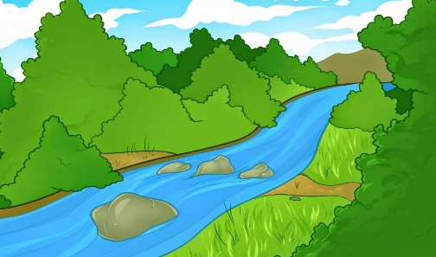
ELM CLASS NEWSLETTER Autumn TERM 2
Half term topic – Raging Rivers!

We have had a brilliant start to year 6 so far with lots of learning and fun experiences. As we lead up to Christmas, we have lots of new topics to learn about as well as Christmas experiences to prepare for. The class will continue to be taught by Mrs Simpson and supported by Mrs Lewis. Mr Harrison is a student teacher that will also be supporting the learning in Elm Class. Mr Wells and Mr Nichols will work with Elm class on Tuesday afternoons.
I will communicate with parents mainly through the use of Class Dojo but will also be available to email parents where necessary. vriding@fleetwoods.lancs.sch.uk

Our curriculum for this half-term is as follows:
English: In our writing lessons we will be looking at writing a narrative based on ‘Kensuke’s Kingdom’ by Michael Morpurgo. In this unit the children will look at several different writing devices such as speech, passive voice and use of prepositions.
We will also have weekly grammar, handwriting, spelling and reading sessions to further support the children’s literacy skills. Children will be given a reading book and a reading diary to take home. These will come into school once a week (Fridays) and can be changed when needed. If the children would like to bring in a book from home that they are enjoying this is also ok.
Maths: In maths we will begin by looking at fractions. We will look at simplifying, ordering and comparing different factions. We will then learn how to add, subtract, multiply and divide fractions. We will explore different forms of fractions such as mixed numbers and improper fractions and look at how these can be converted it make calculations easier.
We will then move on to looking at converting units. We will begin by looking at metric units and conversions before moving on to miles to kilometres and imperial measurements.
Science: In science we are going to be learning all about adaptations and evolution. We will look at how and why different species adapt and change over time to survive in their environment.
Computing: In computing we are going to be creating our own spreadsheets and formulae to help plan an event. We will look at budgeting and how to ensure a profit is made using formulae.
PE: PE will take place on a Tuesday and Friday afternoons. Please send your child to school wearing their PE kit and school jumper on Tuesdays and Fridays. PE clothes will be red t-shirt, PE hoodie or school sweatshirt/cardigan and black shorts, leggings or joggers and pumps or trainers (no PE bags can be brought into school). Our PE focuses will be invasion games and gymnastics.
RE: Our focus this term will be on ‘Advent’. We will be looking at how Christians prepare for Christmas and will study the meaning of each advent candle. We will also look at how Christmas highlights a significant difference between Christianity and Judaism.
PSHE: In PSHE we are learning about ‘Valuing Difference’. In this topic we will look at respecting others and showing tolerance. We will recognise that people are all different at that this should be celebrated. We will also challenge gender stereotypes through a range of activities.
GEOGRAPHY: In geography we are going to be looking at rivers. We will begin by recapping our previous learning on the water cycle. We will then go on to learn about the different features of the river system and will do a case study on some local rivers including the River Wyre. We will also look at different problems associated with the Earths water, such as flooding and drought, and how this impacts different places around the world.
DT: We are going to be investigating bridges. We will be looking at a range if bridge types and will investigate strength, reinforcement and structure. We will then design, build and evaluate our own bridges using a range of materials and equipment.
SPANISH: In Spanish we are going to be learning about weather. We will look at how to ask questions about the weather and will work on holding short conversations about the weather.

Expectations:
· No equipment brought into school (e.g. pencil cases) into school as all equipment will be provided.
· PE kits must be worn to school on a Tuesday and Friday with appropriate footwear (e.g. trainers) no additional clothing can be brought into school.
· Read at home and bring reading book to school each day.
· Completing homework tasks in homework book.
· Having a good attitude towards work.
· Showing good behaviour which follows our core Christian values.
· Being prepared to have a go and not give up.
Monday
Tuesday | PE
Wednesday
Thursday
Friday | PE  Bring in reading books and homework books
General Timetable

Kind regards,
Mrs Simpson

