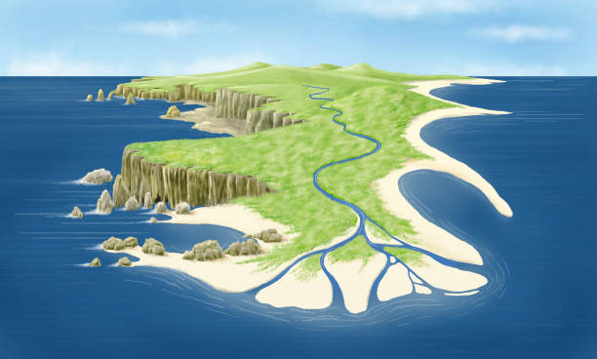
ELM CLASS NEWSLETTER Spring TERM 2

Spring 2 already… time flies when you’re having fun! As we continue through Spring in year 6 we start to really focus on preparing for SATs. There will be lots of intervention groups that focus on building confidence and familiarising the children with SATs style questions. Spring term is all about learning in year 6 and requires lots of energy, focus and hard work! My aim is to ensure all of the children feel as comfortable and confident as possible when we get to their SATs week. The class will continue to be taught by Mrs Simpson and supported by Mrs Lewis. Mr Wells will work with Elm class on Monday afternoons.
I will communicate with parents mainly through the use of Class Dojo but will also be available to email parents where necessary. vriding@fleetwoods.lancs.sch.uk
Our curriculum for this half-term is as follows:
English: Our writing focuses for this half term will be dramatic openings and non-chronological reports. We will be thinking about the different components needed to create these two very different types of text and the different techniques we can use to make them appropriate for their audience as well as interesting and exciting.
We will also have weekly grammar, handwriting, spelling and reading sessions to further support the children’s literacy skills. Children will be given a reading book and a reading diary to take home. These will come into school once a week (Fridays) and can be changed when needed. If the children would like to bring in a book from home that they are enjoying this is also ok.
Maths: In maths we will start by looking at the relationship between fractions, decimals and percentages then move on to work on position and direction. We will then move on the revisiting and recapping the whole of the year 6 curriculum to build confidence and develop problem solving skills.
The children will also have weekly sessions on arithmetic and SATs question practice. This will help them build up their speed and accuracy with a range of calculations.
Science: This half term we will be learning about classification of animals and living things. We will look at the classification models used by scientists and even look at designing some of our own. We will think about the importance of classification and where else we see it in our lives.
Computing: Computing will take place with Mr Wells and will look at quizzing. The children will be creating their own quizzes for specific audiences using a range of question types.
PE: PE will take place on Wednesday and Friday afternoons. Please send your child to school wearing their PE kit and school jumper on both od these days. PE clothes will be red t-shirt, PE hoodie or school sweatshirt/cardigan and black shorts, leggings or joggers and pumps or trainers (no PE bags can be brought into school). Our PE focus will be rugby and fencing.
Swimming: On Wednesday afternoons group of children will be going swimming instead of doing our in-school PE lesson. These children have been contacted by Mrs Gladwin on dojo. Please ensure children bring their swimming kit to school with them.
RE: In RE we are going to be thinking about the key questions ‘Who is Jesus?’ and ‘Who was Jesus?’ We will think about these questions from our own viewpoint as well as from others viewpoints. We will also consider how this question would have been answered in the past as well as now.
PSHE: In PSHE we will be looking at rights and responsibilities. We will look at how the media reports stories and how reliable they are. We will also look at money management and the role of taxes. We will finally look at democracy and how this is evident in Britain.
Spanish: We are going to be learning how to talk about families. We will start by learning the Spanish vocabulary for the key family terminology. We will then go on to put this terminology into questions and short sentences. We will also look at how to read and write these words and phrases.
Music: Music will take place with Mr Wells and will look at songs that make people happy or are about being happy. The children will look to create our own simple melodies and write lyrics to go with them.
Geography: We are going to be exploring different types of weathering and look in particular at their effect on the coastline. We will learn about different coastal features and how they came to be.
Expectations:
· No equipment brought into school (e.g. pencil cases) as all equipment will be provided.
· PE kits must be worn to school on a Tuesday with appropriate footwear (e.g. trainers) no additional clothing can be brought into school.
· Read at home and bring reading book to school on Fridays.
· Completing homework tasks in homework book.
· Having a good attitude towards work.
· Showing good behaviour which follows our core Christian values.
· Being prepared to have a go and not give up.

Monday
Tuesday
Wednesday | Swimming/PE
Thursday
Friday | PE  Bring in reading books and homework books
General Timetable

Kind regards,
Mrs Simpson

