Maple Class Newsletter
Autumn Term 1 2025

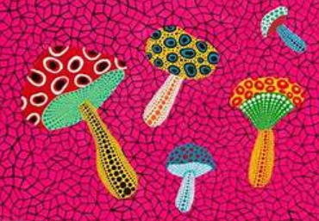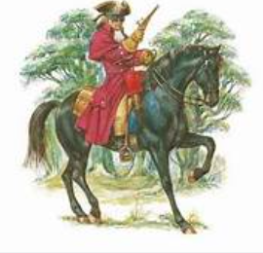
I hope you’ve all had a great Summer break and a well-earned rest. We’ve got a busy Autumn term ahead of us; I’m excited to be welcoming the children back after the holidays and into our new Maple mixed-class.
Our curriculum for this half term is as follows:
English: We will begin a fictional unit of writing based on poetry. We will enjoy reading and sharing different types of poetry looking at their structure and language before focusing in on a poem called ‘The Highway man’ written by Alfred Noyes.
We will also have weekly grammar, handwriting and reading sessions to further support the children’s literacy skills. Please support your child’s reading at home by listening to them read at least 3 times each week. Home reading books and reading records can be sent into school each time your child has read or when they need to change their book, so I am able to read their reading diary and change their books. Children will be awarded with a stamp in their reading record each time they read at home, 10 stamps= a prize!
Maths: We will begin the Autumn term with our usual place value unit. This will involve partitioning numbers up to 1,000,000 (Year 5) and up to 10,000 (Year 4). We will be comparing and ordering numbers within this unit as well as answering word problems, applying their new knowledge.
Following this unit, children will have the opportunity to develop their addition and subtraction skills-they will be encouraged to use the inverse methods when checking their answers and will, again, be working with numbers up to 10, 000 in Year 4 and up to 1,000,000 in Year 5.
Science: This half term we will focus on ‘rocks’, where children will explore different types of rocks and their properties. They will use this knowledge to make predictions when carrying out fair tests and will develop an understanding of why different rocks are used for different purposes.
RE: In RE, we will begin learning about what it means to be ‘called by God’. Children will be encouraged to ask thoughtful questions, to explore stories of the Old testament and to explore the roles of faith leaders.
PE: Our topic in PE this half term is gymnastics. Children are to wear their PE kit to school on a Monday.
Music: Our music topic this half term will be ‘enjoying musical styles’. Children will listen to a range of different genres of music, they will be encouraged to discuss which they prefer, giving reasons for their preferences. They will also be given the chance to play music taking inspiration from the different genres.
History: In History, we will be focusing on the Romans-children will learn about the significance of the Romans on history including their impact on our lives today! We will be lucky enough to experience a Roman visitor in school to support this unit too!
Art: Our first art unit of the year will be based on ‘dot art’ inspired by Japanese artist Yayoi Kusama. We will be making observations about her different artwork before creating our own pieces.
PSHE: We will focus on ‘me and my relationships’. This unit will encourage children to consider the qualities required to be a good friend, it will also allow them to think about peer pressures and how it is okay to ‘say no’ to our friends.
Computing: In computing, we will focus on two different units this half term. Initially we will begin by developing our coding skills before developing skills in making ‘effective searches’ online.
Please take some time to read through this newsletter with your child and encourage them to complete tasks on their extended learning menu, as these help to support their learning.
Thanks,
-Mrs Oxley

