Maple Class Newsletter
Autumn Term 2 2025

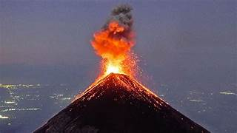
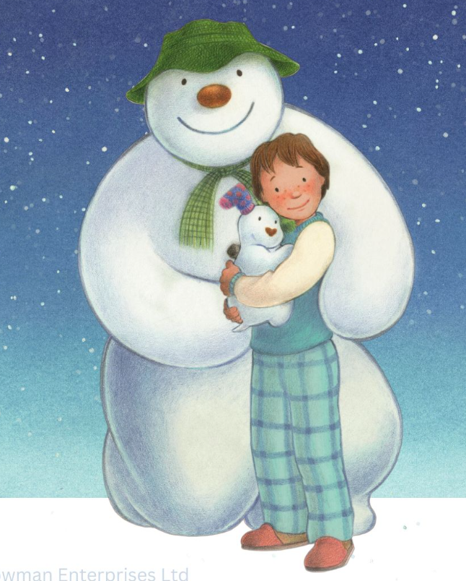
I hope you’ve all had a great half-term break. We’ve got another busy Autumn term ahead of us in Maple!
Our curriculum for this half term is as follows:
English: We will be focusing on the well-known story of ‘The Snowman’ by Raymond Briggs this half term. We will be looking at building suspense in our writing, using advanced description as well as using a variety of sentence openers.
We will also have weekly grammar, handwriting and reading sessions to further support the children’s literacy skills. Please support your child’s reading at home by listening to them read at least 3 times each week. Home reading books and reading records can be sent into school each time your child has read or when they need to change their book, so I am able to read their reading diary and change their books. Children will be awarded with a stamp in their reading record each time they read at home, 10 stamps= a prize!
Maths: We will begin this half term by focusing on multiplication and division before moving on to a unit about length, perimeter and area.
Science: This half term we will be developing our ‘rocks’ knowledge from Autumn 1 as we move onto learning about fossils and soils. We will be collecting different soil samples from our school grounds and will use these when completing a scientific experiment.
RE: In RE, we will begin learning about why Holy books are so important to people of faith. Children will be encourage to ask meaningful questions and to ask questions such as ‘How and why do Christians read the Bible?’
PE: Our topic in PE this half term is dodgeball (with a small group of Maple going swimming on a Thursday afternoon instead). Children are to wear their PE kit to school on a Thursday.
Spanish: Our Spanish focus this half term is ‘Feliz Navidad!’- Maple will learn about the culture and traditions of Christmas in Spain as well as basic conversations and greetings linked with this festive time of year!
Geography: In geography, we will be focusing on extreme weathers-volcanoes and earthquakes in particular! We will locate these, looking at the Ring of Fire. We will also be considering the impact of these natural disasters both in the past and more recently.
DT: Our first DT unit this year will be based on ‘food’. We will spend time researching existing festive sweet treats. Children will have the opportunity to design and create their own brand of packaging as well as some Christmas- themed chocolate truffles.
PSHE: We will focus on ‘Valuing differences’. This unit celebrates diversity-children will be encouraged to consider their own differences as we celebrate our own and others differences too!
Computing: In computing, we will focus on online safety. We will discuss what to do in-order-to keep safe when using different websites and apps and how to respond if we feel unsafe whilst online.
Please take some time to read through this newsletter with your child and encourage them to complete tasks on their extended learning menu, as these help to support their learning. As always, we look forward to celebrating all completed tasks in a ‘homework share’ during the last week of the half term.
Thanks,
-Mrs Oxley

