Maple Class Newsletter
Spring Term 1 2026
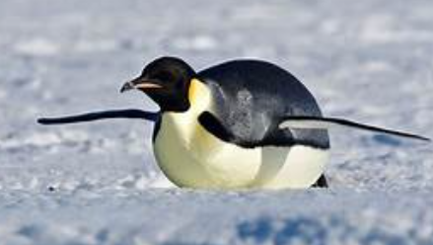
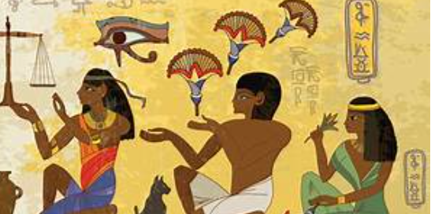

I hope you’ve all had a fantastic Christmas break. We’ve got a busy Spring half term ahead of us in Maple!
Our curriculum for this half term is as follows:
English: We will be focusing on non-chronological report writing. As a class we will write an non-chronological report about Emperor Penguins before children then plan, write and edit their own non-chronological report about an animal of their choice.
We will also have weekly grammar, handwriting and reading sessions to further support the children’s literacy skills.
Please continue to support your child’s reading at home by listening to them read at least 3 times each week. Home reading books and reading records can be sent into school each time your child has read or when they need to change their book, so I am able to read their reading diary and change their books. Children will be awarded with a stamp in their reading record each time they read at home, 10 stamps= a prize! Please note, at this stage in your child’s reading journey, discussion about what they have read and discussion about new vocabulary is invaluable!
Maths: We will begin this half term by focusing on fractions before making a start of the next unit of multiplication and division. Both of these units will rely heavily on the knowledge and understanding of times tables facts. Please encourage your child to use TTRS regularly to support their speed and fluency with their times tables up to 12 x 12.
Science: This half term we will be developing our knowledge of ‘sound’. Children will learn about the difference between volume and pitch, they will also learn about how sound travels.
RE: In RE, we will gain an understanding of why Jesus was such a successful teacher. We will learn about how Jesus’ teachings have impacted on the lives of Christians.
PE: Our topic in PE this half term is cricket-this will be support by Joe from Fleetwood Town on a Monday.
Spanish: Our Spanish focus this half term is ‘Mi Familia’-we will learn about the names of different family members and how to describe those in our families.
History: In history we will be learning all about the Egyptians! We will learn about when the Egyptians lived, about their culture, Egyptian beliefs and Gods/Goddesses.
DT: Our DT topic this half term is focusing on improving ‘textiles’ skills. We will be researching egg cosies before designing and making our own.
PSHE: We will focus on keeping safe! This unit will cover important topics around bullying, staying safe around medicines and vapes as well as making sensible choices to limit risks.
Computing: In computing, we will focus on AI. We will learn about the pros and cons of AI, how to use this technology to help us but also how to recognise the dangers of AI too.
Please take some time to read through this newsletter with your child and encourage them to complete tasks on their extended learning menu, as these help to support their learning. As always, we look forward to celebrating all completed tasks in a ‘homework share’ during the last week of the half term.
Thanks,
-Mrs Oxley

