Welcome to Oak Class
Welcome to Oak Class, I hope you had a great Christmas and happy new year! We have a busy but slightly shorter half term ahead of us! Please continue to support your child at home by asking questions about their school day, listening to your child read daily and assisting with any homework.
Miss Shatford will be teaching Oak Class on Mondays, Tuesdays, Thursdays and Fridays, and Mrs Potter on a Wednesday. To support us this half term, we have Mr Nicholls (Monday to Thursday), Mrs Grundy (Monday, Tuesday, and Thursday) and Mrs Brakewell (Fridays).
Reading this together will help to prepare your child for their learning this half term.
If you have any concerns, please come in to see us or contact us via email or Dojo. cshatford@fleetwoods.lancs.sch.uk mpotter@fleetwoods.lancs.sch.uk
Kind regards
Oak Class team
English  We have started a new traditional-tale unit based around Pinocchio based around the book by Carlo Collodi. We will build up to writing our own story/independent write about Pinocchio.  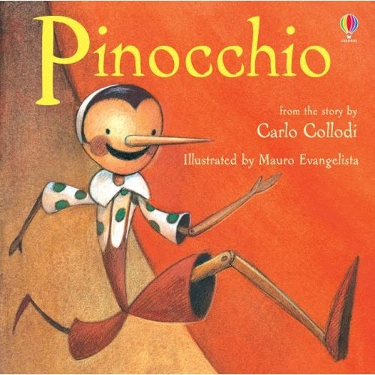  Phonics  Year 1s and some Year 2s will be continuing to learn new Phase 5 sounds. Some Year 2s will be looking at spelling patterns and starting to complete reading comprehensions, answering, and discussing questions based on a text they have read. | Oak Class  Newsletter  Spring 1  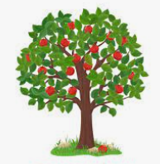 |  | Maths  Year 1:  Children this half term will start building their place value knowledge up to 20 and 50. They will begin to count in twos, fives, and tens, and understand tens and ones. We will be using base ten, counters and lots of different objects and maths resources to support our learning. We will begin to solve problems and become more familiar with mathematical language.  Year 2:  Children are going to continue with addition and subtraction, being able to add and subtract two 2-digit numbers. Our second topic is going to be statistics, looking at how to present statistical data using tally charts, tables, pictograms, and block diagrams. Towards the end of the half term, we will start multiplication and division looking at equal groups and starting to multiply and divide in twos.  With Mrs Potter, both Year 1 and 2 will continue with shape focusing on 2D and 3D shapes. We will start a unit on length and height in which we measure, compare and order different measurements. Children will also be learning four operations with length and height.
RE

During this half term, we will be learning about what makes Jesus so special. We will focus on friendships in the bible and look at different stories that shows Jesus’ power and qualities that makes him special. During lessons, we will make links between the bible stories and our own lives today.

Worship:
Worship over this half term will be based around our value ‘trust’. There will be 3 class worships and 2 whole-school worships a week. The ‘VIP award’ will be awarded every Friday for a pupil who has shown they can promote our school values and achieved the VIP goal of the week.
Science  During science this half term, children will be doing one lesson on plants during winter, and we will be planting our own seeds to see how they grow during this season (indoors). Our next topic is on animals, learning about different animal classifications and comparing animal groups. We will know the difference between carnivores, herbivores, and omnivores. | Art  We will be designing and making animals out of clay. We will be learning different skills to create a variety of shapes and patterns with different materials. |  | PE  1 x PE lessons with coach Ryan on bounce ball.  1 x PE lesson with Miss Shatford on dance.
Design and Technology

Children will be making their own hand puppets. We will be looking at different ways to join fabrics, and then designing our puppet before creating it.
Music

During this unit, children will be focusing around one song: round and round. They will be learning different skills to improvise effectively, both singing and with instruments.

Geography  During this half term, we will be comparing Antarctica and the United Kingdom. Children will know the physical and human features of the United Kingdom and compare them to Antarctica. This topic will link to animals, weather and temperature, and day-to-day differences in living in these different locations.  We will also have Stephen Pilling come in to deliver a Lego workshop – children will get the chance to build their very own Antarctica. | PSHE  In PSHE, we will be working on ‘Keeping safe’ in which we discuss who can help us in certain scenarios. We will briefly discuss good and bad touches, and what you (the children) would do if they got in similar situations to our PSHE friend Harold and Geoffrey the giraffes. |  | Computing  In computing, we will be learning about how to use technology to create sound. Children will be creating a story on the computer and insert appropriate sound over the half term.
Class Dojo  Class Dojo is a fantastic way for us to keep you updated with day-to-day classroom life and for you to send messages and pictures to share.  If you have an urgent message or a message regarding attendance, please ring the office as we may not be available to check the Dojo messages during the school day. |  | Reading  Reading remains such an important part of your child’s education. We want every child to have a love for reading!  Please continue to listen to your child read regularly this half term too- reading at home will support your child’s learning and will help to reinforce their phonics knowledge too.

