Ash Class Newsletter
Happy new year! I hope you all had a good Christmas and can’t wait to start 2026 with a bang. Spring term is where we see the most progress in the children, as they start to develop their knowledge across the national curriculum and early years areas. So, it is an exciting 11 weeks ahead of us! Please continue to support your child at home by asking questions about their school day, listening to your child read daily and assisting with any homework. Homework is not expected to be completed by Receptions but is encouraged and will get rewarded with dojos, stickers and shown in celebration assembly to the whole school.
Miss Shatford will be teaching Ash Class every day. We also have Mrs Roberts and Mr Nicholls throughout the week.
Reading through this together will help to prepare your child for their learning this half term. J
If you have any concerns, please come in to see us or contact us via email or Dojo. cshatford@fleetwoods.lancs.sch.uk
Kind regards
Ash Class team
English  We will be looking at the book ‘One snowy night’ linking to our topic on Winter. We will be writing simple sentences and building up our adjectives word bank to use in our sentences. We will be answering retrieval questions and making predictions throughout the book.  We will be creating our own animal to include in the story.  After, we will be looking at non-fiction text creating invites for a party. We will be looking at recipes also. This links to our book Cake by Sue Hendra and Paul Linnet.  We are focusing on comprehension skills over the next term, ensuring we understand the meaning of stories and answering retrieval questions.  Phonics  Year 1s will be moving onto Phase 4, using their sounds from phase 3 into more complex words.  Receptions will be continuing with Phase 2 with some moving onto phase 3. | Ash Class  Newsletter  Spring 1  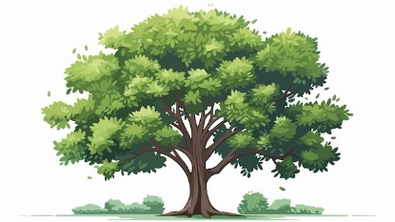 |  | Maths  Both Year 1 and Reception will be doing a topic on shape looking at 2D shapes including circles and triangles, 4-sided shapes and patterns. We will also be exploring 3D shapes together and naming them. We will be using the areas to see what we can create using 3D shapes.  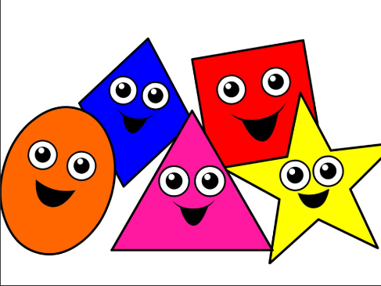  Year 1s will be continuing with addition and subtraction. We will be moving onto place value within 20 and addition and subtraction within 20.  Receptions will be confident with their numbers up to 10. Confidently representing, subitising and composing. We will also be completing a unit on length and height.
RE

Over the next 6 weeks, we will be focusing on Islam and learning about who and where they worship, the 5 pillars and Islam traditions and stories. Over EYFS and KS1, we learn about different religions and compare their beliefs to Christians.

Worship:
Worship over this half term will be based around our school rule ‘be brave’. There will be 3 class worships and 2 whole-school worships a week. The hero award will be awarded every Friday to a pupil who has shown they can promote our school values and achieved the VIP goal of the week.
Science  We will be spending two weeks on seasonal change, looking at daylight and weather during the winter period. The second lesson will be based on animals during winter.  Over the whole of spring term, we will be focusing on plants. The children will be learning about tree and plant parts as well as some of their functions. We will know the difference between evergreen and deciduous trees and planting our own plants to grow in our outdoor classroom. | Our Classroom  For the first two weeks, our classroom will have winter enhanced activities including ice and show.  Then, our classroom will change to celebrate parties linked to our book on ‘Cake’.  Our final week will be about Chinese New Year. |  | PE  1 x PE lessons with Fleetwood Town doing gymnastics.  1 x Forest lesson with Mrs Pollard  As it will be getting colder, please bring the appropriate clothing:  - Waterproof coat  - Waterproof trousers/suit  - Wellies  - Spare socks  - Hat/scarf/gloves  - Extra jumper
History / Geography  In Geography, we are comparing Cape Town to London and linking it to our own local area. The children will learn about animals and culture in South Africa, as well as human and physical features in both Cape Town and London.  In History, over the whole of Spring term, we will be looking at what makes someone significant in history. We will be focusing on who Rosa Parks and Emily Davison is and how they impacted and changed politics today. | PSHE  Our next topic is on Keeping Safe. PSHE is taught separately for year 1 and receptions but topics overlap. We will be looking at the importance of sleep and what can go into our bodies (e.g., medicine). We will know who can keep us safe and listening to our feelings in different situations. Year 1s will be looking at appropriate and inappropriate touches. |  | Computing  Year 1s will be sorting and grouping data. Both understanding how to do it away from a computer and then creating algorithms to sort and group shapes and colours using algorithms. We will also be looking at pictograms and asking questions to their peers to create their own online pictogram on purple mash.
Class Dojo  Class Dojo is a great way for us to keep you updated with day-to-day classroom life and also for you to send messages and pictures to share.  If you have an urgent message or a message regarding attendance, please ring the office as we may not be available to check the Dojo messages during the school day.   |  | Reading  Reading remains such an important part of your child’s education. We want every child to have a love for reading!  Please continue to listen to your child reading regularly this half term too- reading at home will support your child’s learning and will help to reinforce their phonics knowledge too.  

