Fleetwood’s Charity Primary School
Homework Menu
Oak Class – Spring 1

Weekly Activities
Please bring your homework in to show to the class on the last week of half term so that we can share and celebrate all your hard work!
Reading | Read to an adult or independently for 10 minutes each day; this could be a story book, newspaper, recipe or even a comic.  Continue with Miss Shatford’s reading challenge!!
Phonics | I have sent home spellings that children should know by the end of the year – if you see any spellings in your reading books, write the word in your homework book three times.  I have also attached Phonics Phase 5 sheet which will help parents/guardians during reading and recap sounds.
Times  Tables | Times tables will be set on Times Tables Rockstars weekly - practise for 10 minutes, at least once a week.
Science
Draw one animal from each animal classification/group and label their features (mammals, birds, fish, reptiles, and amphibians)
E.g., does your bird have wings?

Geography
Make a poster on the differences and similarities between Antarctica and the United Kingdom. You can use what you have learnt in lessons and your own research at home.

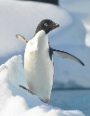
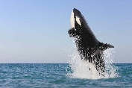
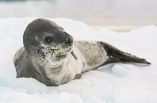
RE:
Can you write Mrs Gladwin a message, either hand-written or typed on a computer/tablet, with a picture on why Jesus is so special?
Think about the bible stories we have discussed in RE lessons.

English
For extra dojos, write a creative and adventurous story any way you like. The main character must be Pinocchio. I want to see capital letters, full stop, and conjunctions.
Design and Technology:
Make your own puppet at home out of any material(s) you have. I want to see lots of decorations on them!

