Welcome to Oak Class
I hope you had a great week off and enjoy the run up to Easter! We have a busy half term ahead of us! Please continue to support your child at home by asking questions about their school day, listening to your child read daily and assisting with any homework. During this half-term, there will be more frequent intervention times to boost specific areas of Maths, writing or reading. You will receive a letter/message if your child is part of any groups.
Miss Shatford will be teaching Oak Class on Mondays, Tuesdays, Thursdays and Fridays and Mrs Potter on a Wednesday. To support us this half term, we have Mr Nicholls (Monday to Thursday), Mrs Grundy (Monday, Tuesday, and Thursday) and Mrs Brakewell (Fridays).
Reading this together will help to prepare your child for their learning this half term.
If you have any concerns, please come in to see us or contact us via email or Dojo. cshatford@fleetwoods.lancs.sch.uk mpotter@fleetwoods.lancs.sch.uk
Kind regards
Oak Class team
English  We are looking at non-chronological reports this half term. We will be linking it closely with our science topic on animals. The theme is on big cats in which we will be making a report on cheetahs, learning the key features of a report and skills to help our sentences develop. To put all our new skills into practise, children will be writing their own report on an animal of your choice (most likely a big cat). We will be finding lots of facts about our chosen animals through books, iPad, and our BIG trip to the zoo!  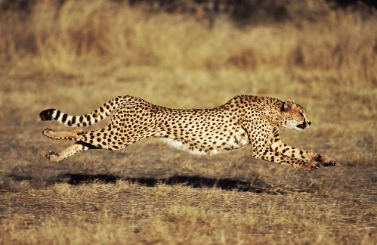  Phonics  Year 1s and some Year 2s will be continuing to learn new Phase 5 sounds. There are also additional support groups this half term to really develop our reading skills.  Some Year 2s will be looking at spelling patterns and starting to complete reading comprehensions, answering, and discussing questions based on a text they have read. | Oak Class  Newsletter  Spring 2 |  | Maths  Year 1:  Children this half term will start building their place value knowledge up to 50. They will be able to count to 50 and have a greater understanding on tens and ones using concrete resources. We will also be recapping addition and subtraction learning about number doubles, number bonds to 20 and missing number problems.  Year 2:  Children are going to continue with statistics, looking at how to present statistical data using pictograms. We will start multiplication and division looking at equal groups. Children will be learning how to multiply and divide by 2, 5 and 10 as well as doubling/halving and odd/even numbers.  With Mrs Potter, both Year 1 and 2 will continue with shape focusing on length and height in which we measure, compare and order different measurements. Children will also be learning four operations with length and height.
RE

This half term we will be extending our knowledge on the Easter story. By the end of the unit, children will know the importance of Easter and the concept of salvation.

Worship:
Worship over this half term will be based around our value hope and thankfulness. There will be 3 class worships and 2 whole-school worships a week. The ‘VIP award’ will be awarded every Friday for a pupil who has shown they can promote our school values and achieved the VIP goal of the week.
Science  During this half term, we will be continuing to look at animals learning about different animal classifications and comparing animal groups. We will know the difference between carnivores, herbivores, and omnivores.  Towards the end of the half term, we will be looking at caring for our planet and why it is important. We are also looking at how we can care for our planet (Hence the science extended learning). | Guided reading  This half term, I am really focusing on reading and writing. During guided reading, we are focusing on both fiction and non-fiction text, learning the features of each. We will also be reading and verbally answering questions about books. |  | PE  1 x PE lessons with coach Ryan on kicking. This will involve learning how to kick different types of objects, aiming for targets and how to apply the new skills into a game situation.  1 x PE lesson with Miss Shatford on tri-throlf. This is a throwing unit learning how to throw underarm and overarm. This will then be applied into target games (like golf).
Science trip:  On Thursday 14th March, we have our trip to the zoo. Please get in contact with me with any problems and I will try my best to help as much as possible.  Letters and more information will be coming out soon! | PSHE  During this half term, we will be looking at the rights of others and how we show respect towards others. We will be doing this through caring about the impact of our own behaviours (both in and out of school). |  | History  We have an exciting half term learning about school in the past and comparing it to our school today. We will be investigating what our school was like in the past. We are looking at school as far back as 1695.  We also have a visitor coming into see us (Mrs Potter’s surprise!).
Class Dojo  Class Dojo is a fantastic way for us to keep you updated with day-to-day classroom life and for you to send messages and pictures to share.  If you have an urgent message or a message regarding attendance, please ring the office as we may not be available to check the Dojo messages during the school day. |  | Reading  Reading remains such an important part of your child’s education. We want every child to have a love for reading!  Please continue to listen to your child regularly read this half term too- reading at home will support your child’s learning and will help to reinforce their phonics knowledge too.

