a
Welcome to Oak Class
Welcome back, we hope that you have all had a great half term break. We have another busy half term ahead. Please continue to support your child at home by asking questions about their school day, listening to your child read daily and assisting with any homework.
Reading through this together will help to prepare your child for their learning this half term.
If you have any concerns, please come in to see us or contact us via email or Dojo, noxley@fleetwoods.lancs.sch.uk m.wells@fleetwoods.lancs.sch.uk
Kind regards
Oak Class team
English  Text focus- How to make a bird feeder.  This half term we will be learning how to write our own set of instructions. We will focus on the structure and language features used when writing instructions and will have the opportunity to follow different sets of instructions before writing own set of instructions.  Phonics  This half term the year 1 children will continue their phonics journey in preparation for their phonics screening check in June. They will be looking at real/nonsense words and will be applying their previously taught sounds.  Year 2 children will consolidate their learning. | Oak Class  Newsletter  Spring 2  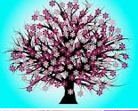 |  | Maths  This half term both Year 1 and Year 2 will be learning all about ‘measure’.  They will be learning how to measure the length and height of objects. They will also begin to understand how to compare measurements.  Y2-will also be learning about mass, capacity and temperature.  Y1-will also be learning about mass and capacity.  In addition, Year 1 will continue to develop their understanding of Place Value, whilst Year 2 will be continuing their work on multiplication and division.
RE

In RE the children will looking at how Christian symbols help us to develop a deeper understanding of the Easter story.
Science  This half term, the children will be looking at plants, particularly to conditions they need to grow and stay healthy. | Computing  This half term, the children will be developing the previous work using the BeeBots, to begin to write simple algorithms to create simple programs using 2code. |  | PE  This half term, the children will be developing their running and throwing skills in athletics, as well as developing their bowling and striking skills in a range of games.
Topic  In history we will be learning about a significant person in history; David Attenborough. We will learn about his contribution to our planet and will link his work with our knowledge of our local environment.  Also, in DT we will focus on ‘food technology’ as we prepare ingredients, learn how to use equipment safely whilst baking our own biscuit treats. WE will then enjoy a teddy bear treat time outside.  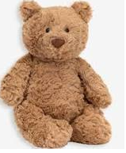 | PSHE  All children in Oak class will continue learning through  ‘The Archbishop Young Leaders award’ this half term.  This half term we will be focusing on ‘perseverance’.  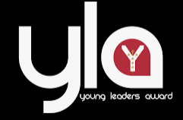  We will also be learning about staying safe online in conjunction with ‘Safer internet day 2023’. |  | Music  This half term the children will be completing the fantastic work they have been doing learning the recorder,  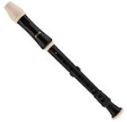
Class Dojo  Class Dojo is a great way for us to keep you updated with day to day classroom life and also for you to send messages and pictures to share.  If you have an urgent message or a message regarding attendance, please ring the office as we may not be available to check the Dojo messages during the school day.  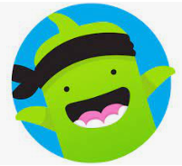 |  | Reading  Reading remains such an important part of your child’s education. So many children in Oak class are reading regularly and this is great to see!  Please continue to listen to your child reading regularly this half term too- reading at home will support your child’s learning and will help to reinforce their phonics knowledge too.

