Welcome to Oak Class
Welcome back, we hope that you have all had a great half term break. We have another busy half term ahead. Please continue to support your child at home by asking questions about their school day, listening to your child read daily and assisting with any homework.
Reading through this together will help to prepare your child for their learning this half term.
If you have any concerns, please come in to see us or contact us via email or Dojo, noxley@fleetwoods.lancs.sch.uk mpotter@fleetwoods.lancs.sch.uk
Kind regards
Oak Class team
English  For the first couple of weeks we will be focusing on poetry in Oak class.  We will then continue our learning and are going to be learning all about pirates! We will learn how to include the features of Non-chronological reports when writing our own about pirates and their antics at sea. Children will then use this knowledge to write their own Non-chronological report about a topic of interest to them.  Phonics  During this half term, all children will continue to learn phonics/key spelling patterns and rules in line with their current ability. Year 1s/some year 2 children will be practising real/alien words in preparation for the Phonics Screening check in June. | Oak Class  Newsletter  Summer 1  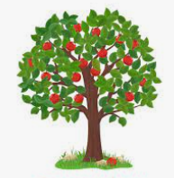 |  | Maths  In maths we will begin this half term by learning about fractions. We will learn about different fractions of shapes before moving on to fractions of amounts.  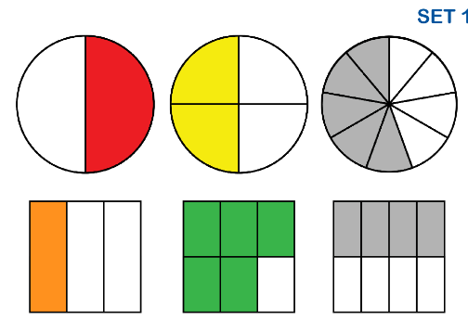  We will also be learning about position and direction in our maths.
RE
l

Science  This half term we will be learning about living things and their habitats. We will be thinking about which things are alive, dead, never been alive. We will be thinking about different habitats and microhabitats. We will also learn about certain animal/mini beast life cycles too.  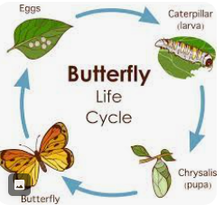 | Computing  In computing this half term we will use the Purple mash program to learn how to send and receive emails safely. We will apply our typing skills and revisit keeping safe on the internet. |  | PE  x1 session will be in the forest this half term (Friday mornings)  x1 session will be with Coach Ryan (Monday afternoons)
Geography | PSHE  We will continue our Young Leaders Award by focusing on ‘team work’ this half term.  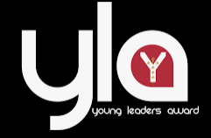 |  | Music
Class Dojo  Class Dojo is a great way for us to keep you updated with day to day classroom life and also for you to send messages and pictures to share.  If you have an urgent message or a message regarding attendance, please ring the office as we may not be available to check the Dojo messages during the school day. |  | Reading  Reading remains such an important part of your child’s education. So many children in Oak class are reading regularly and this is great to see!  Please continue to listen to your child reading regularly this half term too- reading at home will support your child’s learning and will help to reinforce their phonics knowledge too.

