A&G Precision 7 Sons & Preesall Fleetwood’s Charity Primary School Visit to the ASK

On the 20th March 2019, 18 bright eyed but apprehensive Year 6 students from Preesall Fleetwood’s Charity Primary School along with A&G Precision & Sons, entered the Education Station at the ASK Facility for a day of Lego building, STEM exploring FUN! A&G Precision & Sons are one of P&SCSS-Airframe Suppliers who have jumped right into the new Future Proofing a Diverse Talent Pipeline initiative with both feet forwards, this day being one of many events they have organised and supported.

The day opened with an introduction to BAE Systems, its products, customers, operating countries and seeing what the children knew about the company; followed by an introduction to the STEM Ambassadors running the day, namely, Anastasia Whittaker, Chloe Miller, Abi Talbot, Bethany Taylor, Islam Mirawalla & Zaheda Wemi.

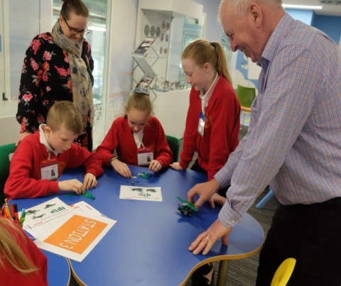Following this, it was straight into the morning’s activity of Lego Aeroplane Building, an activity some of you may have seen through the LEAN Training. Brief instructions were given in that the children had 5 minutes planning and 15 minutes building time. First time round, the 5 minutes planning consisted of tipping the Lego EVERYWHERE, a quick grab of the parts they wanted to build (mostly the interesting parts like the wheels and front fuselage) and some designing their own new aircraft, such as the Ice Cream Plane that dispensed endless ice cream to the pilot… yummy!! Onto building the children went, again with no help from their teachers or the ambassadors. The bossy inspector came along at the end and awarded points for what had been completed, as you can imagine, not many points were awarded at this stage and so once the inspection was finished, the children were asked what could have gone better with suggestions from the ambassadors.

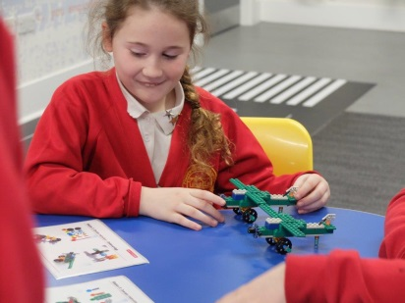Round 2 was on, this time the 5 minutes planning saw all teams aligning clear roles, now including a final inspector. Parts were separated into groups for building and each person was given a clear role in the team. Ready to build a 2nd time, the children flew into assembly, this time the room a lot louder as communication grew between the group and enthusiasm listed with planes coming together left, right and centre. This time the bossy inspector was able to give many, many points for final aircraft and smiles filled the room, with winning teams getting a Hawk Poster each

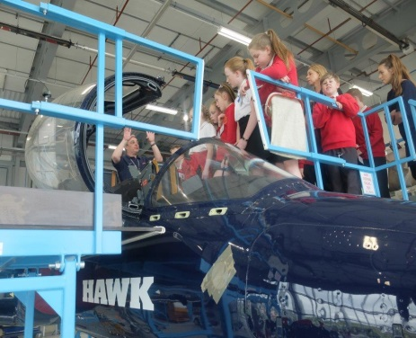Lunch was provided by A&G Precision and followed by a paper aeroplane competition, a communications game, based around Chinese Whispers but with actions instead of words and time to explore the education station (outfits to try on, videos to watch, STEM games to play).

After lunch, and the children, teachers and A&G were treated to a trip down to the Hawk aircraft in the ASK where they went up the ladders to look right into the cockpit and along the side of the plane. As well as this, the children were also given the opportunity to sit in one of two seats from an aircraft and try on a Typhoon helmet… COOL!

Finishing the day, thank you’s given all round, especially to A&G who had provided lunch and travel and instigated the day for the children and the ambassadors who had lead lots of fun throughout. The children were given goody bags on their way out. A school trip to remember!