Willow Class Newsletter
Spring Term 1 2026
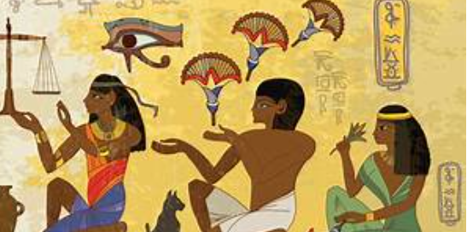
I hope you’ve all had a fantastic Christmas break. We’ve got a busy Spring half term ahead of us in Willow!
Our curriculum for this half term is as follows:
English: We will be focusing on explanation texts, using the book ‘The Street Beneath My Feet’. We will also be focusing on ‘Extreme Weather’, which has many ‘real-life links at the moment!
We will also have weekly grammar, handwriting and reading sessions to further support the children’s literacy skills.
Please continue to support your child’s reading at home by listening to them read at least 3 times each week. Home reading books and reading records can be sent into school each time your child has read or when they need to change their book, so we are able to read their reading diary and change their books. Children will be awarded with a stamp in their reading record each time they read at home, 10 stamps= a prize! 😊
Please talk to your child about what they have read, being able to predict what may happen next, how a character is feeling, and why, show that a child understands what they have read. This is key.
ZPD codes give your child a range within which to read. This means they may sometimes have easier books for pure pleasure and other times be more challenged. A balance is important. Please let us know if you have any queries about this.
Maths: We will begin this half term by focusing on the second unit of multiplication and division. Please encourage your child to use TTRS regularly to support their speed and fluency with their times tables up to 12 x 12. We have focused in on 3x’s, 4x,s 6x’s and 8x’s so far this year, and have moved to 7x’s and 9x’s this week. 2x’s 5x’s and 10x’s are reviewed regularly but practising at home is key. TTRS codes are in the front of their reading records, and this is a great tool for learning.
Science: This half term we will be developing our knowledge of ‘sound’. Children will learn about the difference between volume and pitch, they will also learn about how sound travels.
RE: In RE, we will gain an understanding of why Jesus was such a successful teacher. We will learn about how Jesus’ teachings have impacted on the lives of Christians.
PE: Our topic in PE this half term is cricket-this will be supported by Fleetwood Town on a Monday.
History: In history we will be learning all about the Egyptians! We will learn about when the Egyptians lived, about their culture, Egyptian beliefs and Gods/Goddesses.
DT: Our DT topic this half term is focusing on improving ‘textiles’ skills. We will be researching egg cosies before designing and making our own.
PSHE: We will focus on keeping safe!
Computing: In computing, we will focus on touch typing and spreadsheets.
Forest: We have Forest sessions on a Thursday afternoon this term.
The Homework Menu is attached. As always, we look forward to celebrating all completed tasks in a ‘homework share’ during the last week of the half term.
Many thanks,
Mrs Potter

