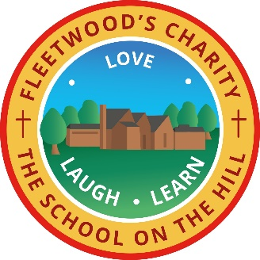
Fleetwood’s Charity Primary C of E School
Mill Street, Preesall, Poulton Le Fylde, FY6 0NN
Telephone: 01253 810324 Headteacher: Mrs V Gladwin
www.fleetwoods.lancs.sch.uk Email: head@fleetwoods.lancs.sch.uk

Dear Parents/Carers,
Please see below a curriculum overview for what we are going to be looking at each term.

Autumn – Sparks Might Fly and The Great Plague
- Maths
  - Place Value
  - Addition and Subtraction
  - Multiplication and Division
- Geography
  - Mapping
- History
  - The Great Plague
- Science
  - Electricity
  - Sounds
- Design and Technology
  - Electrical Systems
  - Textiles
- Art
  - Textiles
- Music
  - Mamma Mia
  - Glockenspiel Stage 1
- PE
  - Dance
- Computing
  - Online Safety
  - Hardware Investigators
  - Coding
- English
  - Autumn is Here (Poetry)
  - The True Story of the Three Little Pigs (Narrative)
- Spanish
  - Las Formas (Shapes)
- PSHE
  - Me and My Relationships
  - Valuing Difference
- RE
  - God, David and the Psalms
  - Christmas – Exploring the Symbolism of Light

Spring – The Art of Food and Passport to Europe
- Maths
  - Multiplication and Division
  - Measurement – Length, Perimeter and Area
  - Fractions
  - Mass and Capacity
- Science
  - Eating and Digestion
  - Consolidation
- History
  - The Vikings
- Geography
  - Studying a Region in Europe
- Art/Design Technology
  - Food
  - Seurat and Pointillism
- Computing
  - Spreadsheets
  - Writing for Different Audiences
- Music
  - Three Little Birds
  - The Dragon Song
- English
  - Wisp – Story of Hope (Story)
  - The Street Beneath my Feet (Non-fiction)
- PE
  - D
  - D
- PSHE
  - Keeping Myself Safe
  - Rights and Responsibilities
- Spanish
  - Las Verduras (Vegetables
  - Los Saludos (Greetings)
- RE
  - Jesus, Son of God
  - Exploring Easter as a Story of Hope

Summer – Water, Water Everywhere and Hunted
- Maths
  - Decimals (including money)
  - Measurement - Time
  - Statistics
  - Geometry – Properties of shape
  - Position and Direction
- History
  - Ancient Egypt
- Geography
  - The Water Cycle
- Art
  - Collage
  - 3D Tomb Making
- PE
  - I
  - I
- Computing
  - Making Music
  - Effective Searches
  - Logos
- Music
  - Bringing us Together
  - Reflect, Rewind and Replay
- Science
  - States of Matter
  - Living things and their Habitats
- English
  - Flood (Narrative)
  - My Strong Mind (Non-Fiction, Instruction)
- Spanish
  - Los Helados (Ice-cream)
  - La Fruta (Fruit)
- RE
  - Are all Churches the same?
  - What is a prayer?
- PSHE
  - Being my Best
  - Growing and Changing

