

Tel: 0161 368 1466 www.floweryfieldschool.org.uk
E-mail: admin@floweryfield.tameside.sch.uk

Off Old Road,
Hyde, Cheshire,
SK14 4SQ
Flowery Field Primary School

Principal – Mrs C Silk

September 2026
Welcome back to the start of another academic year!
Dear parents / carers,
Welcome back to the start of another academic year. We are looking forward to another successful year of learning, and already it’s been great to see the children’s enthusiasm towards being back in the classroom. This letter is designed to share with you some important information at the start of the year.
Please see the class timetable below:
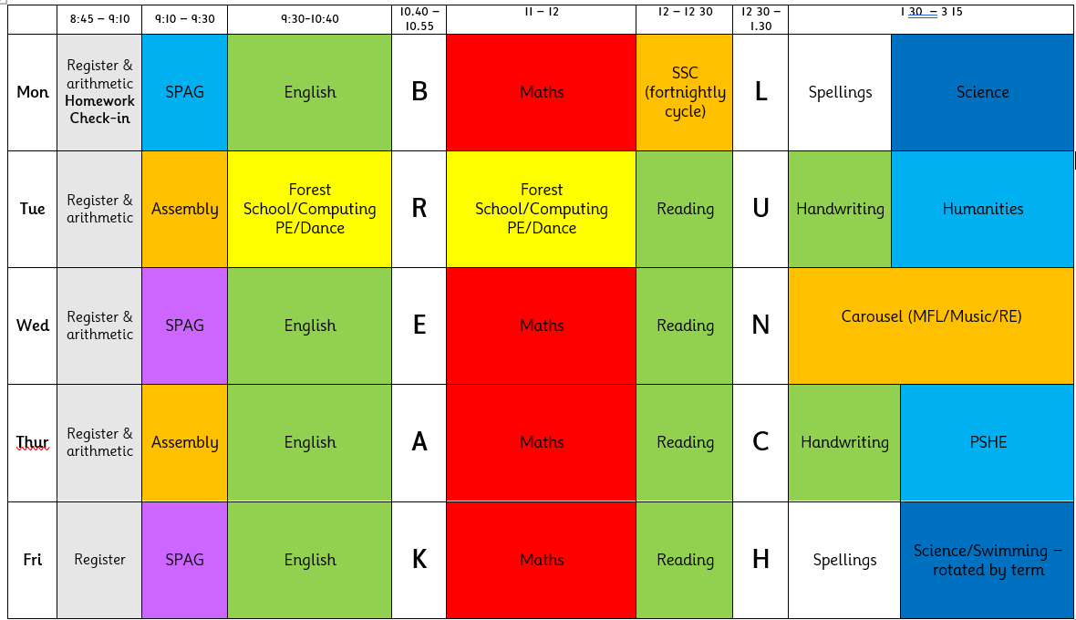
Kit - the class’s PE / dance day is Tuesday. Details of our PE kit can be found on the website. Please send your child into school in their full PE kit on these days. Children are welcome to wear their school sweatshirt, hoody or fleece with their school PE kit. Please note that other items of clothing are not permitted.
Forest school is also an essential part of our curriculum. Places will be allocated half termly. Please ensure your child has a Forest School kit which consists of waterproof pants, jacket, wellies and a change of clothes in a named bag. Children should not arrive at school in their Forest School kit.
In Year 4, children will take part in weekly swimming lessons each Friday and these will be on a termly rotational basis. Lessons will start from Friday 11th September. A separate letter will be sent with more information regarding what to bring.
Please note jewellery is not permitted for Forest School, swimming or PE. This includes after school clubs.
Reading at home – each child has been given a reading record this week. As usual, we expect that your child is reading at home for around fifteen minutes each day. These should be brought into school each day. Their chosen books can be from the class library or from their own books at home.
Homework – each Monday, starting from Monday 7th Sept, homework will be set online. All children will receive updated login details. Homework will need to be completed / handed in online by the following Sunday. Homework is then reset each Monday. Homework consists of 20 weekly 1-minute TTRS games and 10 spelling games on Edshed that match the class weekly spellings. Throughout the year, there will be additional set homework tasks related to the humanities topics covered in class. These encourage children to design and create pieces of work that help them to deepen their understanding and showcase their learning. Letters will be sent home towards the end of each term that details homework topic ideas. Please find the links and QR codes at the end of this letter.
School Meals – Details of this can be found on the school website. Any Reception or KS1 children wishing to sample the menu over the next few weeks can do this free of charge. Children in Y3, 4, 5 and 6 will need to pay for their school meals. These are currently charged at £2.25 a day.
Communication – You will receive an online link to our weekly newsletter through the MCAS app. This can also be found in the news section of our website. Here you will also find key dates and events. We will share learning through our website and Twitter feed. If you want to speak to the class teacher, you can arrange an appointment through the office or send an email to admin@floweryfield.tameside.sch.uk.
As always, we thank you for your support and understanding.
Yours sincerely,
Mrs Yan – Year 4 Teacher

Homework links via QR codes.

Please ensure children can access their accounts for both websites. If there are any issues, please let me know.
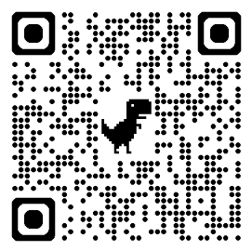

EdShed https://play.edshed.com/en-gb/login TTRS https://play.ttrockstars.com/auth/school/student

