

Tel: 0161 368 1466 www.floweryfieldschool.org.uk
E-mail: admin@floweryfield.tameside.sch.uk

Off Old Road,
Hyde, Cheshire,
SK14 4SQ
Flowery Field Primary School

Principal – Mrs C Silk

September 2026
Dear parents / carers,
Welcome back to the start of another academic year. We are looking forward to another successful year of learning, and already it’s been great to see the children’s enthusiasm towards being back in the classroom. This letter is designed to share with you some important information at the start of the year.
Please see the class timetable below:
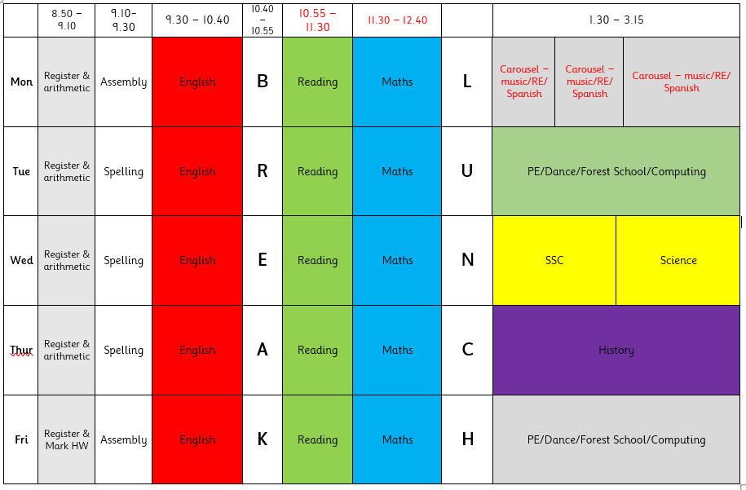
Kit – The children will be doing dance and PE on Tuesday and Friday. Please wear PE kits on those days. Details of our PE kit can be found on the website. Please send your child into school in their full PE kit on these days. Children are welcome to wear their school sweatshirt, hoody or fleece with their school PE kit. Please note that other items of clothing are not permitted.
Forest school is also an essential part of our curriculum. Places will be allocated half termly. Please ensure your child has a Forest School kit which consists of waterproof pants, jacket, wellies and a change of clothes,, in a named bag. Children should not arrive at school in their Forest School kit.
Please note jewellery is not permitted for Forest School or PE. This includes after school clubs.
Reading at home – each child has been given a reading record this week. As usual, we expect that your child is reading at home for around fifteen minutes each day. These should be brought into school each day. Children in EYFS and Key Stage 1 will receive access to E-Collins Books, alongside their library books. These have been matched to your child’s current reading level. We would encourage children to access these resources, alongside other reading materials regularly.
Homework – each Friday, starting from Friday 11th Sept, homework will be set online via teams, ed shed and TTRS. All children will receive updated login details. Homework will need to be completed / handed in online by the following Friday.
School Meals – We are pleased to announce our new school menu. Details of his can be found on the school website. Any Reception or KS1 children wishing to sample the menu over the next few weeks can do this free of charge. Children in Y3, 4, 5 and 6 will need to pay for their school meals. These are currently charged at £2.25 a day.
Communication – You will receive an online link to our weekly newsletter through the MCAS app. This can also be found in the news section of our website. Here you will also find key dates and events. We will share learning through our website and Twitter feed. If you want to speak to the class teacher you can arrange an appointment through the office or send an email to admin@floweryfield.tameside.sch.uk.
As always, we thank you for your support and understanding.
Yours sincerely,
The year 6 team

