

Tel: 0161 368 1466 www.floweryfieldschool.org.uk
E-mail: admin@floweryfield.tameside.sch.uk

Off Old Road,
Hyde, Cheshire,
SK14 4SQ
Flowery Field Primary School

Principal – Mrs C Silk
January 2026
Dear Parents and Carers,

Over the course of this half-term, our humanities focus will be History. Our topic is titled: The Transatlantic Slave Trade
As part of this topic, the children will be developing their historical knowledge and enquiry skills by exploring six key questions:

L1 —What is slavery and how has it existed throughout history?
L2 — How did the Transatlantic Slave Trade begin and what was Britain’s role?
L3 — How were African people captured and what was the Middle Passage like?
L4 — What was life like for enslaved people and how did they resist?
L5 — How did the Transatlantic Slave Trade change life in the Kingdom of Benin?
L6 — Why was slavery abolished and what is its legacy today?

To support your child’s learning, there is some essential vocabulary that will be used throughout this unit:
Vocab:
- Slavery: When people are owned by others and forced to work without pay.
- Trade: Buying, selling, or exchanging goods or people.
- Empire: A group of countries ruled by one powerful country or leader.
- Capture: Taking someone by force.
- Middle Passage: The dangerous sea journey for enslaved Africans to the Americas.
- Plantation: A large farm where enslaved people worked, often growing sugar or cotton.
- Auction: A sale where people bid to buy something or someone.
- Resistance: Fighting back or standing up against something unfair.
- Abolition: Ending something, like the law to stop slavery.
- Legacy: What is left behind from past actions or events.

We kindly ask that you support your child in learning the definitions of these words at home. In class, we will be revisiting this vocabulary regularly and carrying out some low-stakes quizzing to help consolidate understanding.

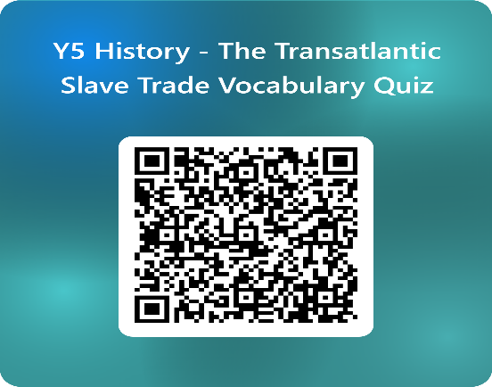
Thank you very much for your continued support. If you have any questions about this topic, please do not hesitate to contact the class teacher.

Yours sincerely,
THE YEAR 5 TEAM

