

Off Old Road,
Hyde, Cheshire,
SK14 4SQ
Tel: 0161 368 1466 www.floweryfieldschool.org.uk
E-mail: admin@floweryfield.tameside.sch.uk

Flowery Field Primary School

Principal – Mrs C Silk
January 2026
Dear Parents and Carers,

Over the course of this half-term, our humanities focus will be History. Our topic is titled:
The Anglo-Saxon occupation of Britain

As part of this topic, the children will be developing their historical knowledge and enquiry skills by exploring six key questions:

- Who were the Anglo-Saxons and why did they come to Britain?
- How did the Anglo-Saxons live and work?
- How was Anglo-Saxon Britain ruled?
- What did the Anglo-Saxons believe?
- Who was St Hilda and why is she remembered today?
- What is the Anglo-Saxon legacy in Britain today?

To support your child’s learning, there are some essential vocabulary that will be used throughout this unit:

- Anglo-Saxons – People from Germany, Denmark, and the Netherlands who settled in Britain after the Romans left.
- Settlement – A place where people build homes and live together, like a village or town.
- Pagan – Believing in many gods and nature spirits, as the Anglo-Saxons did before Christianity.
- Christianity – The religion based on Jesus Christ, which spread in Anglo-Saxon Britain.
- Kingdom – An area ruled by a king, such as Mercia or Wessex in Anglo-Saxon times.
- Thane – A powerful man who owned land and served the king.
- Monastery – A place where monks lived, prayed, and worked.
- Runes – The letters of the Anglo-Saxon alphabet used for writing.
- Invasion – When people enter another country to take over.
- Legacy – What is left behind by people in the past, such as place names and words.

We kindly ask that you support your child in learning the definitions of these words at home. In class, we will be revisiting this vocabulary regularly and carrying out some low-stakes quizzing to help consolidate understanding. An example of ones of these quizzes can be found here:

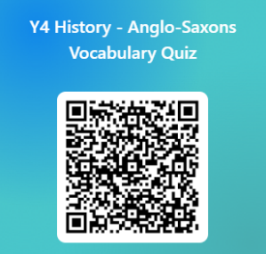

Thank you very much for your continued support. If you have any questions about this topic, please do not hesitate to contact the class teacher.

Yours sincerely,
Year 4

