

Tel: 0161 368 1466 www.floweryfieldschool.org.uk
E-mail: admin@floweryfield.tameside.sch.uk

Off Old Road,
Hyde, Cheshire,
SK14 4SQ
Flowery Field Primary School

Principal – Mrs C Silk
January 2026
Dear Parents and Carers,

Over the course of this half-term, our humanities focus will be History. Our topic is titled:
Famous Victorians who changed History

As part of this topic, the children will be developing their historical knowledge and enquiry skills by exploring six key questions:

- What makes someone historically famous?
- How did Florence Nightingale change hospitals?
- Why do we remember Mary Seacole?
- How did Lord Shaftesbury improve life for Victorian children and workers?
- How did Charles Dickens change Victorian Britain?
- Who is the most important Victorian we’ve learned about?

To support your child’s learning, there is some essential vocabulary that will be used throughout this unit:

Victorian – A person who lived when Queen Victoria was queen (1837–1901).
Famous – Someone a lot of people know about.
Significant – Someone or something that is important and made a difference.
Legacy – What a person leaves behind that still matters today.
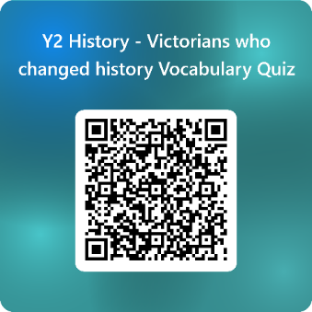
Past – Something that has already happened.

We kindly ask that you support your child in learning the definitions of these words at home. In class, we will be revisiting this vocabulary regularly and carrying out some low-stakes quizzing to help consolidate understanding. An example of one of these quizzes can be found by following this QR code:

Thank you very much for your continued support. If you have any questions about this topic, please do not hesitate to contact the class teacher.

Yours sincerely,
Year 2 Team

