

Tel: 0161 368 1466 www.floweryfieldschool.org.uk
E-mail: admin@floweryfield.tameside.sch.uk

Off Old Road,
Hyde, Cheshire,
SK14 4SQ
Flowery Field Primary School

Principal – Mrs C Silk
Thursday 8th January 2026
Dear Parents and Carers,

Over the course of this half-term, our humanities focus will be History. Our topic is titled:
Ancient Egypt

As part of this topic, the children will be developing their historical knowledge and enquiry skills by exploring six key questions:

L1 - Where is Egypt and why was the River Nile important?
L2 – What was life like for Ancient Egyptian people?
L3 – Who were the pharaohs and why were they important?
L4 - Why did Egyptians build pyramids and what was mummification?
L5 – What were hieroglyphics and how did Egyptians write?
L6 - What is the legacy of Ancient Egypt today?

To support your child’s learning, there is some essential vocabulary that will be used throughout this unit:

Pharaoh – The king or queen ruler of Ancient Egypt.
Nile – The river that gave life to Egypt, helping crops grow.
Pyramid – A large stone building with a square base and triangular sides used as tombs.
Mummy – A body preserved by wrapping in cloth after death.
Hieroglyphics – The writing system of Ancient Egypt using picture symbols.
Scribe – A person who could read and write hieroglyphics.
Afterlife – The life Ancient Egyptians believed people had after they died.
Gods – Powerful beings Egyptians worshipped, like Ra (sun god) and Anubis (god of mummification).
Tomb – A special place where a dead person is buried.
Civilisation – A group of people with their own cities, leaders, writing, and ways of life.

We kindly ask that you support your child in learning the definitions of these words at home. In class, we will be revisiting this vocabulary regularly and carrying out some low-stakes quizzing to help consolidate understanding. An example of ones of these quizzes can be found here:

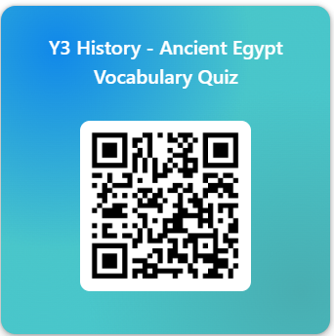
Thank you very much for your continued support. If you have any questions about this topic, please do not hesitate to contact the class teacher.

Yours sincerely, Year 3 Team

