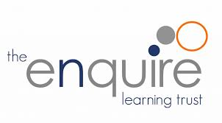
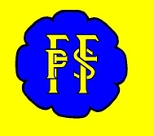
Tel: 0161 368 1466 www.floweryfieldschool.org.uk
E-mail: admin@floweryfield.tameside.sch.uk

Off Old Road,
Hyde, Cheshire,
SK14 4SQ
Flowery Field Primary School

Principal – Mrs C Silk
April 2026
Dear Parents and Carers,

Over the course of this half-term, our humanities focus will be History. Our topic is titled:
Meet our monarchs.

As part of this topic, the children will be developing their historical knowledge and enquiry skills by exploring six key questions:

L1 - What is a monarch?
L2 – Who is our current monarch?
L3 – Who was the monarch before Charles III?
L4 – How do you become a monarch?
L5 – How has the monarch’s power changed over time?
L6 - What would you do if you were a monarch?

To support your child’s learning, there is some essential vocabulary that will be used throughout this unit:

Monarch – A king or queen who leads a country.
King – A man who is the monarch.
Queen – A woman who is the monarch.
Royal family – The family of the king or queen.
Crown – A special hat worn by kings and queens.
Coronation – A special party when someone becomes king or queen.
Charles III – Our king now.
Queen Elizabeth II – Our queen before King Charles.
Past – A time before now.
Parliament – A group of people who help make the country’s rules.

We kindly ask that you support your child in learning the definitions of these words at home. In class, we will be revisiting this vocabulary regularly.

Thank you very much for your continued support. If you have any questions about this topic, please do not hesitate to contact the class teacher.

Yours sincerely,

Year One Team

