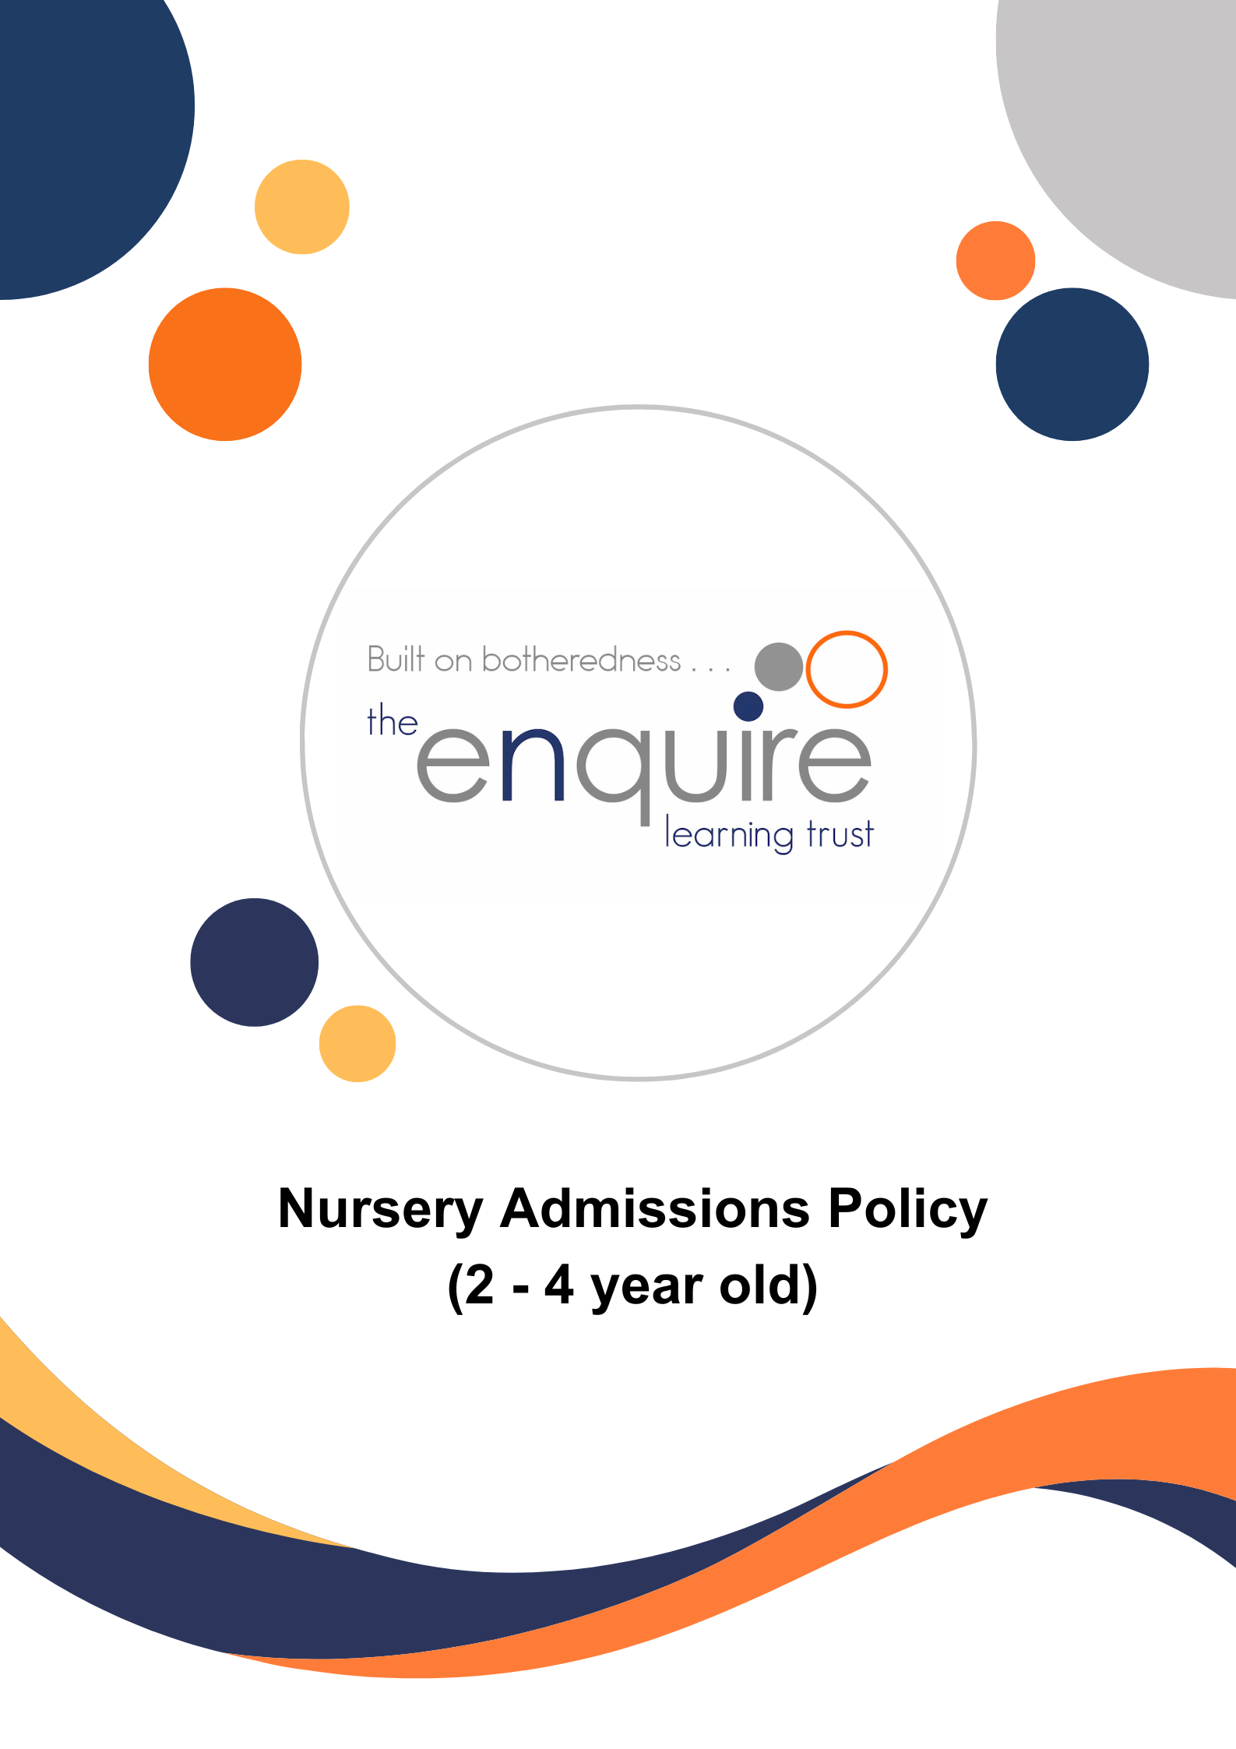

Contents

Section | Title
1 | Aims
2 | Nursery Session Options
3 | Criteria for Admission to the Nursery
4 | Application Dates
5 | Decisions on Places
6 | Home Visits
7 | Waiting Lists
8 | Leavers during the year
9 | Attendance and loss of Nursery Place
10 | Transfer from Nursery into School
 | APPENDIX 1 – HM Government Childcare hours summary

Version History

Approved by: | Trustees
Last reviewed: | March 2022
Next review due by: | September 2025

Date | Author | Version | Comment
March 2022 | LT | 1 | Policy Created
December 2023 | LT | 2 | Policy updated to accommodate Government funding changes for 2024.

- Aims

Our aims are:

  - To ensure access and entitlement to the benefits of high-quality child centred Nursery education on a fair and equitable basis, for children and families in our local community.
  - To establish an admissions policy governed by clearly defined criteria that may be articulated to parents and other professionals.
  - To help promote consistency of practice and procedure between Nursery classes in The Enquire Learning Trust.
  - To ensure, as far as possible, that all children who gain a place will fully benefit from their Nursery education with us, their needs being fully met, whilst we make the very best of our available resources.

- Criteria for Admission to the Nursery

The school will offer children a place in the Nursery from the term after their second/third birthday:

Child born between | Universal government funding starts
1 September – 31 December | Term beginning on or after 1 January
1 January – 31 March | Term beginning on or after 1 April
1 April – 31 August | Term beginning on or after 1 September

Places will be offered according to the criteria in the following order of priority:

  - Places will be offered on a first come first serve basis in line with the application dates below.
  - The Nursery will take children from the term after their second/third birthday.
  - A child will remain in Nursery until the end of the academic year in which they are 4 years old.
  - A child’s intake into Nursery may be staggered over two or more weeks.
  - Any spare places will be allocated during the year, as they become available, to children who are in the half-term after their second/third birthday or older.

- Application dates

Each academy to provide details here regarding their own arrangements in line with own Local Authority dates, for example:

Academic year 2025/26 – Flowery Field Primary School
*Closing date for applications | 4th April 2025
Offer day | 2nd May 2025
Accepting a place deadline | 16th May 2025

*Applications will be considered throughout the year if places are available*

- Part-time and full-time places

Each academy to amend accordingly to fit local arrangements

  - All children applying to our Nursery are entitled to a part-time place (15 hours a week for 38 weeks of the year) the term after their third birthday.
  - Full-time places will be given to children whose parent(s) qualify for 30 hours free childcare:
You can usually get 30 hours free childcare if you (and your partner, if you have one) are:
- In work – or getting parental leave, sick leave or annual leave;
- Each earning at least the National Minimum Wage or Living Wage for 16 hours a week
This earnings limit doesn’t apply if you’re self-employed and started your business less than 12 months ago.
You’re not eligible if:
- Your child doesn’t usually live with you;
- The child is your foster child;
- Either you or your partner has a taxable income over £100,000.
You can get 30 hours free childcare at the same time as claiming Universal Credit, tax credits or childcare vouchers.

See - https://www.gov.uk/apply-30-hours-free-tax-free-childcare

  - Parents/ carers may wish to privately “top-up’ their 15 hour entitlement by paying themselves for the extra 15 hours and allowing their children to attend all day. Please contact the school office for exact costs and to agree a payment schedule.

- Decisions on places

  - Decisions will be made by Flowery Field. Decisions to offer a place will be based on the criteria and procedures laid out in this Admissions Policy.
  - Decisions will be final and there is no right of appeal.
  - The offer of a Nursery place DOES NOT mean automatic entitlement to a place in one of the Reception Classes.
  - Parents/Carers who accept a place, will be expected to commit to taking up the place for the rest of the academic year.

- Home Visits

  - These may be made before a child takes up their place.

- Waiting Lists

7.1 If the Nursery is oversubscribed, a reserves list will be maintained and will remain in
place until the end of the relevant academic year.

8. Leavers during the year

8.1 If a child is withdrawn by their parents from Nursery during the school year, we request
that parents/carers must give the school a minimum of 4 weeks’ notice if possible. The place of a child who has been withdrawn cannot be held open and will be automatically made available to allocate to a child on the waiting list. If parents/carers later wish their child to return to the Nursery, then they will have to re-apply for a place and the application will be considered according to the criteria along with any other applications at the time, unless there are special circumstances. The fact that a child has previously been in the Nursery class, or any other Nursery class, will in no way influence the decision on being offered a place.

9. Attendance & loss of Nursery place

  - If attendance and / or punctuality is poor or erratic, the Nursery teacher will talk to the child’s parents/carers and remind them that for the child to benefit fully from Nursery education attendance needs to be regular and punctual due to the great demand for places. This conversation should be recorded and dated in the child’s Learning Journey.
  - If after a period of two weeks, attendance and/or punctuality remain poor, a letter will be sent to the parents/carers inviting them to meet with the Principal.
  - If following the meeting, there is no sustained improvement in attendance and/or punctuality within an agreed period, then the child may lose their place. Parent/carers will be notified of the loss of place in writing.
  - If a child is absent for a period of three weeks without any contact from the parents and the school has been unable to make contact within this time, the child may lose their place and it may be offered to someone else. This will be decided by the Principal, and a letter explaining the situation will be sent to the parents/carers.

10. Transfer from Nursery into School

  - All parents and carers must be aware that a place in the Nursery does not guarantee a place in the academy and that they must still go through the correct Local Authority Admissions Procedure. However, the Trust Admissions Code states that where a child attends one of our Nurseries and is in receipt of Early Years or Pupil Premium funding then a place could be secured in the Reception Class.
  - The Nursery staff will liaise closely with colleagues in Reception classes to plan for a smooth transition into our Reception class, or any other chosen or allocated school. Nursery staff will send on reports and other agreed records to other schools as appropriate.

APPENDIX 1

