

c
Tel: 0161 368 1466 www.floweryfieldschool.org.uk
E-mail: admin@floweryfield.tameside.sch.uk

Off Old Road,
Hyde, Cheshire,
SK14 4SQ
Flowery Field Primary School

Principal – Mrs C Silk
January 2026
Dear parents and carers,
Thank you for your continued support throughout this school year. It has made a real difference to the children’s enthusiasm, progress and confidence in History and Geography. This letter is designed to share all of the quizzes we have created so far this year, so that you can access them easily at home. Regular practice and retrieval are vital in helping children strengthen their knowledge over time, ensuring that important learning is remembered and can be built upon in the future.
Here are the QR codes for the first History topic (Vocabulary and Retrieval):
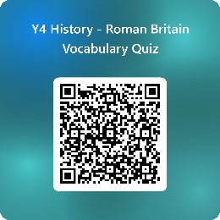
Here are the QR codes for the first Geography topic (Vocabulary and Retrieval):
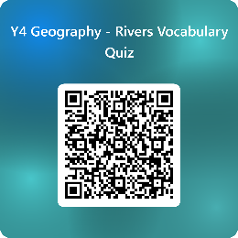
Here is the QR code for the second History topic (Vocabulary):
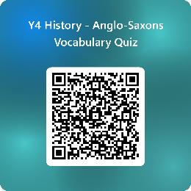
The next letter towards the end of the half-term will share the QR code for the Retrieval Quiz for the current History topic. Letters shared from January 2026 will now be saved on the new Year Group pages of the school website – see the ‘Document Vault’.
Thank you once again for your continued support in helping your children to succeed.
With warm regards,

Mrs Silk

