

Tel: 0161 368 1466 www.floweryfieldschool.org.uk
E-mail: admin@floweryfield.tameside.sch.uk

Off Old Road,
Hyde, Cheshire,
SK14 4SQ
Flowery Field Primary School

Principal – Mrs C Silk
February 2026
Dear Parents and Carers,
We have absolutely loved seeing the amazing and creative geography projects that the children have been producing at home. The effort, imagination and pride they have shown has been wonderful, and these pieces of work have been proudly shared in our assemblies. It has been a real joy to see how impressed and inspired the other children have been by their peers’ achievements.
There is now a growing enthusiasm across the school to get involved in these projects, which is fantastic to see. The children are motivating one another and developing a real excitement for learning beyond the classroom.
In class, we continue to practise our history and geography quizzes regularly to help children revisit and secure key knowledge. The help and support that children are receiving at home is making a real difference, and we can see how this is strengthening their understanding and confidence in lessons. Thank you for the time and encouragement you provide—it truly supports their progress. The history quiz for this half-term can be found below:
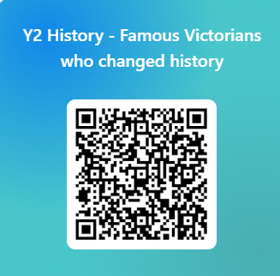
As we approach the holidays, we would once again love for the children to extend their learning about the famous Victorian we met (Florence Nightingale, Mary Seacole, Lord Shaftesbury and Charles Dickens) beyond the classroom in a creative and enjoyable way. Below are some suggested ideas to inspire them but feel free to find your own ideas:
- a simple hospital ward collage/picture (clean vs dirty comparison)
- draw or write about how Florence Nightingale and Mary Seacole helped soldiers
- fact file about one of these famous Victorians
- draw a poster about one of the four famous Victorians
- role play and/or dress up as one of the four famous Victorians
We are excited to see how the children continue to express their learning in creative and thoughtful ways.
Thank you, as always, for your continued support.
With warm regards,
Mrs Silk

