

Tel: 0161 368 1466 www.floweryfieldschool.org.uk
E-mail: admin@floweryfield.tameside.sch.uk

Off Old Road,
Hyde, Cheshire,
SK14 4SQ
Flowery Field Primary School

Principal – Mrs C Silk

Dear parents and carers,
We are very grateful for the time you spend helping your children practise their quizzes and complete their home learning tasks during our previous humanities topic. It has also been wonderful to see some of the amazing creations and projects the children have brought in – your support truly inspires their learning and creativity!
As we begin our final half-term of the academic year, we would like to take this opportunity to thank you for your continued support throughout the year. We are incredibly proud of all that the children have achieved, and we look forward to ending the year with an exciting and engaging humanities topic that will allow them to apply the knowledge and skills they have developed over the past months.
Over this half-term, our humanities focus will be the use of canals. As part of this unit, the children will be developing their knowledge and skills by exploring key questions such as:
- LC1 –What are we investigating about canals?
- LC2 –How can we collect data about how a place is used?
- LC3 –How is our local canal used today?
- LC4 –What does our data show and how has canal use changed?
To support your child's learning, there is some important vocabulary that will be used throughout this unit:
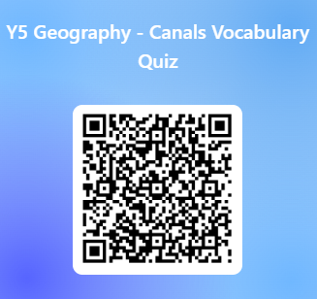
We kindly ask you to support your child in learning these vocabulary words at home. In class, we will be revisiting this vocabulary regularly and carrying out some low-stakes quizzing to help consolidate understanding.
Thank you very much for your continued involvement. If you have any questions about this unit or how to support your child further, please do not hesitate to contact the class teacher.
Yours sincerely,
The Year 5 Team

