**Welcome to Nursery**

**Flowery Field Primary School**

***‘A happy place to learn’***

**We offer broad, balanced learning experiences in a warm, nurturing and inclusive environment, led by an experienced and dedicated team who always put the needs of our children at the heart of everything we do.**

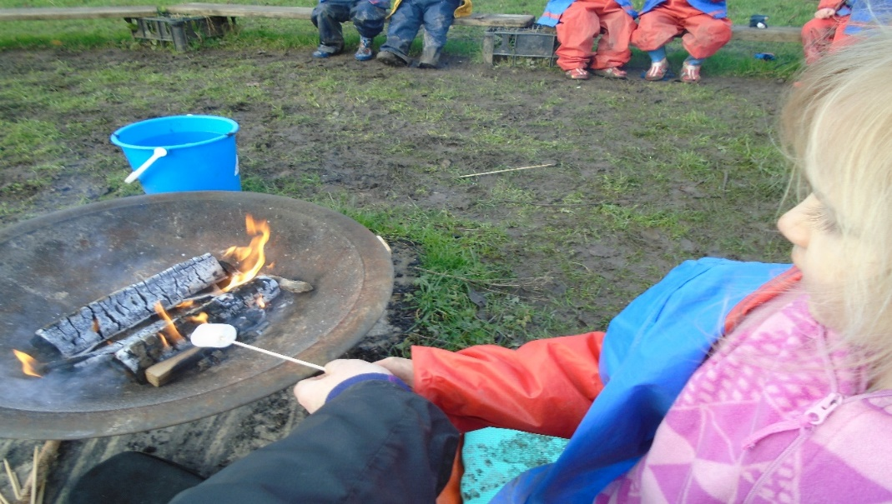

**Welcome to Flowery Field Primary School**

We hope this information will help to give you a ‘snapshot’ of our Nursery routines and answer any queries you may have. Up to now, your child has been growing and learning in a secure family environment and perhaps attends a playgroup or childminder provision. We understand that moving on to Nursery is a big step for families, so we try to make this transition as smooth as possible.

We recognise the important role you have already played in preparing your child for Nursery and by working together we will encourage them to learn in a happy and enjoyable way, whilst meeting their needs and interests.

We have an ‘open door’ policy and are always happy to speak to you, answer queries or put your mind at rest. If it is busy at the beginning or end of the day, we will make time to speak to you as soon as we can.

**Transition to Nursery**

Families are always welcome to visit school and get a ‘feel’ for our setting. Children who are offered places are invited to a visit in the summer term, where they will meet the Nursery team and see how the classes operate on a daily basis. This is also a good time to ask any questions you may have. We are always happy to share ideas to help you prepare your children for Nursery.

**Help us to get to know your child**

We want you to give us as much information as possible to help us to get to know your child and their interests. If you have any reports or booklets from your child’s previous settings please share them with us, as they will provide helpful information about their progress and next steps in their learning.

In addition, you may need to give us medical information about your child; for instance, we need to know if they suffer from asthma, have an allergy, or any other conditions that may affect them. We will put a health care plan in place for children who need one. If there is anything else you feel we should know about, or if you have any particular worries about your child moving to Nursery, please speak to the teacher. It is also helpful if we are aware of changes in family circumstances; such as moving to a new address or medical needs, which may affect your child.

**Getting to know you**

Parents/carers are individuals too; please let us know if there is anything we can do to enable you to support your child, for example, we are happy to provide letters in alternative formats or help to translate information if required.

**Curriculum**

Our Nursery and Reception teachers work together to ensure our curriculum offers a progression of skills and knowledge from Nursery to Reception. This follows whole school themes as well as linking to Early Years topics inspired by the interests of our children. By the end of Nursery our pupils will have firm foundations in place so they are ready for Reception class.

There is a strong emphasis on circle time to promote confidence, social and emotional development along with singing supported by Makaton (signing). Every day the children are taught phonics, reading, writing and maths, then these skills are practised in our seven areas of learning inside and outside where children explore using a variety of resources such as; water, paint, sand, dough, role-play, construction and den making with their friends. We believe that children learn best from practical experiences and all areas of the curriculum are delivered in this way; the children are encouraged to explore their own interests in the seven areas of learning both inside and outside throughout the day.

Our child-centred approach has an exciting mix of adult and child-led activities based on the needs and fascinations of the children. We are very active at Nursery and the children have lots of fun, which makes their learning memorable!

**School uniform**

Nursery children are not expected to wear full school uniform, however most parents find it easiest. Our school uniform is a royal blue sweatshirt or cardigan, a plain white or pale blue polo shirt, dark grey or navy trousers, shorts, skirt, pinafore or blue gingham dress.

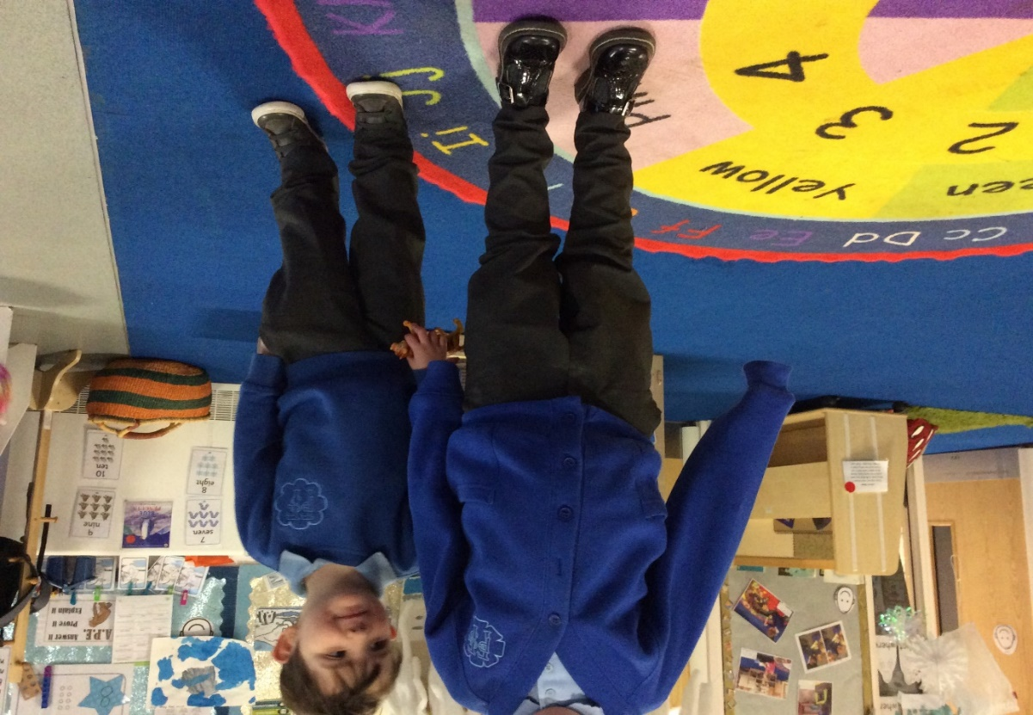It would be helpful if your child wears clothes that they can manage by themselves as we encourage independence in self-care. It can be distressing for a child to be struggling with tricky belts, buttons etc. when they urgently need the toilet! Comfortable tracksuit bottoms, a royal blue sweat top/jumper, sturdy shoes (Velcro fastenings are preferable to laces and buckles) and a warm coat is essential as we use outside as much as possible.

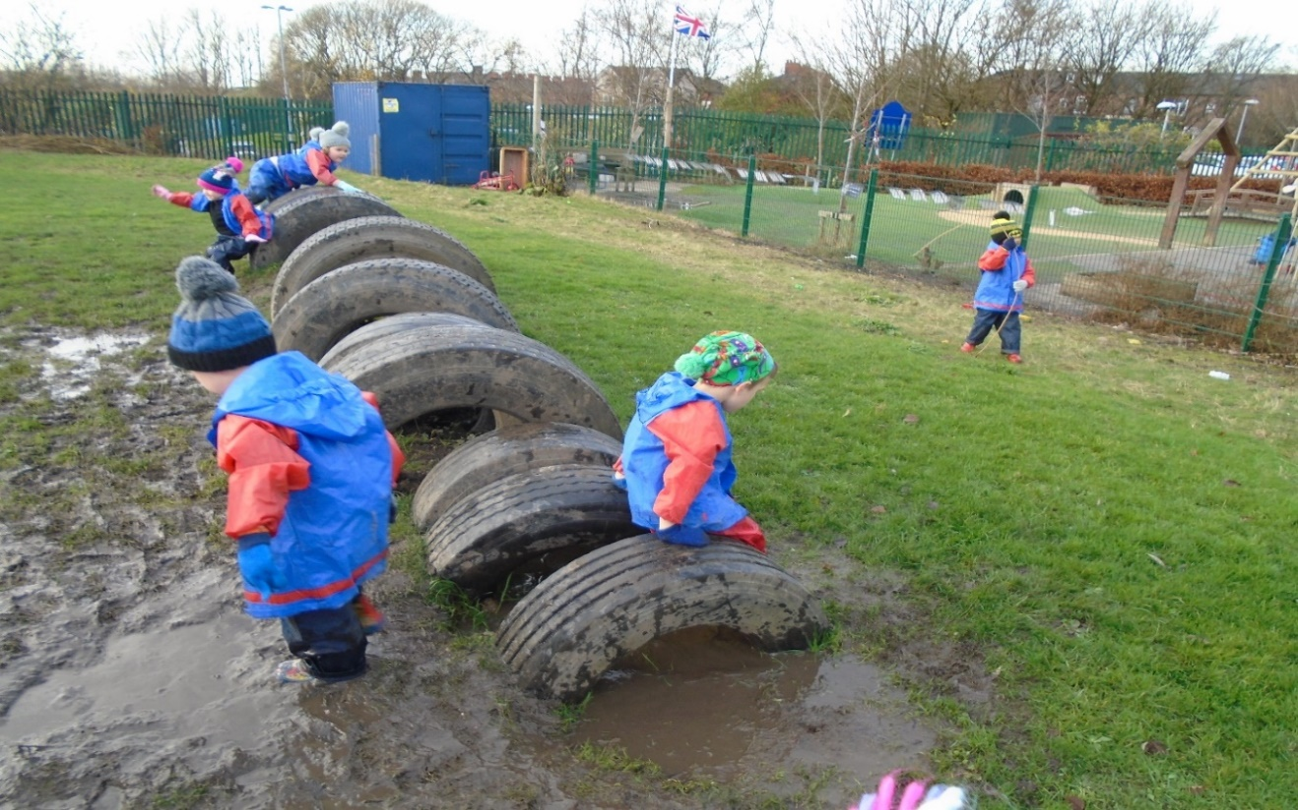

We use aprons for painting and messy play, but accidents do still happen. You should also be aware that we use paint outside too, so we advise that you do not send your child to school in their best clothes or coats. Please bring wellington boots so your child can access the mud kitchen and splash in puddles at Forest School. **It is very important to label all of your child’s clothing.**

PE and dance lessons with our coaches take place once a week and jewellery should not be worn for your child’s safety; on PE days earrings should be removed at home. No PE kit is required. On Forest School days pupils can come in appropriate clothing so they don’t have to worry about getting changed. (We will let you know in advance when your child is going to Forest School).

**Lunchtime**

30 hour children bring their own packed lunches and they are supervised by Midday assistants in the hall, with a member of the Nursery team. We monitor what pupils eat and will inform you if there are any concerns. Whilst we do our best to help our children to unwrap their food, it is useful if you can help your child’s independence and fine motor control by showing them how to unwrap their packed lunch contents by themselves. Our ‘Healthy School’ policy does not allow fizzy drinks, glass bottles or cans, chocolate bars or sweets and we cannot heat or re-heat food.

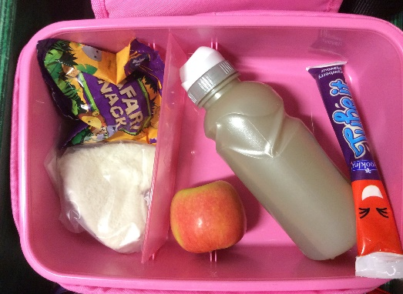

**Snacks**

We offer a variety of healthy snacks as part of our daily routine and Nursery pupils receive milk every day free of charge, they also have access to water all day.

**Safety**

Your child must be accompanied to and from school by a parent/carer or other responsible adult. We do not allow any child out of the classroom until we see the person who has come to collect them waiting outside the door. You must inform school if anyone different will be collecting your child, we will only let your child leave with adults we know. Please message school in plenty of time if there is an alteration to dropping off or collecting arrangements, as the telephone lines are very busy at the beginning and end of the school day. We operate a confidential password system agreed with the parent/carer when other adults collect children.

**First Aid**

Injuries, bumps and cuts will be attended to by qualified first-aiders, you will be informed in person by a member of staff and you will receive a note at the end of the school day. If your child is ill or has a serious injury while they are at school we will contact you to come and collect them, so it is vital that you ensure we have your up-to-date telephone number and email address.

**Attendance and illness**

Nursery is open Monday to Friday and the hours are:

**8.45am - 11.45am for pupils who stay for 15 hours.**

**8.45am - 3.15pm for pupils who stay for 30 hours.**

**Our two Nursery classes have pupils who stay for 15 and 30 hours. We do not offer afternoon provision for 15 hour pupils.**

Parents/carers requiring child-care before or after school can access ‘Rainbows’ our on-site before and after school provision and this operates from 7am until the start of school and from the end of school until 6pm.

It is very important that your child attends school every day; school expects 97% attendance for all pupils. If your child has an appointment with their dentist or doctor and is going to be absent from school, please let us know in advance by telephoning the school office. Try to make appointments after school or in school holidays if possible.

**How can you help your child to get ready for school?**

* Take time to talk to your child, get on their level, make eye contact and listen to them and encourage them to listen to you
* Sing songs and nursery rhymes together
* Share books together, talk about the pictures and predict what might happen next in the story
* Play simple games, taking turns and experience losing as well as winning
* Limit screen time and do practical activities instead; go on walks to the park and around their local environment, explore the natural world around them, talk about what you can see, hear, feel and smell
* Join in messy play with your child, they love experimenting with dough, cornflour mixed with water, blowing bubbles, foam etc.
* Try baking together
* Teach them to dress and undress themselves; fasten buttons and do up zips on coats
* Encourage them to go to the toilet by themselves and wash their hands afterwards
* Practise using a knife and fork and sitting at the table to eat
* Practise making marks with different materials and writing their name
* Model reading, writing and counting for your child
* Make time to interact with them and it will pay off as well as being lots of fun!
* Join the local library or local play sessions

We want parents/carers to feel involved in their child’s education and we aim to develop a strong partnership between home and school. Parents and carers are welcome to come and help with Forest school, seasonal walks in the local environment, other visits and to be a guest reader at story time.

The most important thing is that your child feels happy and secure at school and we hope that by working together we can achieve this.

**Rainbows – Before and After School Club**

Our school offers breakfast, after school and school holiday care provided by Rainbow Child Care. The club is based in a separate building within our school grounds, making drop-off and collection easy for parents/carers. The club opens at 7am and closes at 6pm. For further details, prices, to check availability or to arrange a visit, please contact the Rainbow office on 07423 816977 during office hours or 07769 153279 during club hours. You can also visit their website at www.rainbowdukinfield.co.uk or Email: rainbowclubs@mail.co.uk

**We look forward to seeing you soon!**