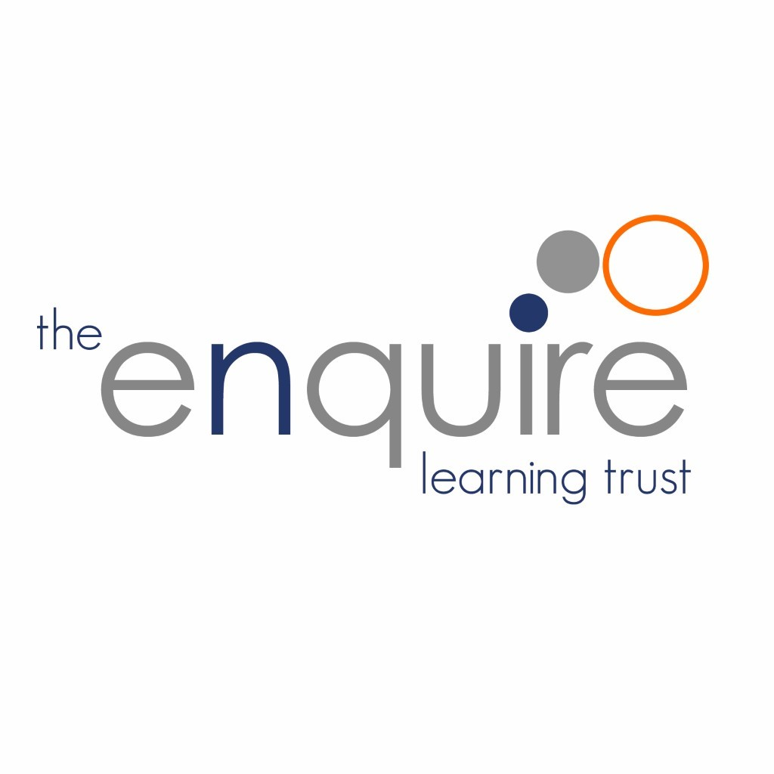 **Relationships and Sex Education Policy**

**2024-25**

**Contents**

|  |  |  |
| --- | --- | --- |
| 1. | Aims | 3 |
| 2. | Statutory requirements | 3 |
| 3 | Policy Development | 4 |
| 4. | Definition | 4 |
| 5. | Curriculum | 4 |
| 6. | Delivery of RSE | 5 |
| 7. | Roles and Responsibilities | 6 |
| 8. | Parents’ right to withdraw | 6 |
| 9. | Training | 6 |
| 10. | Monitoring arrangements | 7 |
| 11. | Appendix 1: Curriculum map | 8 |
| 12. | Appendix 2: By the end of primary school pupils should know | 9 |
| 13. | Review of this Policy | 12 |

**Version History**

|  |  |  |  |
| --- | --- | --- | --- |
| Date | Author | Version | Comment |
| 9/04/2022 | Claire Silk |  |  |
| 01/07/2024 | Claire Silk |  | Updated to reflect SCARF |
|  |  |  |  |
|  |  |  |  |

# **1. Aims**

The aims of relationships and sex education (RSE) in our Trust are to:

* Provide a framework in which sensitive discussions can take place
* Prepare pupils for puberty, and give them an understanding of sexual development and the importance of health and hygiene
* Help pupils develop feelings of self-respect, confidence and empathy
* Create a positive culture around issues of sexuality and relationships
* Teach pupils the correct vocabulary to describe themselves and their bodies

# **2. Statutory requirements**

As a Trust we must provide relationships education to all pupils as per section 34 of the [Children and Social work act 2017.](http://www.legislation.gov.uk/ukpga/2017/16/section/34/enacted)

We do not have to follow the National Curriculum but we are expected to offer all pupils a curriculum that is similar to the National Curriculum including requirements to teach science which would include the elements of sex education contained in the science curriculum.

In teaching RSE, we are required by our funding agreements to have regard to [guidance](https://www.gov.uk/government/consultations/relationships-and-sex-education-and-health-education) issued by the secretary of state as outlined in section 403 of the [Education Act 1996.](http://www.legislation.gov.uk/ukpga/1996/56/contents)

At The Enquire Learning Trust we teach RSE as set out in this policy.

This policy complies with our funding agreement and articles of association.

# 

# **3. Policy development**

This policy has been developed in consultation with staff, pupils and parents. The consultation and policy development process involved the following steps:

1. Review – a Director pulled together all relevant information including relevant national and local guidance
2. Staff consultation – all school staff were given the opportunity to look at the policy and make recommendations
3. Parent/stakeholder consultation – parents and any interested parties were invited to submit responses.
4. Pupil consultation – we investigated what exactly pupils want from their RSE
5. Ratification – once amendments were made, the policy was shared with governors and ratified

# **4. Definition**

RSE is about the emotional, social and cultural development of pupils, and involves learning about relationships, sexual health, sexuality, healthy lifestyles, diversity and personal identity.

RSE involves a combination of sharing information, and exploring issues and values.

RSE is not about the promotion of sexual activity.

**5. Curriculum**

Our curriculum is set out as per Appendix 1 but we may need to adapt it as and when necessary.

We have developed the curriculum in consultation with parents, pupils and staff, taking into account the age, needs and feelings of pupils. If pupils ask questions outside the scope of this policy, teachers will respond in an appropriate manner so they are fully informed and don’t seek answers online.

Primary sex education will focus on:

* Preparing boys and girls for the changes that adolescence brings
* How a baby is conceived and born

For more information about our curriculum, see our curriculum map in Appendix 1.

# **6. Delivery of RSE**.

RSE is taught within the personal, social, health and economic (PSHE) education curriculum. Biological aspects of RSE are taught within the science curriculum, and other aspects are included in religious education (RE).

Relationships education focuses on teaching the fundamental building blocks and characteristics of positive relationships including:

* Families and people who care for me
* Caring friendships
* Respectful relationships
* Online relationships
* Being safe

For more information about our RSE curriculum, see Appendices 1 and 2.

These areas of learning are taught within the context of family life taking care to ensure that there is no stigmatisation of children based on their home circumstances (families can include single parent families, LGBT parents, families headed by grandparents, adoptive parents, foster parents/carers amongst other structures) along with reflecting sensitively that some children may have a different structure of support around them (for example: looked after children or young carers).

# **7. Roles and responsibilities**

7.1 The Board of Trustees

The Trustees will approve the RSE policy, and hold the Principal to account for its implementation.

7.2 The Principal

The Principal is responsible for ensuring that RSE is taught consistently across the academy, and for managing requests to withdraw pupils from any non-statutory components of RSE (see section 8).

7.3 Staff

Staff are responsible for:

* Delivering RSE in a sensitive way
* Modelling positive attitudes to RSE
* Monitoring progress
* Responding to the needs of individual pupils
* Responding appropriately to pupils whose parents wish them to be withdrawn from the non-statutory components of RSE

Staff do not have the right to opt out of teaching RSE. Staff who have concerns about teaching RSE are encouraged to discuss this with the Principal.

The class teachers are responsible for teaching RSE in school.

7.4 Pupils

Pupils are expected to engage fully in RSE and, when discussing issues related to RSE, treat others with respect and sensitivity.

# **8. Parents’ right to withdraw**

Parents do not have the right to withdraw their children from relationships education.

Parents have the right to withdraw their children from the non-statutory components of sex education within RSE.

Requests for withdrawal should be put in writing using the form found in Appendix 3 of this policy and addressed to the headteacher.

Alternative work will be given to pupils who are withdrawn from sex education.

# **9. Training**

Staff are trained on the delivery of RSE as part of their induction and it is included in our continuing professional development calendar.

The Principal will also invite visitors from outside the academy, such as school nurses or sexual health professionals, to provide support and training to staff teaching RSE.

# **10. Monitoring arrangements**

The delivery of RSE is monitored by the Principal through: enquiries and lesson observations.

Pupils’ development in RSE is monitored by class teachers as part of our internal assessment systems.

This policy will be reviewed by the Board of Trustees annually.

### 11. Appendix 1: Curriculum map

Relationships and sex education curriculum map

Include as much detail as you can, including links to resources you’ll use or sharing examples. Being transparent with parents/carers early on will make it easier for you to handle questions, concerns, or objections.

| Year group | Term | Topic/theme details | Resources |
| --- | --- | --- | --- |
| Year 1 |  | Health and Well being   * The names of the main parts of the body (including external genitalia) and the bodily similarities between boys and girls * About people who look after them, their family network, who to go to if they are worried   Relationships   * The difference between secrets and nice surprises, the importance of not keeping any secret that makes them feel uncomfortable, anxious or afraid * To identify their special people (family, friends, carers), what makes them special and how special people should care for one another. * To identify and respect the differences and similarities between people.   Living in the Wider World   * That people and other living things have rights and that everyone has responsibilities to protect these rights. * About the ‘special people’ who work in their community and who are responsible for looking after them and protecting them; how people contact these people when they need their help, including dialling 999 an emergency. | SCARF Units:  Y1 Keeping privates private  Y1 Who can help?  Y1 Good or bad touches?  (Pants, the underwear rule (NSPCC)  Y1 Surprises and secrets  Y1 Same or different  Y1 [Who are our special people?](https://www.coramlifeeducation.org.uk/scarf/lesson-plans/who-are-our-special-people)  Y1 Taking care of something  Y1 Who can help  British Red Cross: Life.live it. First Aid Education for Children) |
| Year 2 |  | Health and Wellbeing   * Rules for and ways of keeping physically and emotionally safe including responsible ICT use and online safety, road safety, cycle safety and safety in the environment, rail, water and fire safety. * About the ways that pupils can help the people who look after them to more easily protect them. * To recognise that they share a responsibility for keeping themselves and others safe, when to say ‘yes’, ‘no’, ‘I’ll ask’ and ‘I’ll tell including knowing that they do not need to keep secrets.   Relationships   * The difference between secrets and nice surprises, the importance of not keeping any secret that makes them feel uncomfortable, anxious or afraid * To judge what kind of physical contact is acceptable, comfortable, unacceptable and uncomfortable and how to respond (including who to tell and how to tell them). * That people’s bodies and feelings can be hurt (including what makes them feel comfortable and uncomfortable.)   Living in the Wider World   * That they belong to different groups and communities such as family and school. * Ways in which they are unique; understand that there has never been and will never be another ‘them’. * Ways in which we are the same as all other people; what we have in common with everyone else. | SCARF Units: Y2 [How safe would you feel?](https://www.coramlifeeducation.org.uk/scarf/lesson-plans/how-safe-would-you-feel)  Y2 [Feeling safe](https://www.coramlifeeducation.org.uk/scarf/lesson-plans/feeling-safe-)  Y2 Some secrets should never be kept  Y2 Some secrets should never be kept  Y2 What makes us who we are?  Y1 Good or bad touches?  Y2 Types of Bullying  Y2 My Special People   Y2 What makes us who we are? |
| Year 3 |  | Health and Wellbeing   * To deepen their understanding of good and not so good feelings, to extend their vocabulary to enable them to explain both the range and intensity of their feelings to others. * Strategies for keeping safe online; the importance of protecting personal information, including passwords, addresses and the distribution of images of themselves and others. * About people who are responsible for helping them stay healthy and safe; how they can help these people to keep them healthy and safe   Relationships   * To judge what kind of physical contact is acceptable or unacceptable and how to respond. * The concept of ‘keeping something confidential or secret’, when they should or should not agree to this and when it is right to ‘break a confidence’ or ‘share a secret’. | SCARF Units:  Y3Relationship tree  ELT Computing curriculum  Y3 Helping each other to stay safe  Y3 Body Space  Y3 None of your business  ( |
| Year 4 |  | Health and Wellbeing   * How pressure to behave in unacceptable, unhealthy or risky ways can come from a variety of sources, including people they know and the media. * How their body will, and their emotions may, change as they move through puberty.   Relationships   * To judge what kind of physical contact is acceptable or unacceptable, and how to respond. * To realise the nature and consequences of discrimination, teasing, bullying and aggressive behaviours (including cyber bullying, use of prejudice based language, ‘trolling’, how to respond and ask for help). * To recognise and challenge stereotypes. * That two people who love and care for one another can be in a committed relationship and not be married or in a civil partnership.   Living in the Wider World   * To understand that there are basic human rights shared by all peoples and all societies and that children have their own special rights set out in the United Nations Declaration of the Rights of the Child. That these are universal rights that are there to protect everyone and have primacy both over national law and family and community practices. | SCARF Units:  Y4 How dare you!  Y3 My Changing Body (Taught in Y4)  Y4 My feelings are all over the place  Y4 Islands  Y4 What would I do?  Y4 Keeping ourselves safe  Y4 That is such a stereotype!  Y4 Together  Y4 It’s your right!  [www.bbc.co.uk/newsround/24211824](http://www.bbc.co.uk/newsround/24211824)  I have the right to be a child |
| Year 5 |  | Health and Wellbeing   * To deepen their understanding of good and not so good feelings, to extend their vocabulary to enable them to explain both the range and intensity of their feelings others. * How their body will, and their emotions may, change as they approach and move through puberty. * About human reproduction * The responsible use of mobile phones: safe keeping (looking after it) and safe user habits (time limits, use of passcodes, turning it off at night etc.)   Relationships   * To recognise what constitutes a positive, healthy relationship and develop the skills to form and maintain positive and healthy relationships. * To recognise ways in which a relationship can be unhealthy and whom to talk to if they need support. * To recognise different types of relationship, including those between acquaintances, friends, relatives and families. * That differences and similarities between people arise from a number of factors, including family, cultural, ethnic, racial and religious diversity, age, sex, gender identity, sexual orientation, and a disability. * To recognise and challenge stereotypes * About the difference between, and in terms associated with, sex, gender, identity and sexual orientation. * How to recognise bullying and abuse in all its forms (including prejudice-based bullying both in person, online and through social media). * To understand personal boundaries; to identify what they are willing to share with their most special people ; friends, classmates, and others; and that we all have rights to privacy. | SCARF Units:  Y5 How are they feeling?  Y4 All Change (taught in Y5)  Y4 Preparing for changes at puberty (taught in Y5)  Y5 Growing up and changing bodies  Y5 Play, like, share /  Y5 Kind conversations  Y5 Relationship cake recipe  Y5 Qualities of friendships  Y5 The Land of the Red People  Y5 Boys will be boys – challenging work-place gender stereotypes  Y5 Stop, Start,stereotypes ( gender)  Y5 Spot bullying  Y5 Ella’s diary dilemma  ([www.safetynetkids.org.uk/personal-safety/mobile-phone-safety](http://www.safetynetkids.org.uk/personal-safety/mobile-phone-safety)  [www.fpa.org.uk/product/4you-growing-up-whats-it-all-about](http://www.fpa.org.uk/product/4you-growing-up-whats-it-all-about)  [www.bbc.co.uk/education/topics/zh882hv/videos/1](http://www.bbc.co.uk/education/topics/zh882hv/videos/1)  [www.stonewall.org.uk](http://www.stonewall.org.uk)  Wonder  Carla’s Sandwich  Bettyforschools.co.uk/resources  I can take care of my body) |
| Year 6 |  | Health and Wellbeing   * How their body will, and their emotions may, change as they approach and move through puberty. * About taking care of their body, understanding that they have the right to protect their body from inappropriate and unwanted contact: understanding that actions such as female genital mutilation (FGM) constitute abuse and are a crime, and develop the skills and strategies required to get support if they have fears for themselves or their peers. * How to manage requests for images of themselves or others; what is and is not appropriate to ask for or share; who to talk to if they feel uncomfortable or are concerned by such a request.   Relationships   * To recognise what constitutes a positive, healthy relationship and develop the skills to form and maintain positive and healthy relationships. * To recognise ways in which a relationship can be unhealthy and whom to talk to if they need support. * That marriage is a commitment freely entered into by both people, that no-one should marry if they don’t absolutely want to and have the freedom to make this decision freely for themselves. * About the difference between, and the terms associated with, sex, gender identity and sexual orientation.   Living in the Wider World   * To know that there are some cultural practices which are against British Law and universal human rights, such as Female Genital Mutilation (FGM) * To explore and critique how the media present information * To critically examine what is presented to them in social media and why it is important to do so; understand how information contained in social media can misrepresent or mislead; the importance of being careful what they forward to other. | SCARF Units:  Y5 Changing bodies and feelings (Taught inY6)  Y6 Is this normal?  Y6 Acting appropriately  Y6 To share or not to share    Y6 Helpful or unhelpful –managing change  Y6 Don’t force me  Y6 We have more in common than not  Y6 Acting appropriately /Is this normal?  Y6 Media manipulation  Y6 Fakebook friends |

### 12. Appendix 2: By the end of primary school pupils should know

| Topic | Pupils should know |
| --- | --- |
| Families and people who care about me | * That families are important for children growing up because they can give love, security and stability * The characteristics of healthy family life, commitment to each other, including in times of difficulty, protection and care for children and other family members, the importance of spending time together and sharing each other’s lives * That others’ families, either in the academy or in the wider world, sometimes look different from their family, but that they should respect those differences and know that other children’s families are also characterised by love and care * That stable, caring relationships, which may be of different types, are at the heart of happy families, and are important for children’s security as they grow up * That marriage represents a formal and legally recognised commitment of two people to each other which is intended to be lifelong * How to recognise if family relationships are making them feel unhappy or unsafe, and how to seek help or advice from others if needed |
| Caring friendships | * How important friendships are in making us feel happy and secure, and how people choose and make friends * The characteristics of friendships, including mutual respect, truthfulness, trustworthiness, loyalty, kindness, generosity, trust, sharing interests and experiences and support with problems and difficulties * That healthy friendships are positive and welcoming towards others, and do not make others feel lonely or excluded * That most friendships have ups and downs, and that these can often be worked through so that the friendship is repaired or even strengthened, and that resorting to violence is never right * How to recognise who to trust and who not to trust, how to judge when a friendship is making them feel unhappy or uncomfortable, managing conflict, how to manage these situations and how to seek help or advice from others, if needed |
| Respectful relationships | * The importance of respecting others, even when they are very different from them (for example, physically, in character, personality or backgrounds), or make different choices or have different preferences or beliefs * Practical steps they can take in a range of different contexts to improve or support respectful relationships * The conventions of courtesy and manners * The importance of self-respect and how this links to their own happiness * That in the academy and in wider society they can expect to be treated with respect by others, and that in turn they should show due respect to others, including those in positions of authority * About different types of bullying (including cyberbullying), the impact of bullying, responsibilities of bystanders (primarily reporting bullying to an adult) and how to get help * What a stereotype is, and how stereotypes can be unfair, negative or destructive * The importance of permission-seeking and giving in relationships with friends, peers and adults |
| Online relationships | * That people sometimes behave differently online, including by pretending to be someone they are not * That the same principles apply to online relationships as to face-to face relationships, including the importance of respect for others online including when we are anonymous * The rules and principles for keeping safe online, how to recognise risks, harmful content and contact, and how to report them * How to critically consider their online friendships and sources of information including awareness of the risks associated with people they have never met * How information and data is shared and used online |
| Being safe | * What sorts of boundaries are appropriate in friendships with peers and others (including in a digital context) * About the concept of privacy and the implications of it for both children and adults; including that it is not always right to keep secrets if they relate to being safe * That each person’s body belongs to them, and the differences between appropriate and inappropriate or unsafe physical, and other, contact * How to respond safely and appropriately to adults they may encounter (in all contexts, including online) whom they do not know * How to recognise and report feelings of being unsafe or feeling bad about any adult * How to ask for advice or help for themselves or others, and to keep trying until they are heard * How to report concerns or abuse, and the vocabulary and confidence needed to do so * Where to get advice e.g. family, academy and/or other sources |

**13. Review of this Policy**

Trustees to review this policy every 3 years. It may however review this policy earlier than this if the government produces new regulations, or if it receives recommendations on how this policy might be improved