Flowery Field Primary School

Handwriting Policy

September 2023

**Handwriting Policy**

At Flowery Field we are very proud of our pupil’s handwriting and take particular care in our handwriting style. We use Letter-join’s on-line handwriting resource and Lesson Planners from the end of Year 2 as the basis of our handwriting policy as it covers all the requirements of the National Curriculum. Our EYFS classes and KS1 follow the letter patter from our phonics scheme, Little Wandle.

**Objective**  
Handwriting is a basic skill that influences the quality of work throughout the curriculum. By the end of Key Stage 2 all pupils should have the ability to produce fluent, legible and, eventually, speedy joined-up handwriting, and to understand the different forms of handwriting used for different purposes.

Our intention is to make handwriting an automatic process that does not interfere with creative and mental thinking.

**Aims:**

* **A picture containing stationary, writing implement

  Description automatically generated**To develop a neat, legible, speedy handwriting style using continuous cursive letters, which leads to producing letters and words automatically in independent writing.
* To establish and maintain high expectations for the presentation of written work.
* For pupils to understand, by the end of Year 6, the importance of neat presentation and the need for different letterforms (cursive, printed or capital letters) to help communicate meaning clearly.

**Expectations**  
All teaching staff in Key Stage Two model the cursive style of the font, letter-join Basic 40.

*Consistency throughout the school*   
Pupils experience coherence and continuity in the learning and teaching of handwriting across all school years and are encouraged to take pride in the presentation of their work. Our objective is to help pupils enjoy learning and developing their handwriting with a sense of achievement and pride.

**Handwriting frequency**Handwriting is a cross-curricular task and will be taken into consideration during all lessons. Formal teaching of handwriting will be carried out twice a week, systematically to ensure Key Stage and year group targets are met.

**Inclusion**

For children who experience handwriting difficulties due to fine motor development, including those who are left-handed and those with special educational needs, the appropriate additional support is put into place. Letter-join’s Lesson Planners all include differentiation activities for extra practice or deeper challenge.

**Handwriting at Home**

Pupils are encouraged to practise their handwriting at home by using the Pupil log-in for Letter-join. They can choose to access handwriting games such as:

* Magic Patterns
* Magic Words
* SoundMatch
* PhonicsMatch
* LetterMatch
* LetterLotto
* Letter Families activity
* 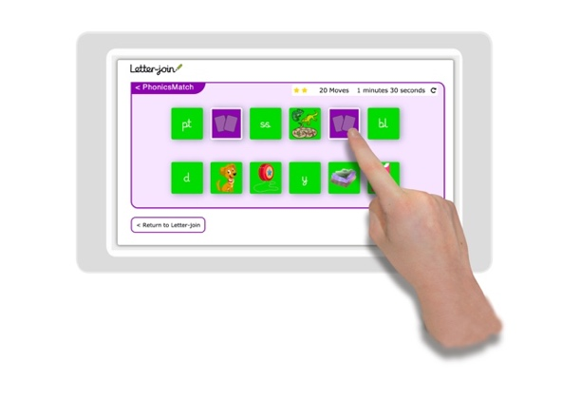Word Search
* Word Bank
* Spelling lists
* Write it Right!

Children can also watch the word and letter animations and practice and explore other handwriting resources on Letter-join.

**Key Stage Teaching**

**Key Stage 1: Year 2 (to support transition to Year 3)**  
Teaching is two lessons a week:

* gross and fine motor skills exercises
* strengthening handwriting, learning and practice
* numerals, capitals and printed letters; where and when to use, learning and practice
* KS1 SPaG exercises

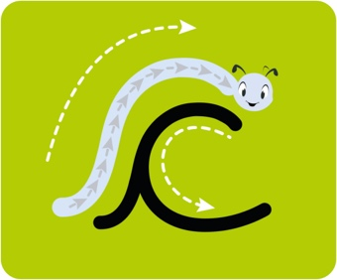**Starting Cursive** introduces children to cursive letters and how to join them. They will have regular practice in letter formation and joining their handwriting.

The sections in this module cover:

* cursive letters and words
* letter families
* high frequency words
* joining techniques
* sequencing sentences
* dictation exercises
* times table facts

• SPaG practice for KS1 SATs

With the regular handwriting practice throughout this module, children will start to develop the fluency and speed of their writing.

**Cursive: Year 2** includes lessons to improve letter formation and orientation of letters through regular practice and to support spelling, grammar and punctuation in readiness for exiting KS1. The sections in this module cover:

* letter families
* high frequency words
* joining techniques
* sequencing sentences
* dictation exercises
* times table facts
* SPaG practice

With the regular handwriting practice throughout this module, children will begin to develop the fluency and speed of their writing.

**Lower Key Stage 2: Years 3 and 4**

Handwriting lessons will continue twice a week in Lower Key Stage 2.

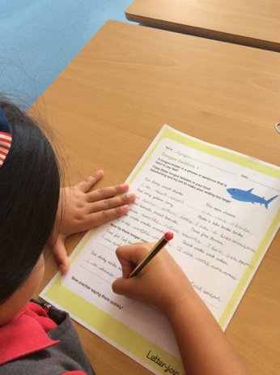**Year 3** is where pupils should be building up to using a cursive style throughout their independent writing in all subjects, helping to refine their handwriting in line with the requirements of each lesson. This module covers topics such as dictation, double letters, number vocabulary, palindromes, tongue twisters, MFL (Spanish), onomatopoeia, simile and statutory spellings.

By the end of Year 3 we aim to see an improvement in the legibility, consistency and quality of the children’s handwriting achieved through a variety of resources which link handwriting to other areas of the curriculum.

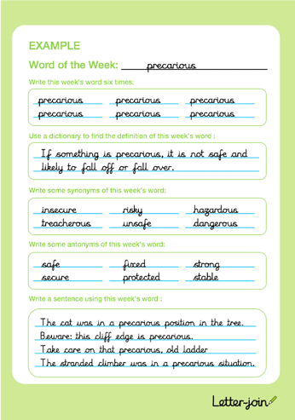**Year 4** focus on using handwriting practice to support other subjects in the curriculum and, at the same time, build upon fluency and consistency. This module aims to promote meaningful links with other subjects such as English, maths, science, geography and MFL (Spanish). Making such links enables children to apply the skills they are learning in context and also provides depth to the curriculum.

Learners will continue to build on producing fluent, consistent and legible handwriting through the regular practice offered in lessons.

By the end of Year 4 we aim for children to have practised applying size-appropriate handwriting to all areas of the curriculum whilst maintaining fluency and legibility.

**Upper Key Stage 2: Years 5 and 6**

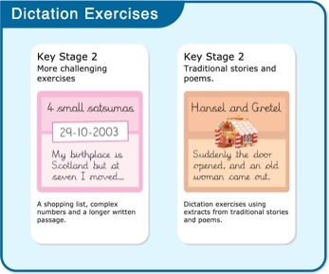More advanced handwriting techniques will be taught during two weekly lessons:

* reinforcing cursive handwriting across the curriculum
* form-filling/labelling using printed and capital letters
* dictation exercises promoting quick note-taking and speedy handwriting writing skills
* KS2 SATs SPaG practice

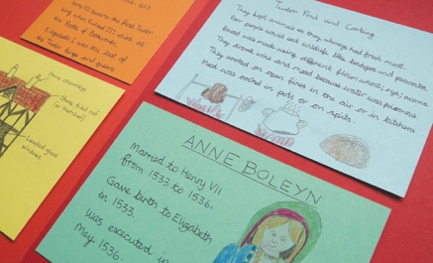**Year 5** continues to build on combining fluent handwriting with other subjects across the curriculum.

Learners will have plenty of opportunity to develop the stamina and skills to write at length, with accurate spelling and punctuation. With Letter-join’s wide range of resources they will be able to work towards producing consistently neat and well-presented handwriting in all curriculum subjects.

At the end of year 5 we aim for children to be producing cursive writing automatically, enabling them to focus on the content of their work rather than the process of writing.

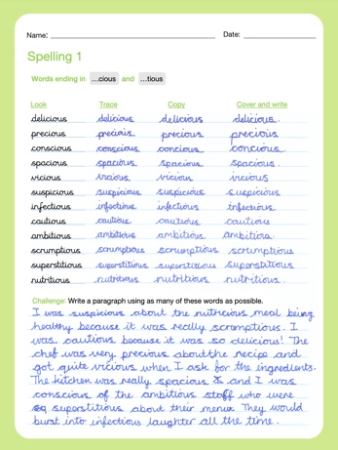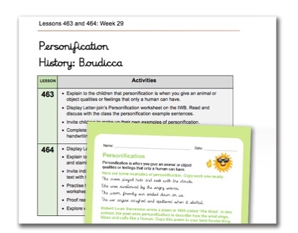**Year 6** learner are presented with a range of tasks where they have to decide on an appropriate style of handwriting. Promoting speedy, fluent writing continues to be a strong feature. Challenging dictation exercises offer opportunities to refine pupils’ revising and checking skills as well as boosting their handwriting speed, stamina and fluency. A range of curriculum-based worksheets will give pupils the opportunity to practise writing at length.

Learners are also presented with a series of worksheets to aid KS2 SATs SPaG revision. They are designed to support year 6 pupils in meeting expected standards for spelling, punctuation and grammar, with lots of SPaG preparation and plenty of handwriting practice.

By the end of Year 6 we want our pupils to be able to adapt their handwriting for a range of tasks and purposes and to create different effects. We want them to be clear about what standard of handwriting is appropriate for a particular task, for example, quick notes, a final handwritten version, an un-joined style or capital letters.

**Correct posture and pencil grip for handwriting**

All pupils, from Nursery to Year 6, are taught to sit correctly at a table, holding a pencil comfortably and correctly.



**Sitting Position**

Sit with a straight back, not leaning over the page



Pull the chair close in to the table

Keep feet flat on the floor

The table reaches to below elbow height



Sit right back in the seat

*Paper position for right-handed children.*

**Left-handed children**

Left-handed children can find it difficult to follow the movements of right-handed teachers as they model letter formation (and vice versa). Teachers demonstrate to left-handers on an individual or group basis.

* Left-handed pupils sit to the left of a right-handed child so that they are not competing for space.
* Pupils position the paper/book to their left side and slanted, as shown.
* Pupil are taught that pencils should not be held too close to the point as this can interrupt their line of vision.
* Extra practice with left-to-right exercises can be necessary before pupils write   
  left-to-right automatically.

*Paper position for left-handed children.*



**The Tripod Pencil Grip**

Both right and left handed children are encouraged to use the tripod grip which allows the pencil to be held securely whilst allowing controlled movements of the pencil nib. We use the Tripod Grip Rhyme:

Point away the pencil, Pinch it near the tip, Lift if off the table, Spin it round... and grip.

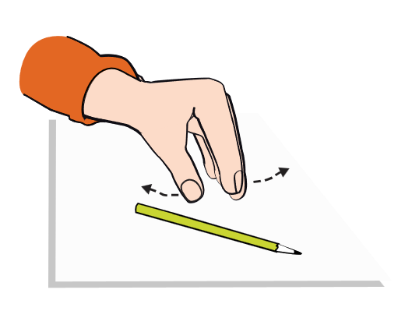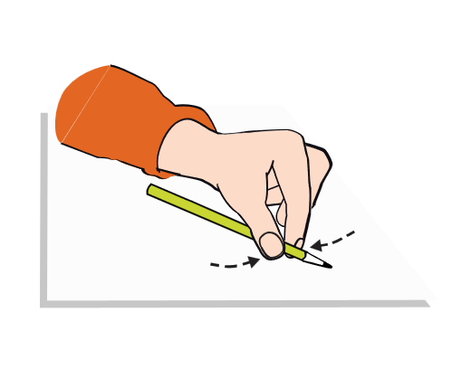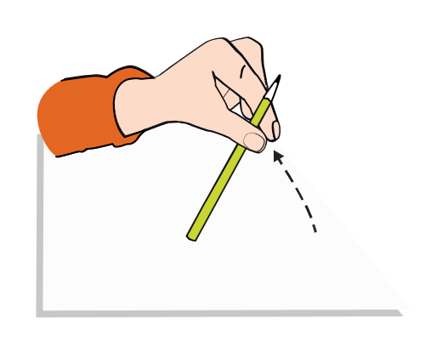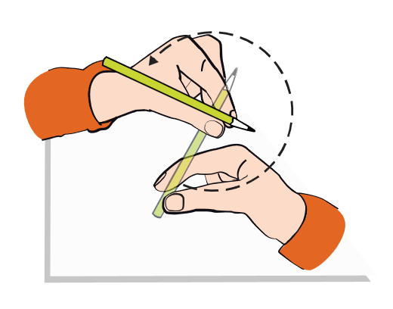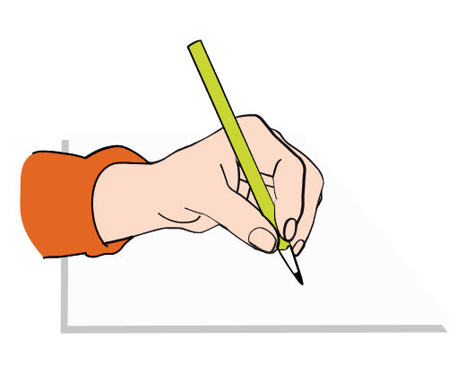

Point away the pencil, Pinch it near the tip, Lift if off the table, Spin it round... and grip.



**Right-handed pencil grip**

**Left-handed pencil grip**