**Welcome to Reception**



***‘A happy place to learn’*** We offer broad, balanced learning experiences in a warm, nurturing and inclusive environment. Our children have opportunities to immerse themselves in school life so that they are fully equipped for the challenges of the National Curriculum in Year One.

**Flowery Field Primary School**

We hope this information will help to explain the Reception class daily routines and answer any queries you may have. Up to now, your child has been growing and learning in a secure family environment and perhaps attends a playgroup or nursery. We understand that moving on to school is a big step for families so we try to make this transition as smooth as possible.

We recognise the important role you have already played in preparing your child for school. By working together as partners in supporting your child both in and out of school, we will be encouraging them to learn in a happy and enjoyable way whilst meeting their needs and interests.

We have an ‘open door’ policy and are always happy to speak to you, answer queries or put your mind at rest. If it is busy at the beginning and end of the day, we will make time to speak to you as soon as we can.

**Help us to get to know your child**

We want you to give us as much information as possible to help us to get to know your child. If you have any reports or booklets from your child’s Nursery please pass them on to their teacher, as they will provide us with useful information about progress and next steps in their learning (we will return them to you). You may need to give us medical information about your child and if necessary we will work with you to put a care plan in place. It is important to let us know if your child has allergies, asthma or any other conditions that will affect them at school. If there is anything else you feel we should know about, or if you have any particular worries about your child moving into Reception class, please speak to the teacher.

**Getting to know you**

Parents/carers are individuals too; please let us know if there is anything else we can do to enable you to support your child in school, for example, you may need someone to translate letters.

**Curriculum**

Reception children follow the Early Years Curriculum designed to help them achieve Early Learning Goals. These are targets that children are expected to achieve by the time they leave Reception class so they are ready for National Curriculum work in Year One. The teachers work carefully to ensure our curriculum offers a progression of skills and knowledge from Nursery to Reception. This follows whole school themes as well as linking to Early Years topics inspired by the interests of our children.

We believe that children learn best from practical experiences and all areas of the curriculum are planned and delivered in this way to ‘bring learning to life’ so it is more purposeful and memorable.

**The Early Years Curriculum has seven subject areas:**

* Communication and Language
* Personal, Social and Emotional Development
* Physical Development
* Literacy
* Mathematics
* Understanding the World
* Expressive Arts and Design

An effective curriculum for young children recognises that they often need to repeat experiences. This is a necessary part of the learning process, which develops confidence and leads to a greater understanding.

In Reception class, we build on the children’s previous knowledge. Practical experiences are more valuable and appropriate at this stage of learning and 80% of our assessments are based on what the children can do when they are interacting independently. We recognise that play provides important opportunities for learning, exploring and discovering both indoors and outdoors; this also helps the children to make links across different areas of learning.

**Taught lessons**

Whilst play is essential for learning, Reception children still have daily routines that include time for teacher taught lessons, which introduce new skills and extend previous knowledge.

These lessons are:

* Literacy – As a school, we deliver the ‘Power of Reading’ approach and this forms the basis for our Literacy planning. We choose a text based on whole school wider curriculum themes and immerse ourselves and our environment in this theme both indoors and outdoors
* Phonics – Learning the sounds that letters make and using these to read and write. We use the ‘Little Wandle’ phonics programme
* Maths – Teaching is practical and we often apply our maths skills to experiments or investigations so children see how maths links to everyday life. We use the ‘White Rose Maths’ scheme to support our maths teaching
* PE – Our school sports coaches deliver PE lessons once a week, developing skills in a variety of sports and also athletics
* Dance – Every class has a weekly dance lesson, taught in our dance studio
* Reading – Is taught individually and in small groups where a decodable text is used to focus on early skills and strategies needed to be able to read a book
* Spanish – We sing songs, learn greetings, count and focus on words that link to current learning or interests
* Wider Curriculum – this supports children to achieve their Early Learning Goals and prepares them for Year One

**Reading**

Shortly after starting Reception your child will be allocated an electronic reading book for you to share with them, they will also choose a library book for you to read with them at home. These books will be changed weekly and kept in a book bag provided by school that you can take home every day – please return them to school every morning as we use them daily. It is important that we value reading so try to make this a relaxed and enjoyable part of your daily routine where you can sit and enjoy reading together and talk about the story and pictures. We encourage our children to read at least four times a week and ask that you sign your child’s reading record book each time you read at home with them.

**School uniform**

Reception children are expected to wear school uniform, which is a royal blue sweatshirt or cardigan, a plain white or pale blue polo shirt, black, dark grey or navy trousers, shorts, skirt or skort, pinafore or blue gingham dress. Uniform is available to buy in Hyde at Kids Stop or feel free to buy it from your preferred supermarket.

For PE your child needs to wear pumps, a royal blue t-shirt and black or blue shorts. Jewellery should not be worn on PE days; if your child comes to school wearing earrings on a PE day they will not be able to take part. Only stud earrings are allowed on other days, this is for your child’s safety. On PE days your child can come to school in their PE kit. In winter months tracksuit bottoms are appropriate to wear.

It is very important to label all of your child’s clothing. It would be helpful if your child wears clothes that they can manage by themselves as independence in self-care is encouraged. It can be distressing for a child to be struggling with tricky belts, buttons etc. when they urgently need the toilet! We use aprons for painting and messy play and we wear waterproofs for the mud kitchen outside, unfortunately accidents do happen, so we advise that you do not send your child to school in their best coat as we use paint and have messy play outside daily. Your child will also need a pair of wellington boots so they can access the mud kitchen and splash in puddles when it rains.

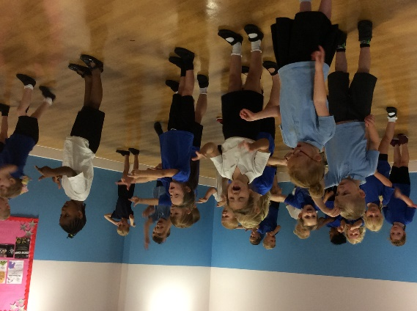

**Lunchtimes**

Reception lunchtime is 11.30am-12.30pm. Children in Reception, Year One and Year Two are entitled to free school meals. Please order school meals electronically on our MCAS app as soon as you can (if you leave it until the day before your child may not receive their choice, as we order ingredients in advance). Our lunchtime supervisors are at hand to help the children, monitor what they eat and will inform the class teacher if there are any concerns.

The kitchen staff are vigilant with dietary requirements; a vegetarian and halal meal option is always available.

If your child prefers to bring a packed lunch, please ensure that they can unwrap the contents by themselves. Our ‘Healthy School’ policy does not allow fizzy drinks, glass bottles or cans, chocolate bars or sweets and we cannot heat or re-heat food.

**Snacks**

Children receive a free piece of fruit every day funded by a Government initiative and Reception pupils receive milk every day free of charge. We ask that every child brings in a bottle of water that they can drink in school during the day, this can be refilled if required. Please ensure that this is labelled with your child’s name.

**Safety**

Your child must be brought to school and collected by a parent/carer or other responsible adult. We do not allow any child out of the classroom until we see the person who has come to collect them waiting outside the door. Please inform staff if anyone different will be collecting your child, we will only let your child leave with adults we know. Please message school in plenty of time if there is an alteration to collecting arrangements, as the telephone lines are very busy at the end of the school day.

**First Aid**

Injuries, bumps and cuts will be attended to by qualified first aiders, you will be informed in person by a member of staff and you will receive a note at the end of the school day. If your child is ill or has a serious injury while they are at school we will contact you to come and collect them, so it is vital that you ensure we have your up-to-date telephone number and email address.

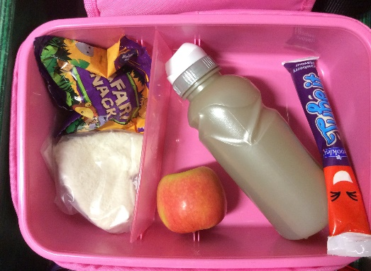

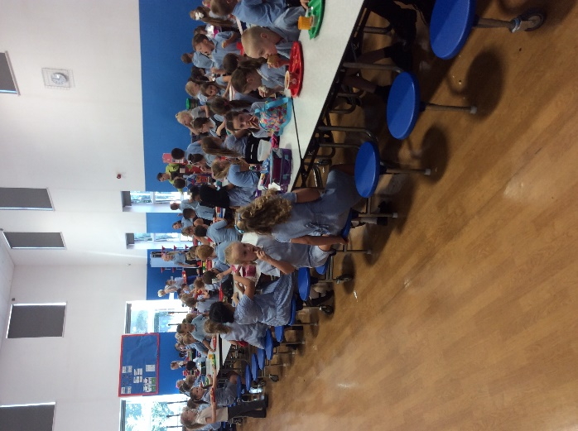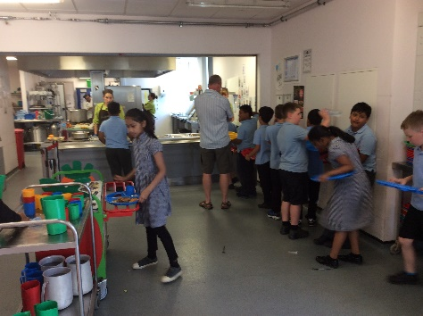

**Attendance and illness**

It is important that your child attends school regularly; school expects 97% attendance for all pupils.

In September 2023 our school times will be changing to **8:45am - 3:15pm.**

If your child has an appointment with their dentist or doctor, please let us know and if they are absent please telephone school. Try to make appointments after school or in school holidays if possible.

**How can you help your child to get ready for school?**

* Establish good routines at home so children get plenty of sleep
* Limit screen time and do practical activities instead, like playing in the garden, going to the park
* Help them to be independent in self-care by using the toilet by themselves and washing their hands afterwards
* Share books together, talk about the pictures and predict what might happen next in the story
* Practise reading and writing their name
* Teach them to dress and undress themselves; fasten buttons and do up zips
* Play simple games, such as cards, dominoes, skittles - taking turns and experiencing losing as well as winning
* Sing songs and nursery rhymes together
* Practise using a knife and fork and sitting at the table to eat
* Take time to talk to your child, listen to them and encourage them to listen to you

We want parents/carers to feel involved in their child’s education and we aim to develop a good partnership between home and school. The most important thing is that your child feels happy and secure at school and we hope that by working together as teachers and parents/carers we can achieve this.

**Rainbows – Before and After School Club**

Our school offers breakfast, after school and school holiday care provided by Rainbow Child Care. The club is based in a separate building within our school grounds, making drop-off and collection easy for parents/carers. The club opens at 7am until school starts and when school closes to 6pm. For further details, prices, to check availability or to arrange a visit, please contact the Rainbow office on 07423 816977 during office hours or during club hours on 07769 153279. You can also visit their website at www.rainbowdukinfield.co.uk or Email:rainbowclubs@mail.co.uk

**We look forward to seeing you!**