Forefield Junior School



Supporting Pupils with Allergies Policy
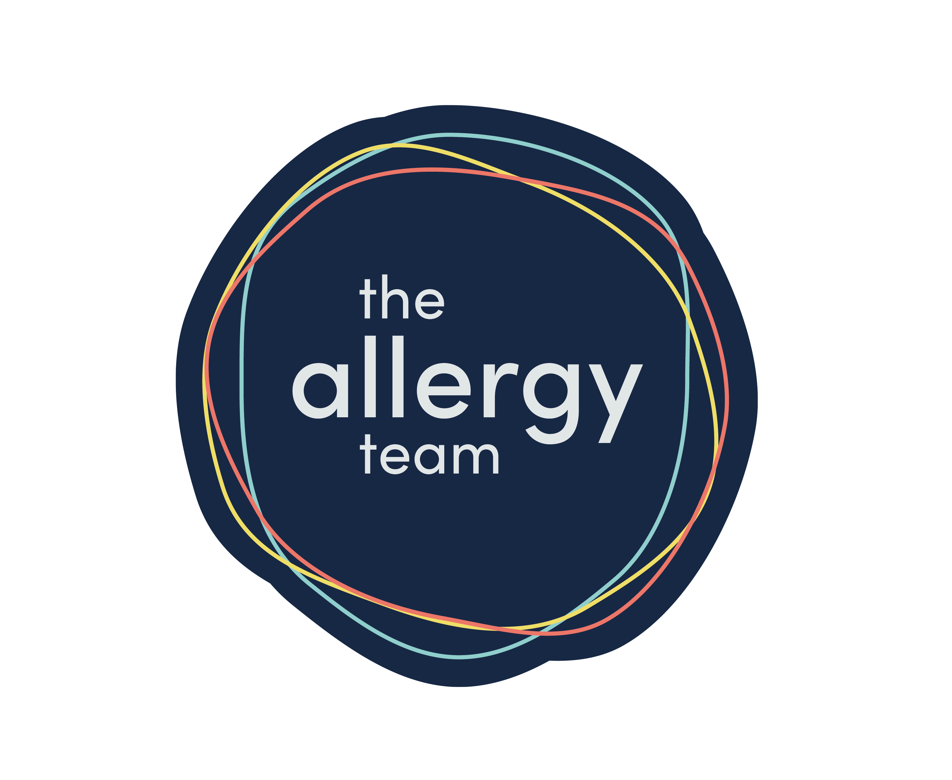
Reviewed September 2026

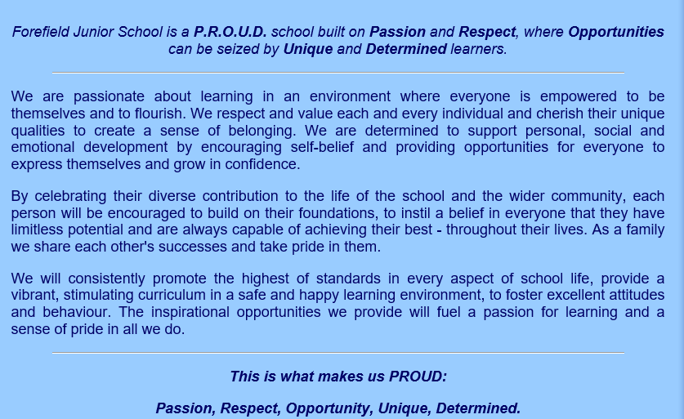

Contents

- Aims
- Legislation and Guidance
- Roles and Responsibilities
- Assessing Risks
- Managing Risk
- Procedures for handling an allergic reaction
- Adrenaline Auto-injectors (AAIs)
- Training
- Links to other policies

Appendix I – First Aid for Anaphylaxis
Appendix II- How to use Epi Pen AAIS
Appendix III- How to use Epi Pen Jext AAIS
Appendix IV-Flowchart for Allergic Reaction with use of Adrenaline Auto Injector
Appendix V- Information on Allergies
Appendix VI- Allergy Incident and near miss report form

1. Aims
This policy aims to:
- Set out our school’s approach to allergy management, including reducing the risk of exposure and the procedures in place in case of allergic reaction
- Make clear how our school supports pupils with allergies to ensure their wellbeing and inclusion
- Promote and maintain allergy awareness among the school community

2. Legislation and guidance
This policy is based on the Department for Education (DfE)’s guidance on allergies in schools and supporting pupils with medical conditions at school, the Department of Health and Social Care’s guidance on using emergency adrenaline auto-injectors in schools, and the following legislation:
- The Food Information Regulations 2014
- The Food Information (Amendment) (England) Regulations 2019

3. Roles and responsibilities
We take a whole-school approach to allergy awareness.

3.1 Allergy lead
The nominated allergy lead is Sarah Russell, Deputy Headteacher, supported by Sarah Harding.
They’re responsible for:
- Promoting and maintaining allergy awareness across our school community
- Recording and collating allergy and special dietary information for all relevant pupils, although the allergy lead has ultimate responsibility, the information collection itself may be delegated to administrative staff
- Ensuring:
- All allergy information is up to date and readily available to relevant members of staff
- All pupils whose allergies require specific school support will have an IHP, developed with the pupil/parents and taking account of clinical advice.
- All staff receive an appropriate level of allergy training
- All staff are aware of the school’s policy and procedures regarding allergies
- Relevant staff are aware of what activities need an allergy risk assessment
- Keeping stock of the school’s adrenaline auto-injectors (AAIs)
- Checking that prescribed auto-injectors are in date and contacting parents with a reminder when nearing expiration dates
- Regularly reviewing and updating the allergy policy. The policy will be reviewed at least annually and following any serious incident or near miss.
- This policy will be published on the school's website and made available to staff, pupils and parents/carers. Awareness of the policy will be raised with pupils and parents/carers at appropriate points throughout the school year.

3.2 Teaching and support staff
All teaching and support staff are responsible for:
- Being aware of specific pupils with allergies in their care. Information regarding specific children with allergies will be shared with all staff at the beginning of the school year, information will be displayed in the staff room, children with AAIs are also named in the medical cupboard and staff will be kept informed of any changes to children’s allergy requirements as they arise.
- Promoting and maintaining allergy awareness among pupils
- Maintaining awareness of our allergy policy and procedures. This policy will be published on the school's website and communicated to staff. All staff will be made aware of the policy as part of annual allergy awareness training.
- Being able to recognise the signs of severe allergic reactions and anaphylaxis
- Attending appropriate allergy training as required
- Carefully considering the use of food or other potential allergens in lesson and activity planning
- Ensuring the wellbeing and inclusion of pupils with allergies

3.3 Parents/carers
Parents/carers are responsible for:
- Being aware of our school’s allergy policy
- Providing the school with up-to-date details of their child’s medical needs, dietary requirements, and any history of allergies, reactions and anaphylaxis
- If required, providing their child with 2 in-date adrenaline auto-injectors and any other medication, including inhalers, antihistamine etc., and making sure these are replaced in a timely manner
- Carefully considering the food they provide to their child as packed lunches and snacks, and ensuring that these foods do not contain any of their child’s known allergens
- Following the school’s guidance on food brought in to be shared
- Updating the school on any changes to their child’s condition

3.4 Pupils with allergies
These pupils are responsible for:
- Being aware of their allergens and the risks they pose
- Learning to understand their own allergic reactions and what this might feel like and the symptoms that might present
- Understanding how and when to use their adrenaline auto-injector
- If age-appropriate, carrying their adrenaline auto-injector on their person and only using it for its intended purpose

3.5 Pupils without allergies
These pupils are responsible for:
- Being aware of allergens and the risk they pose to their peers
Older pupils might also be expected to support their peers and staff in the case of an emergency.

4. Assessing risk
The school will conduct a risk assessment for any pupil at risk of allergic reactions taking part in:
- Lessons such as food technology
- Science experiments involving foods
- Crafts using food packaging
- Off-site events and school trips
- Any other activities involving animals or food, such as animal handling experiences or baking
A risk assessment for any pupil at risk of an allergic reaction will also be carried out where a visitor requires a guide dog.

5. Managing risk

5.1 Hygiene procedures
- Pupils are reminded to wash their hands before and after eating
- Sharing of food is not allowed
- Pupils have their own named water bottles
- Welfare staff ensure tables are cleaned before each sitting to reduce the risk of cross-contamination

5.2 Catering
The school is committed to providing safe food options to meet the dietary needs of pupils with allergies.
The school works closely with its catering provider to ensure the safe provision of food for pupils with allergies.
The catering provider will:
- comply with current food information and allergen legislation;
- maintain accurate allergen information for all menu items;
- implement procedures to prevent cross-contamination;
- ensure staff receive appropriate allergy awareness training;
- identify pupils with allergies through established systems and processes.
- Catering staff receive appropriate training and are able to identify pupils with allergies
- Catering staff follow hygiene and allergy procedures when preparing food to avoid cross-contamination
- Catering staff are aware of children with allergies, a list is maintained and shared with catering staff
- The school catering team use the School Grid system which records and manages pupils’ allergies through the app (using information provided by parents)
- School menus are available for parents/carers to view, a list of allergens is available on request
- Where changes are made to school menus, we will make sure these continue to meet any special dietary needs of pupils
- Food allergen information relating to the ‘top 14’ allergens is displayed on the packaging of all food products, allowing pupils and staff to make safer choices. Allergen information labelling will follow all legal requirements that apply to naming the food and listing ingredients, as outlined by the Food Standards Agency (FSA)
Parents and carers are encouraged to meet with the Catering Manager to discuss individual dietary requirements where necessary.
Allergy, dietary and food intolerance information is recorded on each pupil's profile on the catering iPad. When a pupil selects their name on the dining hall system, their pre-ordered meal is displayed alongside any recorded allergies, dietary requirements or food intolerances and is colour coded so staff can see the difference between allergies and dietary requirements.
Pupils with allergies are provided with a red tray at lunchtime. This enables catering and supervisory staff to readily identify pupils with dietary requirements and ensure appropriate meals are served.
Pupils with allergies meals are prepared with their allergies considered and plated onto red trays prior to children entering the dining hall. When the child gets to the server, the server will collect the meal and check the meal ingredients against the child’s allergies listed on the iPad. Meals are prepared in separate containers and clearly labelled so that there is no cross contamination between foods before being served. One member of staff serves all of the meal to avoid any miscommunication between servers.

5.3 Food restrictions
We acknowledge that it is impractical to enforce an allergen-free school. However, we would like to encourage pupils and staff to avoid certain high-risk foods to reduce the chances of someone experiencing a reaction. These foods include:
- Packaged nuts
- Cereal, granola or chocolate bars containing nuts
- Peanut butter or chocolate spreads containing nuts
- Peanut-based sauces, such as satay
- Sesame seeds and foods containing sesame seeds
If a pupil brings these foods into school, they may be asked to eat them away from others to minimise the risk, or the food may be confiscated.

5.4 Insect bites/stings
When outdoors:
- Shoes should always be worn
- Food and drink should be covered

5.5 Animals
- All pupils will always wash hands after interacting with animals to avoid putting pupils with allergies at risk through later contact
- Pupils with animal allergies will not interact with animals

5.6 Support for mental health
Pupils with allergies can experience bullying and may also suffer from anxiety and depression relating to their allergy. Forefield Junior School is committed to supporting mental health and wellbeing.
Pupils with allergies will have additional support through:
- Pastoral care
- Regular check-ins with their class teacher.

5.7 Events and school trips
- For events, including ones that take place outside of the school, and school trips, no pupils with allergies will be excluded from taking part
- The school will plan accordingly for all events and school trips, and arrange for the staff members involved to be aware of pupils’ allergies and to have received adequate training
- Appropriate measures will be taken in line with the schools AAI protocols for off-site events and school trips (see section 7.5).

6. Procedures for handling an allergic reaction

6.1 Register of pupils with AAIs
- The school maintains a register of pupils who have been prescribed AAIs or where a doctor has provided a written plan recommending AAIs to be used in the event of anaphylaxis. The register includes:
- Known allergens and risk factors for anaphylaxis
- Whether a pupil has been prescribed AAI(s) (and if so, what type and dose)
- Where a pupil has been prescribed an AAI, whether parental consent has been given for use of the spare AAI, which may be different to the personal AAI prescribed for the pupil
- A photograph of each pupil to allow a visual check to be made
- The register is kept in the medical cupboard with the AAI’s and can be checked quickly by any member of staff as part of initiating an emergency response

6.2 Allergic reaction procedures

- As part of the whole-school awareness approach to allergies, all staff are trained in the school’s allergic reaction procedure, and to recognise the signs of anaphylaxis and respond appropriately
- Staff are trained in the administration of AAIs to minimise delays in pupil’s receiving adrenaline in an emergency
- If a pupil has an allergic reaction, the staff member will initiate the school’s emergency response plan, following the pupil’s allergy action plan
- If an AAI needs to be administered, a member of staff will use the pupil's own AAI, or if it is not available, a school one
- Reasons why the pupil’s own prescribed AAI(s) are not immediately available could include, for example, because they are broken, out-of-date, have misfired or been wrongly administered
- If the pupil has no allergy action plan, staff will follow the school's procedures on responding to allergy and, if needed, the school's normal emergency procedures.
- Prior consent is not legally required to use a spare adrenaline device in an emergency.
- If a pupil needs to be taken to hospital, staff will stay with the pupil until the parent/carer arrives, or accompany the pupil to hospital by ambulance
- If the allergic reaction is mild (e.g. skin rash, itching or sneezing), the pupil will be monitored and the parents/carers informed

6.3 Serious incidents and near misses

- The school will record, report and learn from all serious allergy incidents and near misses involving pupils, staff or visitors.
- A serious incident is an event relating to an allergy where a person is harmed or placed at immediate and significant risk of harm. This may include an incident requiring the use of an adrenaline auto-injector, emergency medical treatment, urgent clinical intervention or attendance by emergency services.
- A near miss is an event which did not result in harm but had the clear potential to do so. Examples may include:
- a pupil being given or coming into contact with a food containing a known allergen, but not developing symptoms;
- an allergen being present where it should have been excluded;
- a prescribed or spare adrenaline auto-injector not being immediately available when required;
- a pupil's allergy information not being communicated to a member of staff, catering staff or staff supervising an activity;
- an error in following a pupil's Individual Healthcare Plan or Allergy Action Plan.

- Following a serious incident or near miss:
- The immediate priority will be the safety and medical care of the pupil, including following their Allergy Action Plan/Individual Healthcare Plan and the school's emergency procedures.
- The incident or near miss will be recorded as soon as reasonably practicable, including what happened, when and where it happened, the people involved, the allergen or suspected allergen, action taken and the outcome.
- Parents/carers will be informed of the incident or near miss as soon as reasonably practicable.
- The incident will be reported to the Headteacher and the member of the governing body with responsibility for allergy safety, in accordance with the school's reporting procedures.
- Where required, the school will make any statutory or other required reports.
- The Allergy Lead will review the incident with the relevant staff and consider whether changes are required to the pupil's Individual Healthcare Plan, risk assessment, allergy action plan, staff training, catering arrangements, communication arrangements or other school procedures.
- Where changes are identified, these will be implemented and monitored to reduce the likelihood of a similar incident occurring again.
- Significant incidents and near misses will be reviewed as part of the annual review of this policy.

- The school will maintain an Allergy Incident and Near Miss Record. Records will be stored securely on CPOMS and within the allergy file (see appendix VI), and handled in accordance with the school's data protection requirements. The record will be reviewed periodically by the Allergy Lead to identify recurring issues, trends and opportunities for improvement.
- The school will consider reports of allergy incidents or near misses made by parents/carers, including where symptoms or the impact of exposure become apparent after the pupil has left school.

7. Adrenaline auto-injectors (AAIs)

7.1 Purchasing of spare AAIs
The allergy lead is responsible for buying AAIs and ensuring they are stored according to the guidance.
- AAIs will be sourced from the local pharmacy
- School will hold 2 emergency AAI’s (epi-pen)

7.2 Storage (of both spare and prescribed AAIs)
The allergy lead will make sure all AAIs are:
- Stored at room temperature (in line with manufacturer’s guidelines), protected from direct sunlight and extremes of temperature
- Kept in a safe and suitably central location to which all staff have access at all times, but is out of the reach and sight of children
- Not locked away, but accessible and available for use at all times
- Not located more than 5 minutes away from where they may be needed
Spare AAIs will be kept separate from any pupil’s own prescribed AAI, and clearly labelled to avoid confusion.

7.3 Maintenance (of spare AAIs)
S. Russell and S. Harding are responsible for checking monthly that:
- The AAIs are present and in date
- Replacement AAIs are obtained when the expiry date is near

7.4 Disposal
AAIs can only be used once. Once an AAI has been used, it will be handed to paramedics.

7.5 Use of AAIs off school premises
- For Pupils at risk of anaphylaxis, staff will carry AAI’s on any school trip or off site activity

The school holds an emergency anaphylaxis kit. This includes:
- Spare AAIs
- Instructions for the use of AAIs
- Instructions on storage
- Manufacturer’s information
- A checklist of injectors with expiry date clearly displayed to be checked and recorded monthly
- A note of arrangements for replacing injectors
- A list of pupils to whom the AAI can be administered
- A record of when AAIs have been administered

8. Training
The school is committed to training all staff in allergy response. ‘All staff’ includes any adults who will be present when children are on-site. New staff will receive allergy training as part of their induction.

8.1 Allergy Training

Allergy training will take place in addition to First Aid training, and will ensure that all staff:

- Have an awareness of allergy and the risks it poses
- Understand how to reduce and prevent the risk of allergic reactions
- Understand how allergic reactions can occur and how to manage them
- Understand that allergy includes multiple conditions (food allergy, asthma, eczema, hay fever, others), which can co-exist;
- Know where to find information about pupils’ allergy triggers;
- Can identify the range of symptoms of allergic reactions, including anaphylaxis
- Understand the importance of acting quickly in the case of anaphylaxis
- Know where AAIs are kept on the school site, and how to access them
- Know how to administer AAIs
- Know how to respond in an emergency;
- Understand the impact that an allergy can have on a child or young person’s wellbeing

Staff will be trained in allergy awareness and emergency response, for both anaphylaxis and acute asthma

8.2 Food allergy and asthma training

Staff will be trained to recognise acute asthma as well as anaphylaxis, and will know that AAIs are required immediately in cases of anaphylaxis, rather than salbutamol inhalers.
- Many food-allergic children also have asthma.
- “Wheeze” is a common symptom of asthma and also happens during food-induced anaphylaxis.
- The Allergy Action Plan may include instructions to give a reliever medicine (e.g. using a salbutamol inhaler) after giving a dose of adrenaline if the person is still wheezing.
- Spare emergency salbutamol inhalers and spacers are kept in the medical cupboard with the AAIs.
- Never give the reliever inhaler instead of adrenaline to treat anaphylaxis.

Training will be carried out annually by the allergy lead.

9. Links to other policies
This policy links to the following policies and procedures:
- Health and safety policy
- Supporting pupils with medical conditions policy

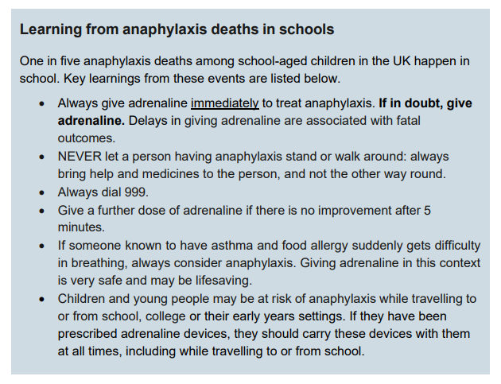

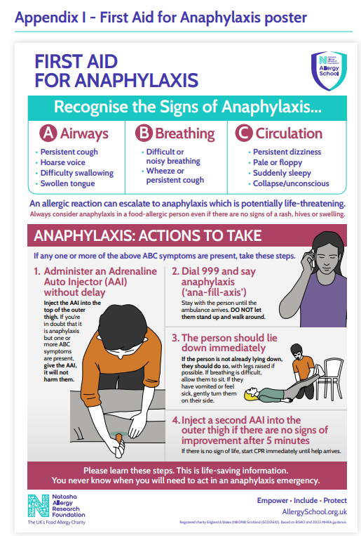
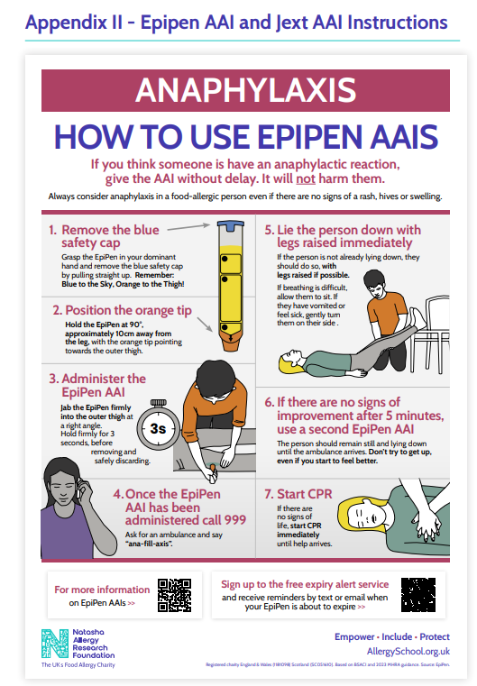
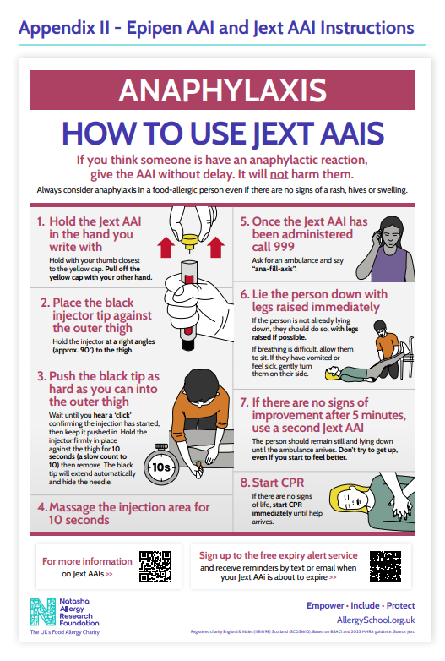
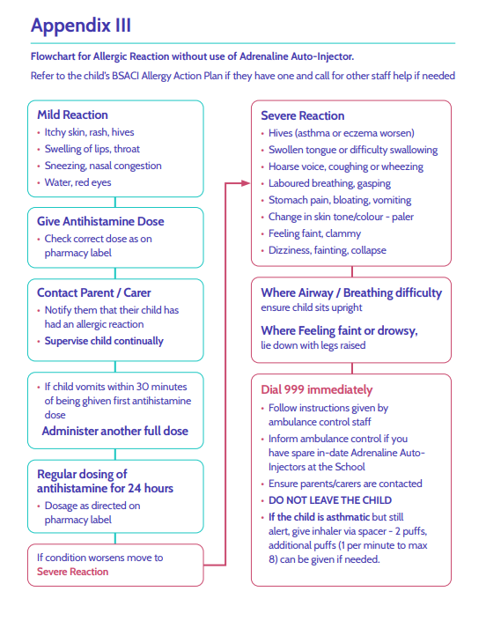

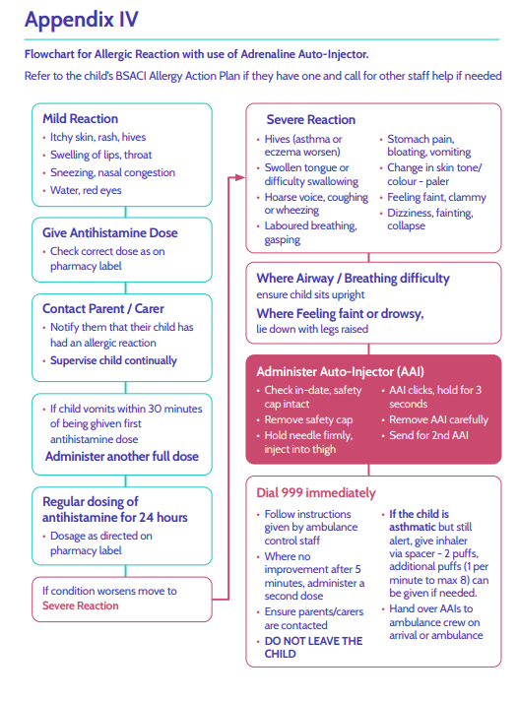
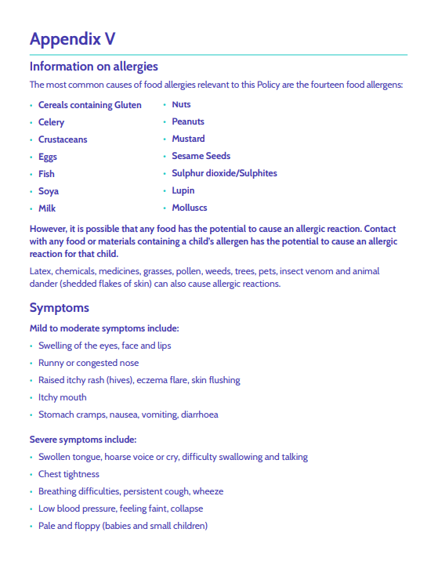

Appendix VI
Forefield Junior School - Allergy Incident and near miss report form

This form should be completed as soon as possible following any allergy-related incident or near miss. Near misses must be recorded even where no harm has occurred, as they may identify gaps in procedures, communication, supervision, or training and help prevent future incidents. Parents/carers and, where appropriate, the individual affected should be involved in reviewing the incident and identifying any lessons learned. The named allergy senior leader and governor should also review incidents to ensure that school policies, risk assessments, and Individual Healthcare Plans were appropriate, followed correctly, and updated where needed.
Date | Time | Incident Location | Child affected | Staff member present | Emergency Services Called Y/N

What happened/allergen involved (if known)

Why the incident happened (as far as is known)

How staff and pupils responded

What support was provided to the individual including any medication administered?

What immediate actions were taken afterwards?

Any lessons learned and recommended changes to any policies, procedures, training and supervision?

Reviewed by | Name | Signed | Date
School allergy governor:

School allergy lead:

