 | AUTUMN |  | SPRING |  | SUMMER |  | Key Objectives: | Key Vocabulary:
Year | 1 | 2 | 1 | 2 | 1 | 2
3 | Stone Age Shelters  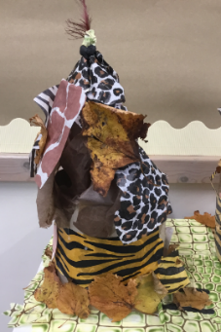  Building structures |  | Puppets  Sewing   |  | Moving Monsters  Pneumatics  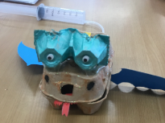 | Crepes  Cooking & nutrition  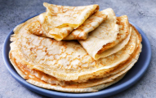 | I can design a product and make sure it looks attractive.  I can follow step-by-step plans – choosing equipment and materials.  I can work accurately to measure, make cuts and make holes.  I can choose a material for suitability/appearance.  I can make a product which uses mechanical components.  I can select the most appropriate tools and techniques for a task.  I can prove that my design meets some of the set criteria.  I can apply my understanding of how to strengthen, stiffen and reinforce more complex structures.  I can describe how food ingredients come together. | cutting, sticking, strengthen, stiffen, structure, reinforce, recipe, seasonal food, 2D/3D shapes, design criteria, evaluate, feature, strong, weak, accurate, decorate, detail, fabric, function, mechanism, pneumatic system, motion
4 |  | Moving Toys  Cams  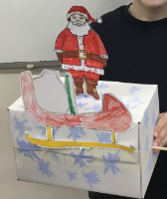 |  | Pizza  Cooking & nutrition  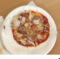 | Torches  Series circuits& switches  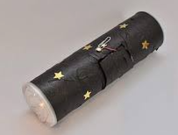 | Car Pro-Bots  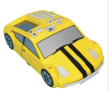  Programming | I can produce a plan and explain it.  I can use ideas from other people when I am designing.  I can measure accurately.  I am determined and adapt my work when my original ideas don’t work.  I can present a finished product in an interesting way.  I can evaluate and suggest improvements for my design.  I can evaluate products for both their purpose/appearance.  I can explain how I have improved my original design.  I know how to be hygienic and safe when using food. | Hygiene, balanced diet, protein, vitamins, carbohydrates, fats, dairy, nutrients, equipment, evaluation, flavour, ingredients, method, quantity, cams, pivot, dowel, follower, frame, function, mechanism, model, battery, bulb, cell, component, conductor, electrical item, electricity, series circuit, switch, test, torch, wire, input, output, programming,
5 | Fishing Rods (LEGO)  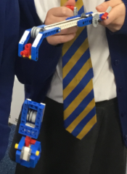  Gears & Pulleys |  | Phone Cases  Sewing  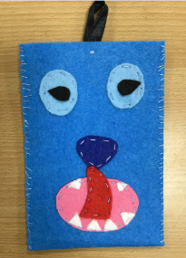 |  | Bridges  Building structures  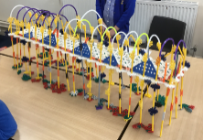 | Mayan Chocolate Brownies  Cooking & nutrition  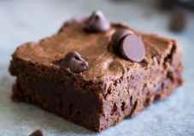 | I can produce a detailed, step-by-step plan.  I can come up with a range of ideas after collecting information from different sources.  I can use a range of tools and equipment competently.  I can evaluate appearance & function against original criteria.  I can suggest alternative plans; outlining the positive features and the draw backs.  I can explain how a product will appeal to a specific audience.  I show that I can be both hygienic and safe in the kitchen. | Healthy, ingredients, method, nutrients, packaging, recipe, accurate, annotate, whip-stitch, design criteria, detail, evaluation, fabric, sew, shape, template, button hole, running-stitch, attach, arched bridge, beam bridge, bridge, compression, forces, measure, predict, reinforce, right-angle, shape, strong structure, suspension bridge, tension, test, truss bridge, weak, gears, pulleys, Lego, build
6 |  | Controllable Vehicles  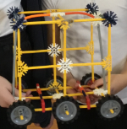  Motors  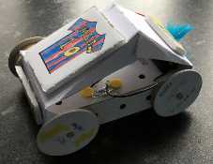 |  | Cottage Pie  Cooking & nutrition  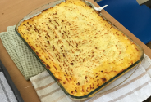 |  | CAD 3  Modelling  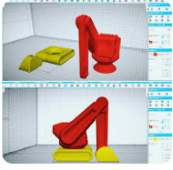 | I can justify my plans in a convincing way.  I can use market research to inform my plans and ideas.  I can follow and refine my plans.  Prepare and cook a savoury dishes using a range of cooking techniques.  I show that I can test and evaluate my products.  I can evaluate my product against clear criteria.  I can explain how products should be stored and give reasons.  Understand and apply the principles of a healthy and varied diet. | Beef, lamb, cross-contamination, diet, ethical issues, farm, healthy, ingredients, method, nutrients, packaging, reared, recipe, research, substitute, supermarket, flavour, processed, unit of measurement, fats, saturated fats, sugar, food labels, seasonal, aesthetics, air resistance, chassis, design, design criteria, function, kinetic energy, mechanism, structure, axel, computer-aided-design (CAD), design brief, input, output,

