Geographical Key Concepts at FJS

Location – The concept of **location** refers to understanding where places are situated on Earth. It involves recognizing the position of places using **maps**, **atlases**, **globes and digital mapping**, as well as using **coordinates** (latitude and longitude) to pinpoint exact locations. Our children learn to describe places using **compass directions**. The concept of location also helps students connect **local**, **regional**, and **global** scales, enabling them to better understand the world around them.

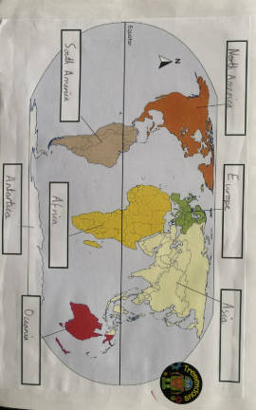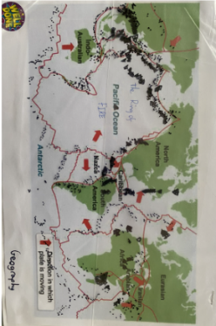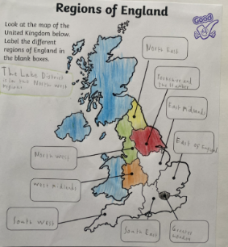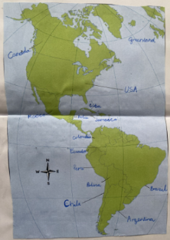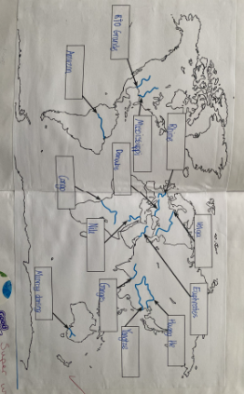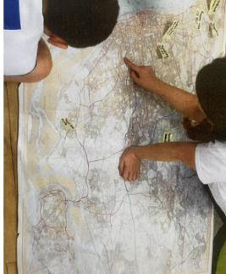

Place - The concept of **place** refers to the unique characteristics that make a location special. It includes both **physical features** and **human features**. Our pupils learn how these features influence how people live, work, and interact with their environment. Understanding place relates to the opinion and meaning that people attach to a location. As a concept, it examines the uniqueness of a space and questions what is specific about this area. By studying places, students gain an understanding of how different locations vary and how people adapt to their surroundings, making the world diverse and interconnected.

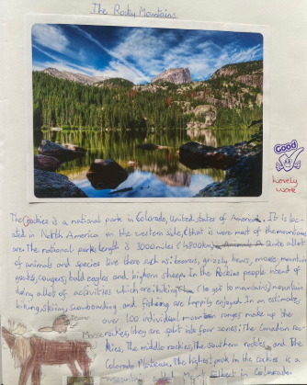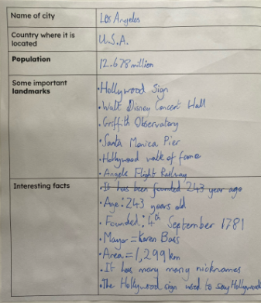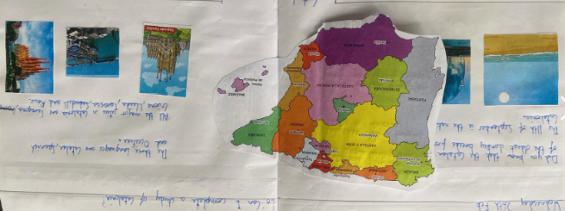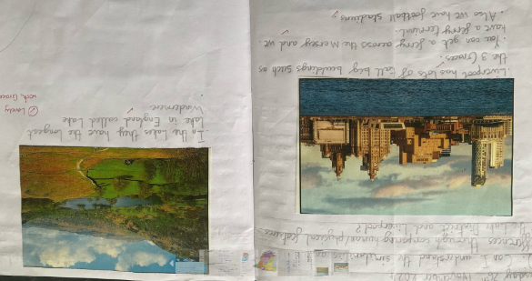

Human Processes – Human geography looks at the impact and behaviour of people and how they relate to the physical world. Human processes could therefore be defined in terms of how human involvement has affected the world.

Physical Processes - Physical geography looks at the natural processes of the Earth, such as climate and plate tectonics. A physical process could be defined as an incident or series of incidents that happen naturally due to the effects and importance of a specific force of nature.

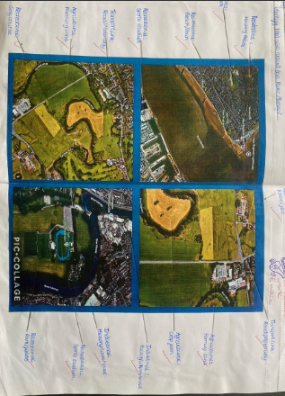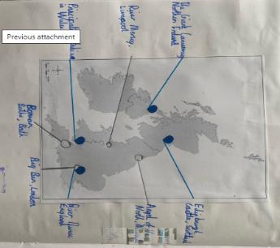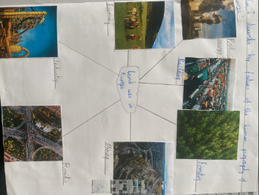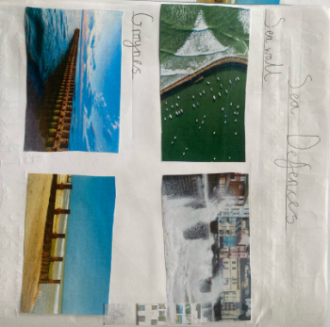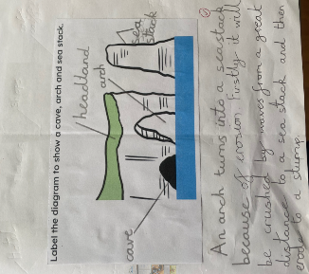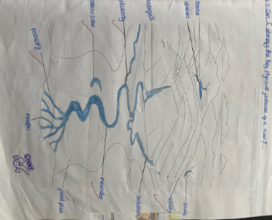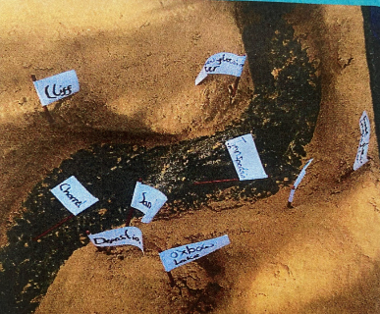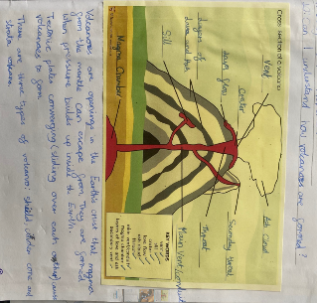

Movement - The concept of **movement** includes how goods, services, and ideas travel between places. A key aspect is **trade**—how countries exchange products from one to another. Students learn about **trade links** that connect regions globally, often by sea, using ships to transport goods across oceans. Movement is a significant consideration in how land is changed over time.

Fieldwork – Fieldwork is learning directly in the real world outside the classroom and has a long tradition in school geography. It is one of the distinctive features of a geographical education and feeds our curiosity about the world. Much fieldwork is done locally and even on the school grounds.

