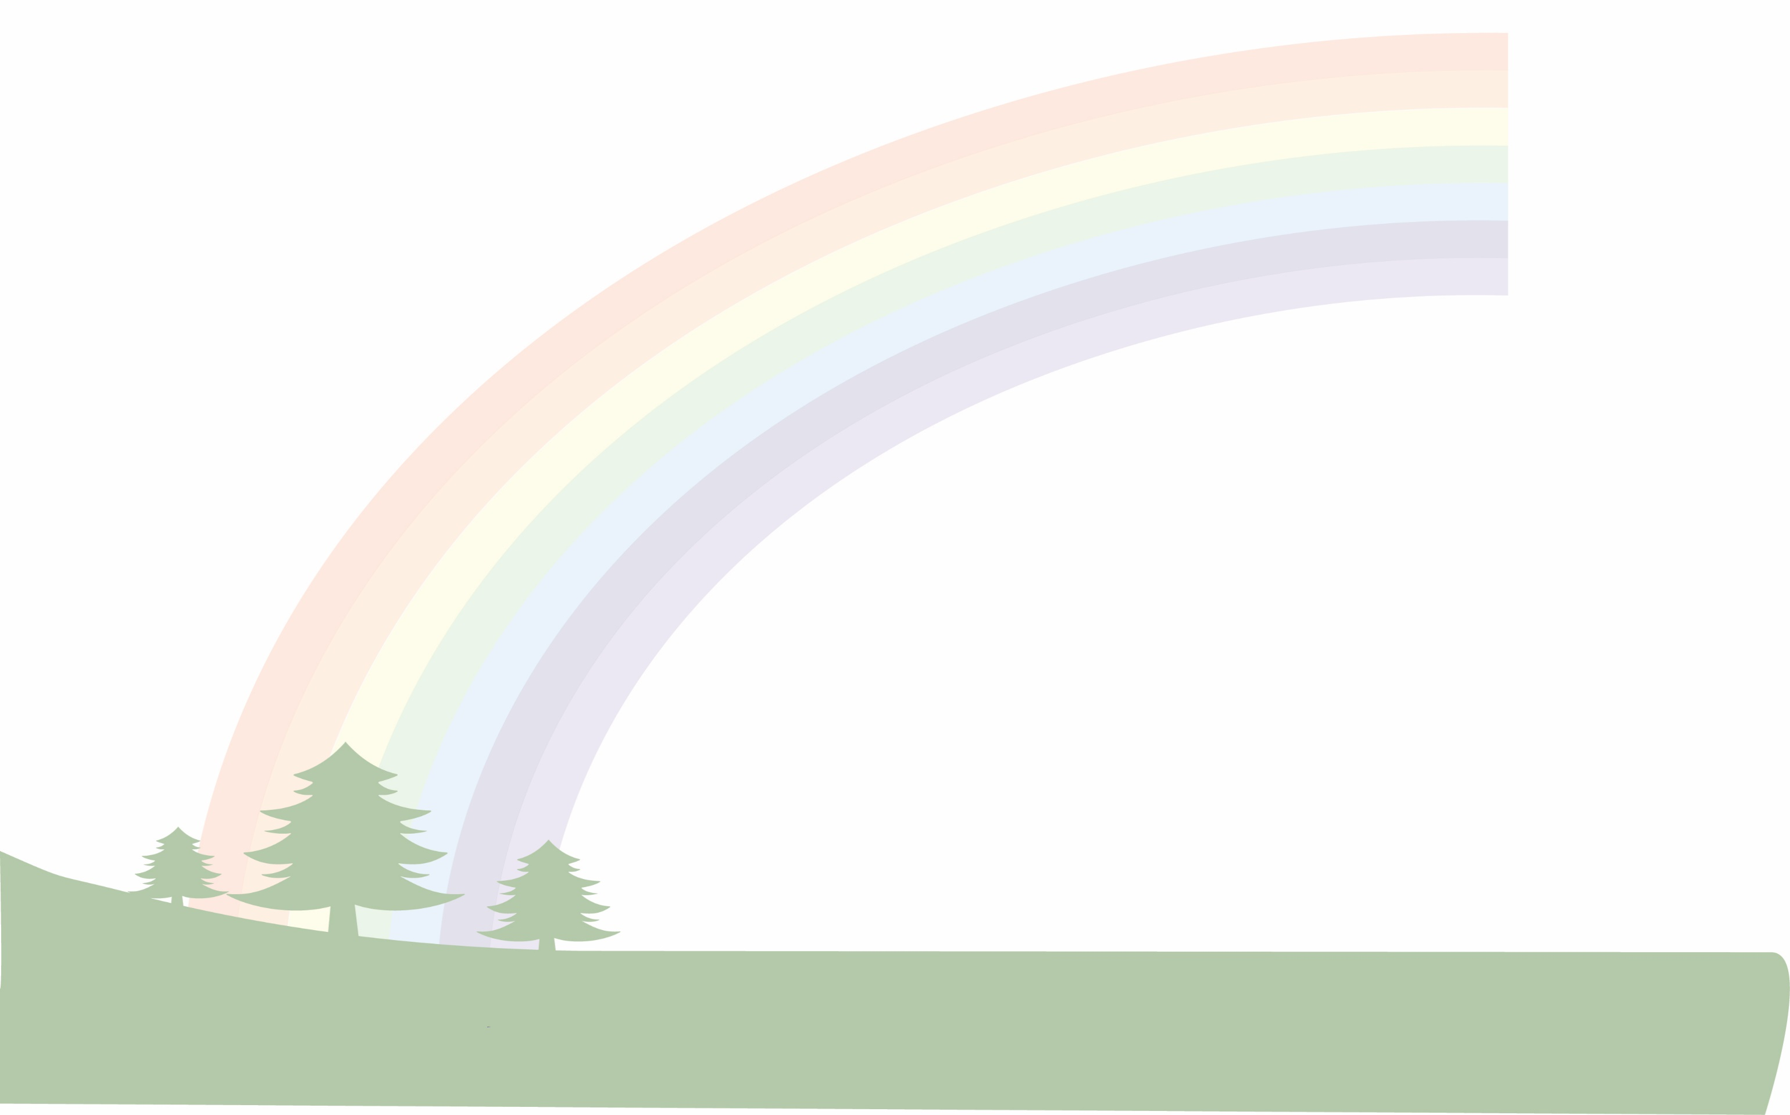
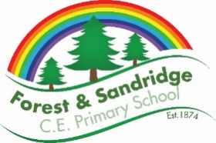
+ Art and Design – Whole school overview

FS1 | Expressive Art and Design  Expressive Arts and Design fosters imagination, curiosity, creativity, cognition, critical thinking and experimentation and provides opportunities to improvise, collaborate, interact and engage in sustained shared thinking. It requires time, space and opportunities to re-visit and reflect on experiences. Multi-sensory, first-hand experiences help children to connect and enquire about the world. Appreciating diversity and multiple perspectives enriches ways of thinking, being, and understanding.  Drawing- across the year our children will have opportunities to mark make with a variety of tools on a very large scale.  Painting- investigate with chunky brushes, nature brushes. Explore using different sized brushes and rollers with poster paint, messy mark making tray.  Printing- Create smaller scale printing, roll tyres walk in paint wearing wellies jump, walk, run.  Malleable and sculpture- use pincer scissors to snip.  Threading cotton reels, cards.  Threading cards, large objects, large beads. threading on to chopsticks, wooden rings onto kitchen roll holder.  Progress to using simple tools to manipulate rolling pins, stamps, large cutters when using playdough.  Explore Stickle bricks, Duplo, people and animals.  Use smaller finger movements beginning to develop and use the pincer grip for emergent drawing, tweezers- different sized objects of differing shape, size, texture, pasta of different shapes, gears.  For more detail please see FS1 Breadth of study.
FS2 | Expressive Art and Design  Children will explore, use and refine a variety of artistic effects to express their ideas and feelings. Children will be able to recognise the work of famous artists and take inspiration from their work. Children will be able to express how they feel about the work of the artist they are studying. Children will work to create collaboratively, sharing ideas, resources and skills, as well as independently. Children will learn the skill of returning to and building on their work, refining ideas and developing their ability to represent them.  For more detail please see FS2 Breadth of study.
FS2 | 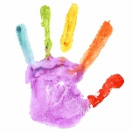  We are Artists | Kandinsky  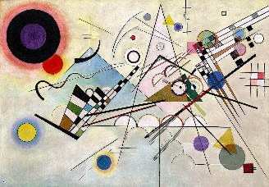 |  | Jackson Pollock  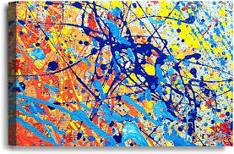 | Van Gough  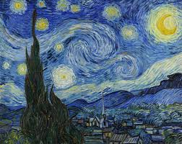 |  | Monet  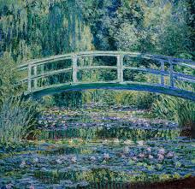 |  | Local Artist- Sue Faux  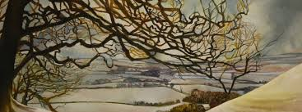
 | Term 1 or 2  Drawing |  | Term 3  Collage/Mosaic |  |  | Term 4 or 5  Painting |  | Term 6  Sculpture
KS1 Year B | Movement: Fauvism  Art area: Drawing  Artist: Maurice de Vlaminck  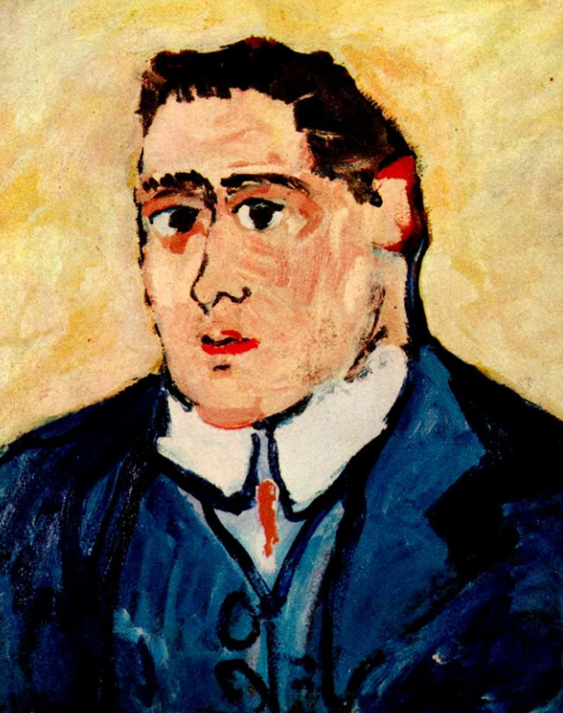  Outcome: Drawing self-portraits- including characteristics of the movement. |  |  |  |  | Movement: Fauvism  Art area: Painting  Artist: André Derain  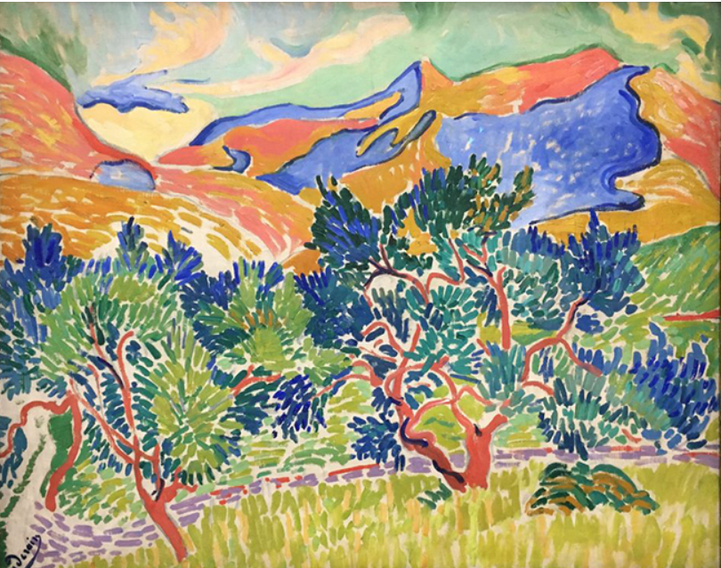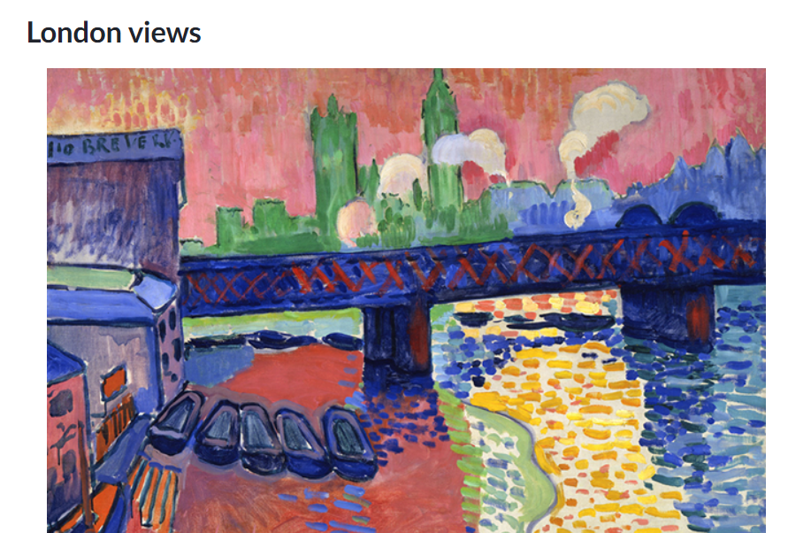  Outcome: Painted landscape- including characteristics of the movement. |  | Movement: Fauvism  Art area: Sculpture  Artist: Kirt Tisdale  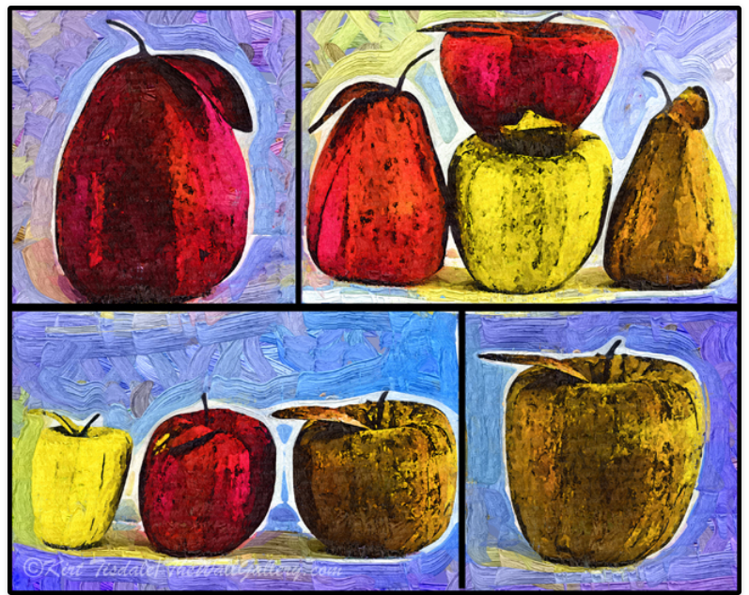  Outcome: Clay sculpture of a piece of fruit- using characteristics of the moment.
KS1 Year A | Movement: Impressionism  Art area: Drawing  Artist: Monet  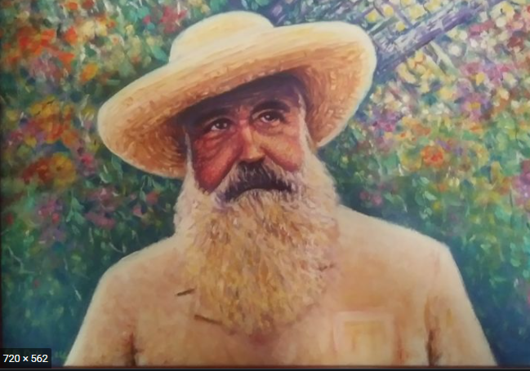  Outcome: Self-Portraits - using knowledge and skills - including characteristics from art movement. |  | Movement: Impressionism  Art area: Collage  Artist: Everett Spruill  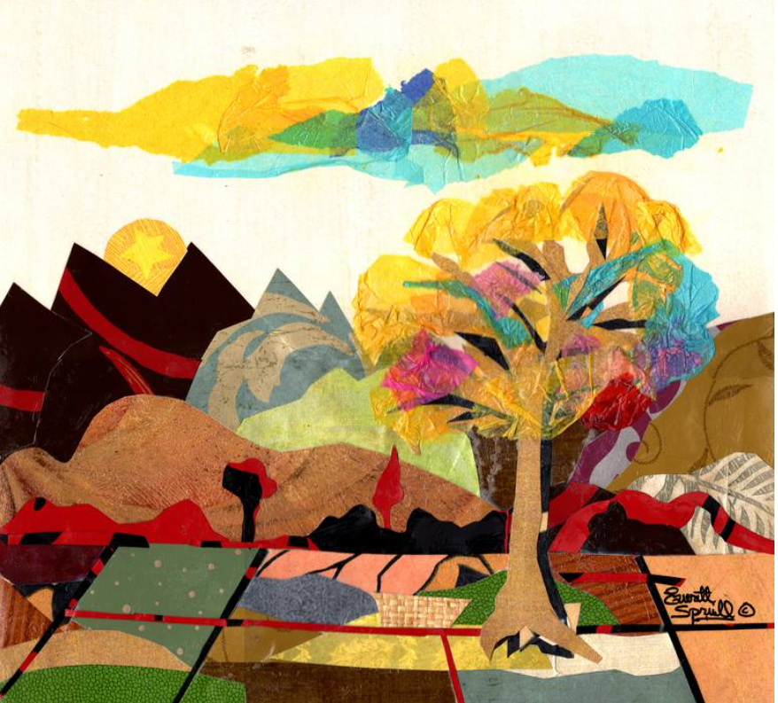  Outcome: 3D Art (collage) Landscapes - using knowledge and skills - including characteristics from art movement. |  |  | Movement: Impressionism  Art area: Painting  Artist: Sharon Hackman (modern impressionist)  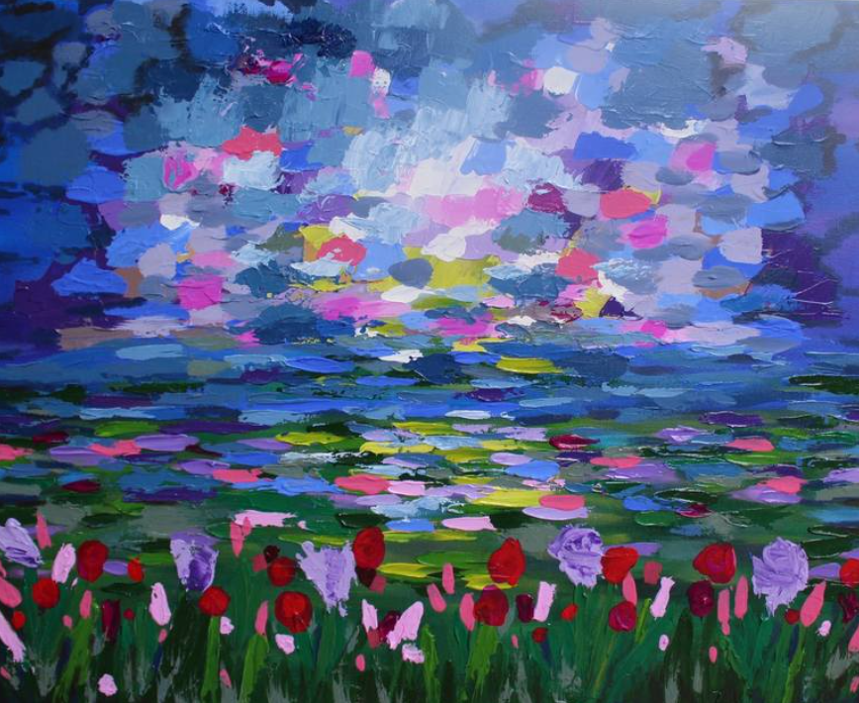  Outcome: Painted Landscape - using knowledge and skills - including characteristics from art movement.
LKS2  Year B | Movement: Cubism  Art area: Drawing  Artist: Picasso  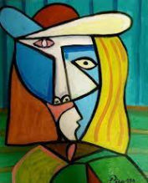  Outcome: Self-Portraits. |  |  |  |  | Movement: Cubism  Art area: Water colours  Artist: Albert Gleizes  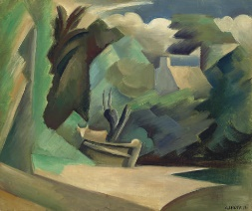  Supplementary artist:  Dame Louise Henderson  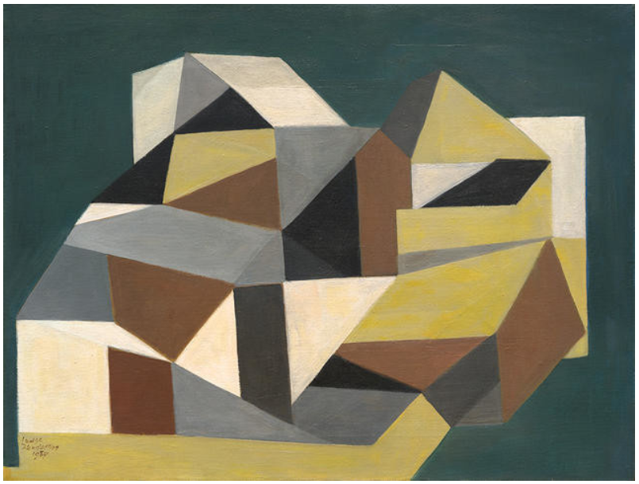  ‘The farm house in Cornwall’.  Outcome: Painted landscape. |  | Movement: Cubism  Art area: Sculpture  Artist: Svetlana Koženová  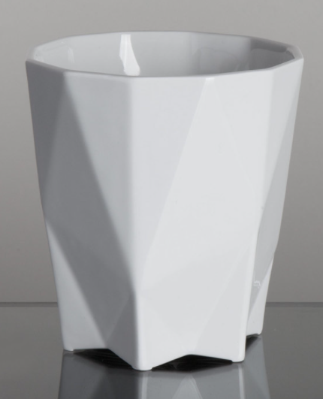  Outcome: Clay cup
LKS2  Year A | Movement: Expressionism  Art area: Drawing  Artist : Munch  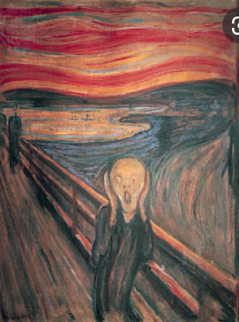  Outcome: Self-Portraits. |  | Movement: Expressionism  Art area: 3D art- Mosaic landscapes  Artist: Rachel Olynuk (modern day artist)  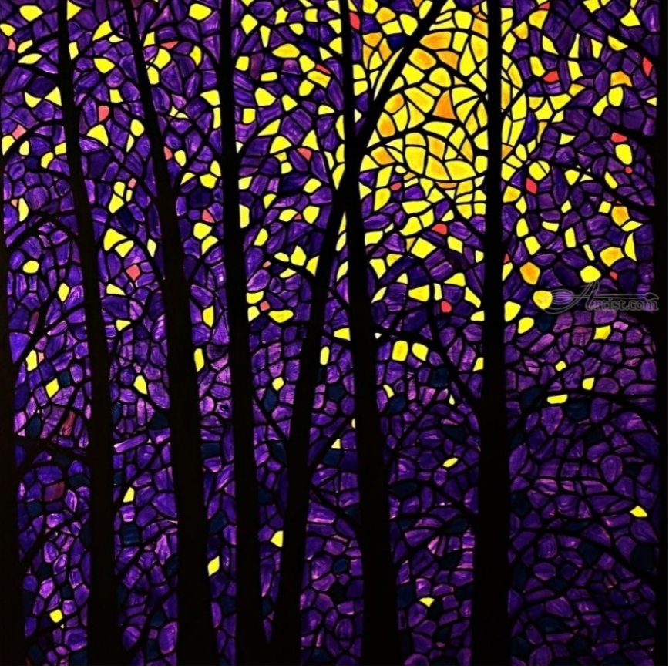  Outcome: Mosaic landscapes. |  |  | Movement: Expressionism  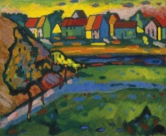  Art area: Water colour landscapes  Artist: Kandinsky  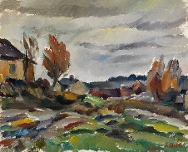  Supplementary artists that could be used:  Ilmari Aalto  Outcome: Painted landscape.
UKS2 Year B | Movement: Pop art  Art area: Drawing  Artist: Warhol  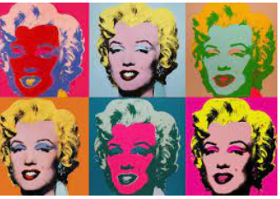Outcome: Self-Portraits in the Pop art style. |  |  |  |  | Movement: Pop art  Art area: Landscapes Poster paint, water colours and acrylics  Artist: Alejois Lorenzo  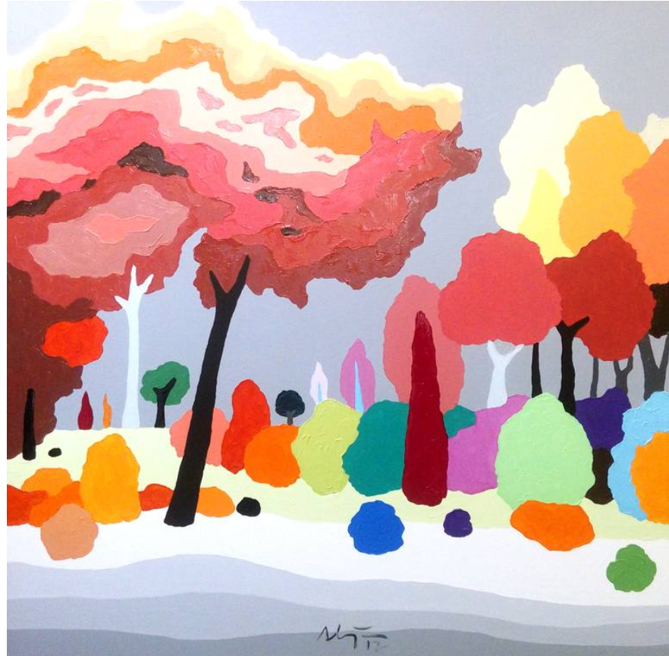  Outcome: Painted Landscape using knowledge and skills - including characteristics from art movement.  Year 6 will complete this in term 3. |  | Movement: Pop art  Art area: Sculpture  Artist: Gardani  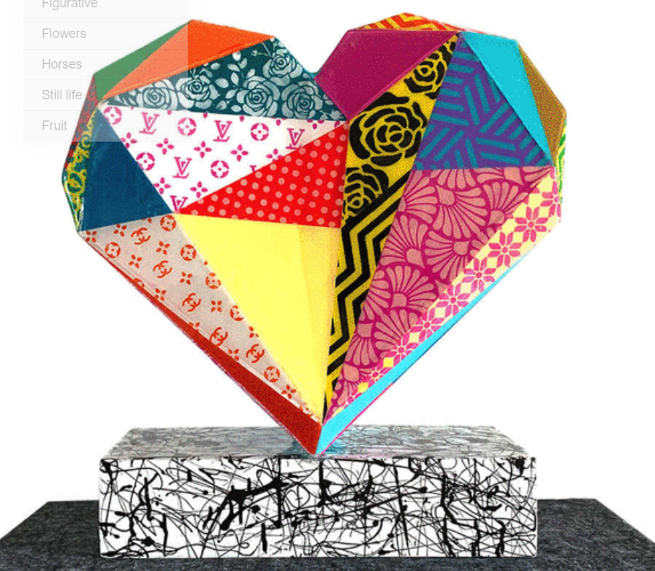  Outcome: Clay, including wires for structure.
UKS2 Year A | Movement: Surrealism  Art area: Drawing  Artist: Dali  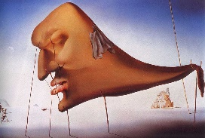  Outcome: Self-Portraits. |  | Movement: Surrealism  Art area: 3D art (mosasic) landscapes  Artist: Look at the actual mosaic aspect of this, when designing looking at Surrealism artists.  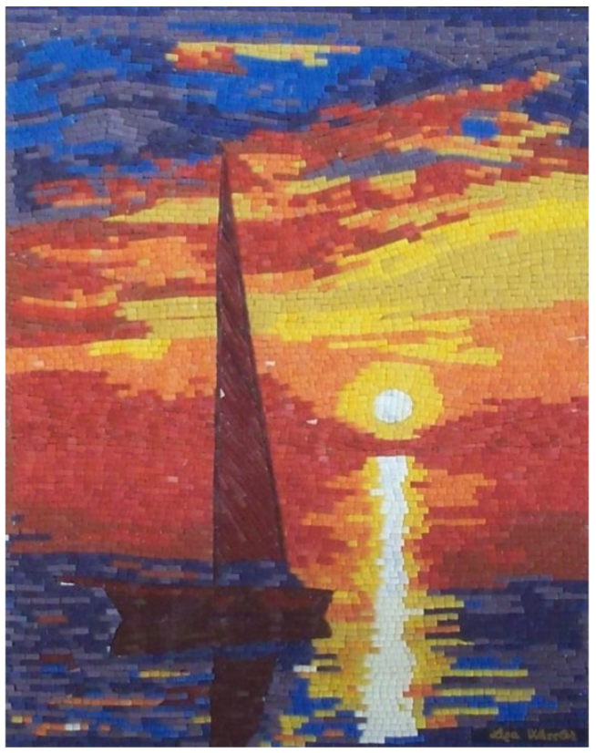  Liza Wheeler  Outcome: Mosaic Landscape using knowledge and skills - including characteristics from art movement. |  |  |  |  | Movement: Surrealism  Art area: Landscapes  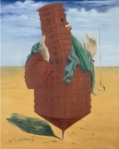  Artist: Max Ernst  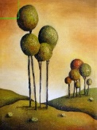  Supplementary artists that could be used:  Leah Saulnier  Outcome: Watercolours + Acrylics painted landscapes.

