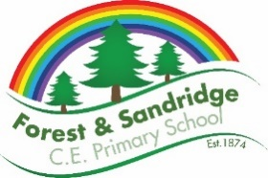
+ Art and Design – Whole school overview

 | Term 1 or 2  Drawing | Term 3  Collage/Mosaic | Term 4 or 5  Painting | Term 6  Sculpture
EYFS | For further information please see EAD EYFS Document.
KS1 Year B  2023-24 | Movement: Fauvism  Art area: Drawing  Artist: Maurice de Vlaminck  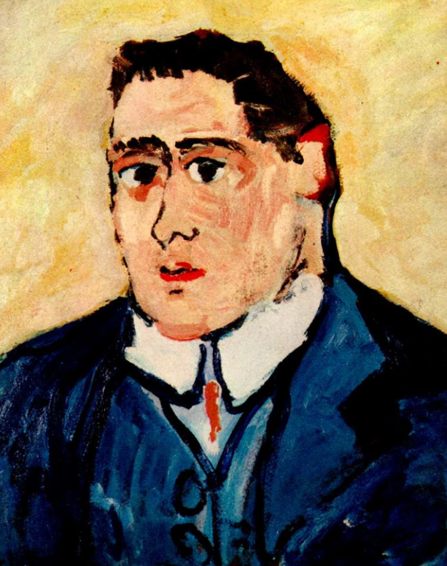  Outcome: Drawing self-portraits- including characteristics of the movement. |  | Movement: Fauvism  Art area: Painting  Artist: André Derain  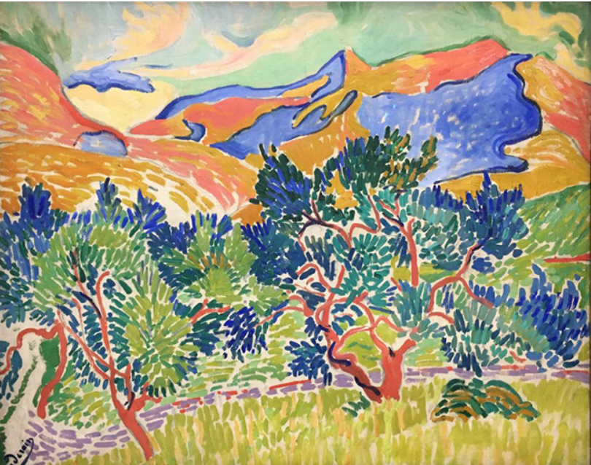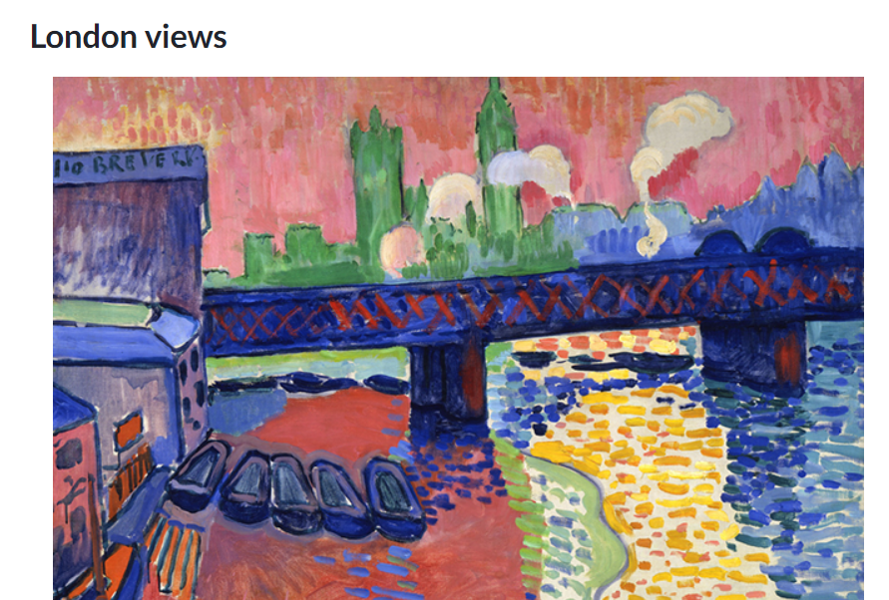  Outcome: Painted landscape- including characteristics of the movement. | Movement: Fauvism  Art area: Sculpture  Artist: Kirt Tisdale  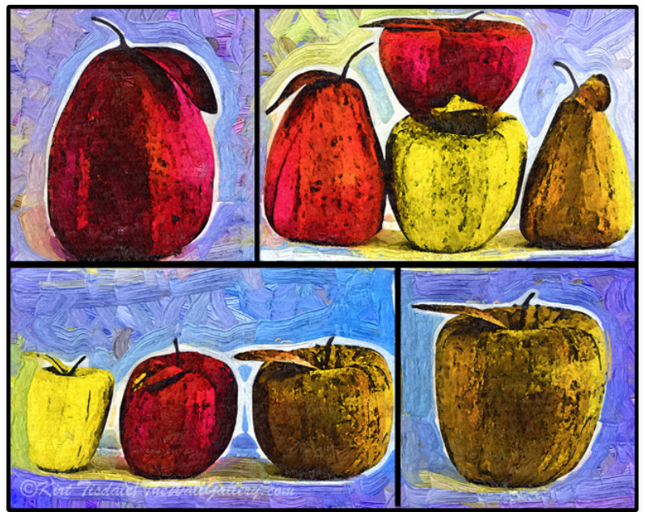  Outcome: Clay sculpture of a piece of fruit- using characteristics of the moment.
KS1 Year A  2024 - 25 | Movement: Impressionism  Art area: Drawing  Artist: Monet  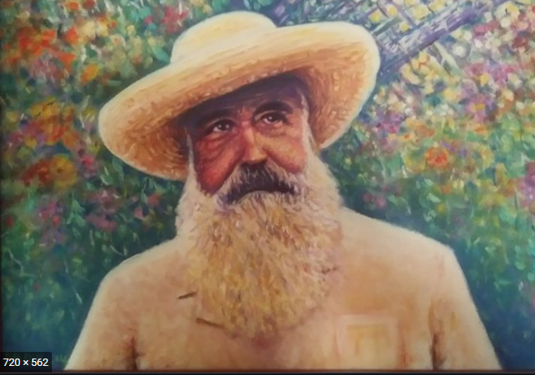  Outcome: Self-Portraits - using knowledge and skills - including characteristics from art movement. | Movement: Impressionism  Art area: Collage  Artist: Everett Spruill  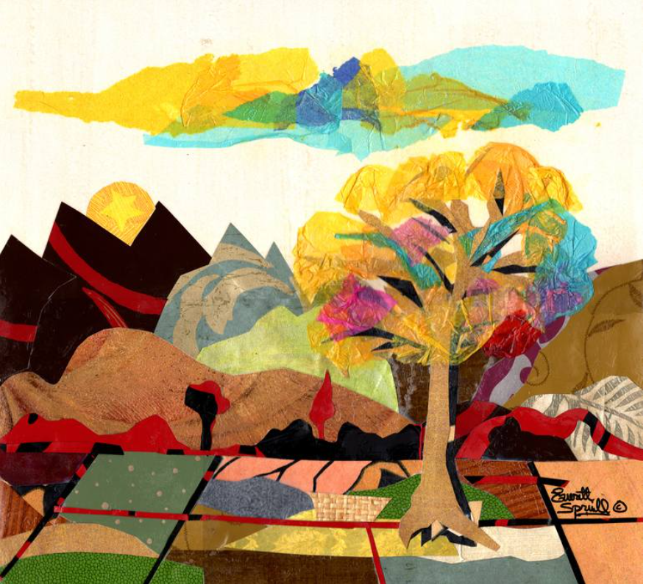  Outcome: 3D Art (collage) Landscapes - using knowledge and skills - including characteristics from art movement. | Movement: Impressionism  Art area: Painting  Artist: Sharon Hackman (modern impressionist)  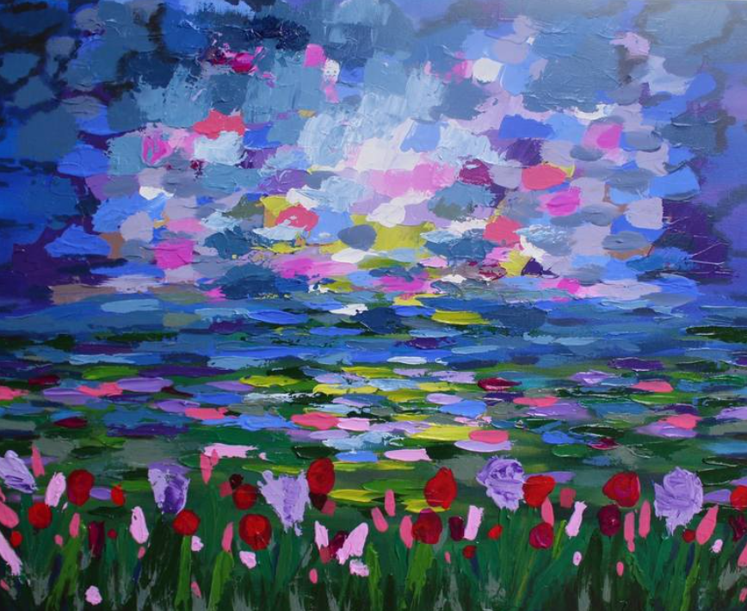  Outcome: Painted Landscape - using knowledge and skills - including characteristics from art movement.
LKS2  Year B  2023-24 | Movement: Cubism  Art area: Drawing  Artist: Picasso  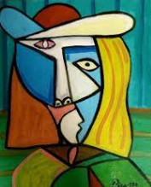  Outcome: Self-Portraits. |  | Movement: Cubism  Art area: Water colours  Artist: Albert Gleizes  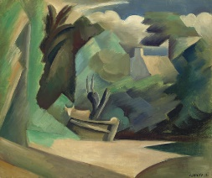  Supplementary artist:  Dame Louise Henderson  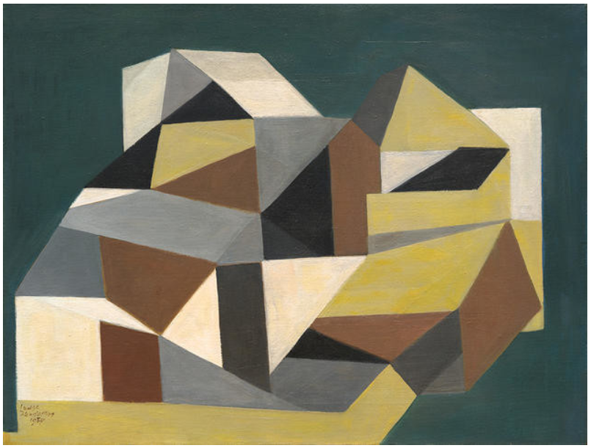  ‘The farm house in Cornwall’.  Outcome: Painted landscape. | Movement: Cubism  Art area: Sculpture  Artist: Svetlana Koženová  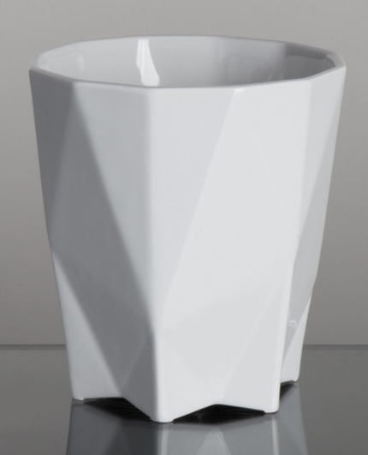  Outcome: Clay cup
LKS2  Year A  2024-25 | Movement: Expressionism  Art area: Drawing  Artist : Munch  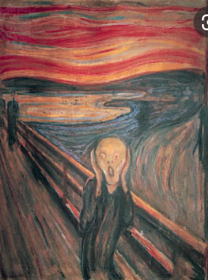  Outcome: Self-Portraits. | Movement: Expressionism  Art area: 3D art- Mosaic landscapes  Artist: Rachel Olynuk (modern day artist)  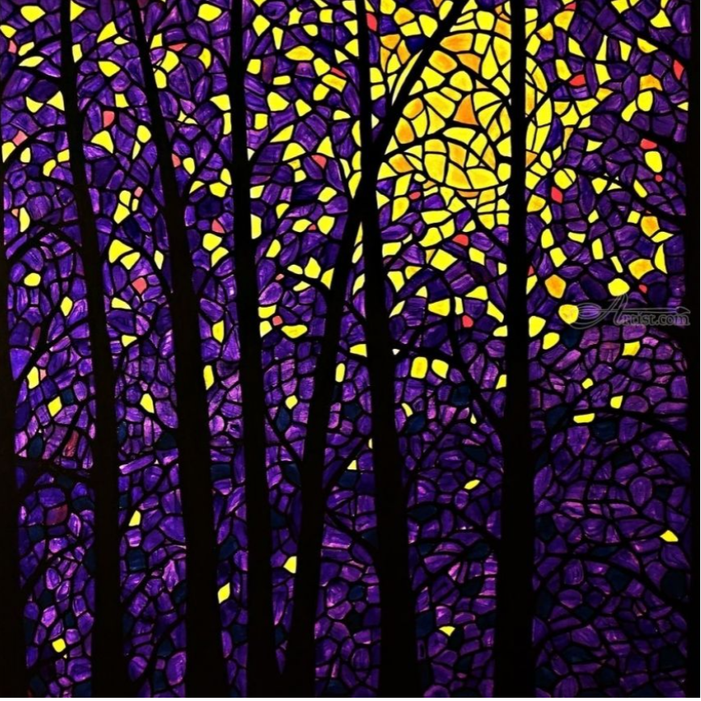  Outcome: Mosaic landscapes. | Movement: Expressionism  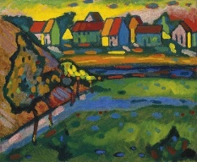  Art area: Water colour landscapes  Artist: Kadinsky  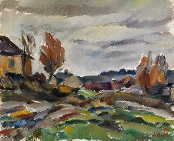  Supplementary artists that could be used:  Ilmari Aalto  Outcome: Painted landscape.
UKS2 Year B  (2023-24) | Movement: Pop art  Art area: Drawing  Artist: Warhol  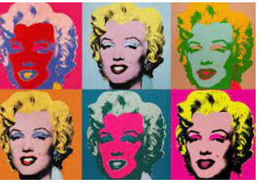Outcome: Self-Portraits in the Pop art style. |  | Movement: Pop art  Art area: Landscapes Poster paint, water colours and acrylics  Artist: Alejois Lorenzo  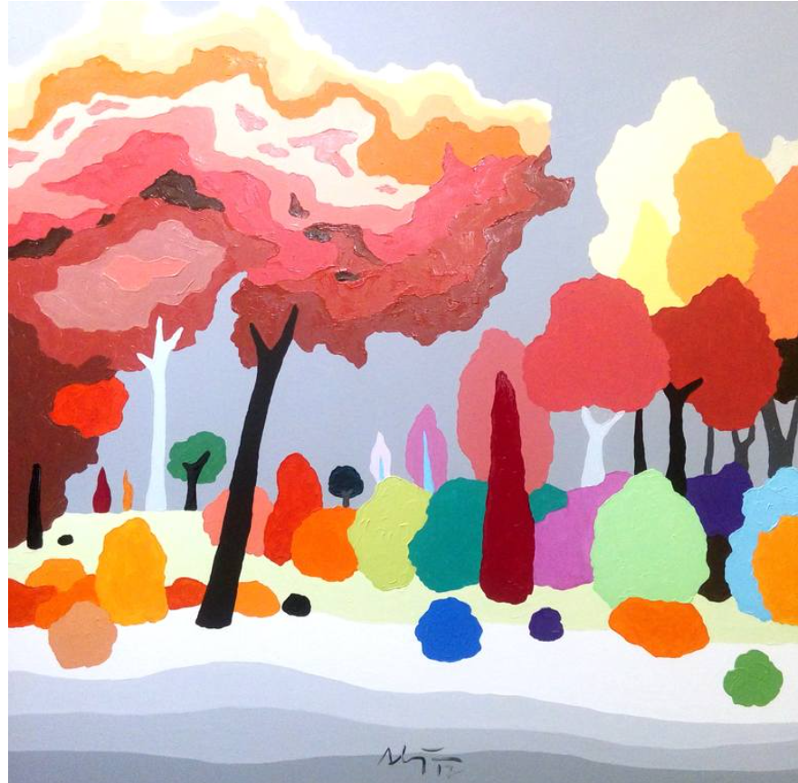  Outcome: Painted Landscape using knowledge and skills - including characteristics from art movement.  Year 6 will complete this in term 3. | Movement: Pop art  Art area: Sculpture  Artist: Gardani  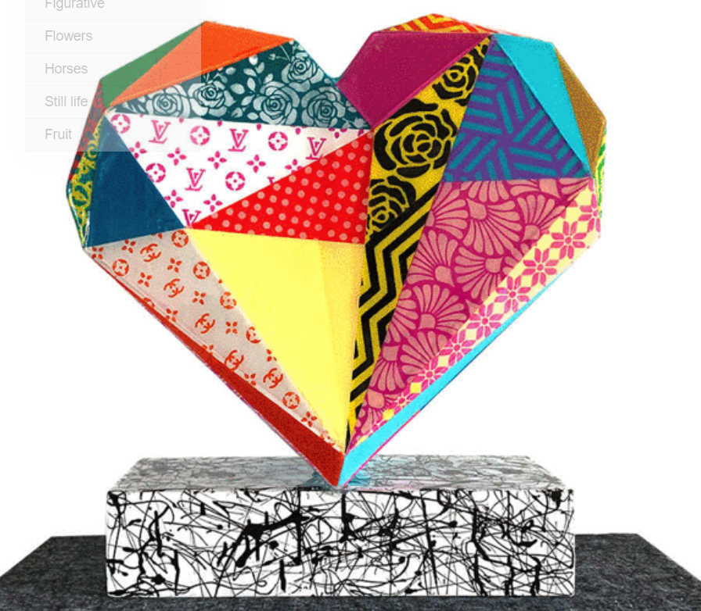  Outcome: Clay, including wires for structure.
UKS2 Year A  2024/25 | Movement: Surrealism  Art area: Drawing  Artist: Dali  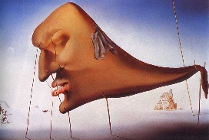  Outcome: Self-Portraits. | Movement: Surrealism  Art area: 3D art (mosasic) landscapes  Artist: Look at the actual mosic aspect of this, when designing looking at Surrealism artists.  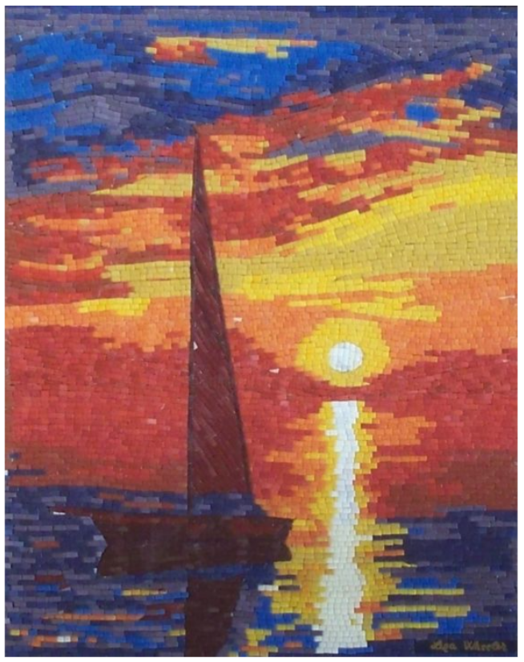Outcome: Mosaic Landscape using knowledge and skills - including characteristics from art movement. | Movement: Surrealism  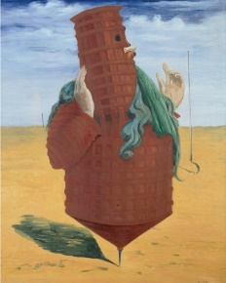  Art area: Landscapes  Artist: Max Earnst  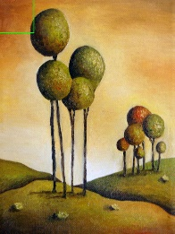  Supplementary artists that could be used:  Leah Saulnier  Outcome: Watercolours + Acrylics painted landscapes.

