‘ | Term 1 | Term 2 | Term 3 | Term 4 |  | Term 5 |  | Term 6
EYFS | For further information please see EAD EYFS Document.
Year 1 |  | Mechanisms |  |  | Structures |  | Food
Year 2 | Textiles |  | Mechanisms |  |  | Food
Year 3 |  | Structures | Mechanisms |  |  | Textiles
Year 4 |  | Mechanisms |  |  | Electrical systems |  | Food
Year 5 |  | Textiles | Mechanisms |  |  | Electrical systems
Year 6 | Structures |  |  |  | Digital Media | Food
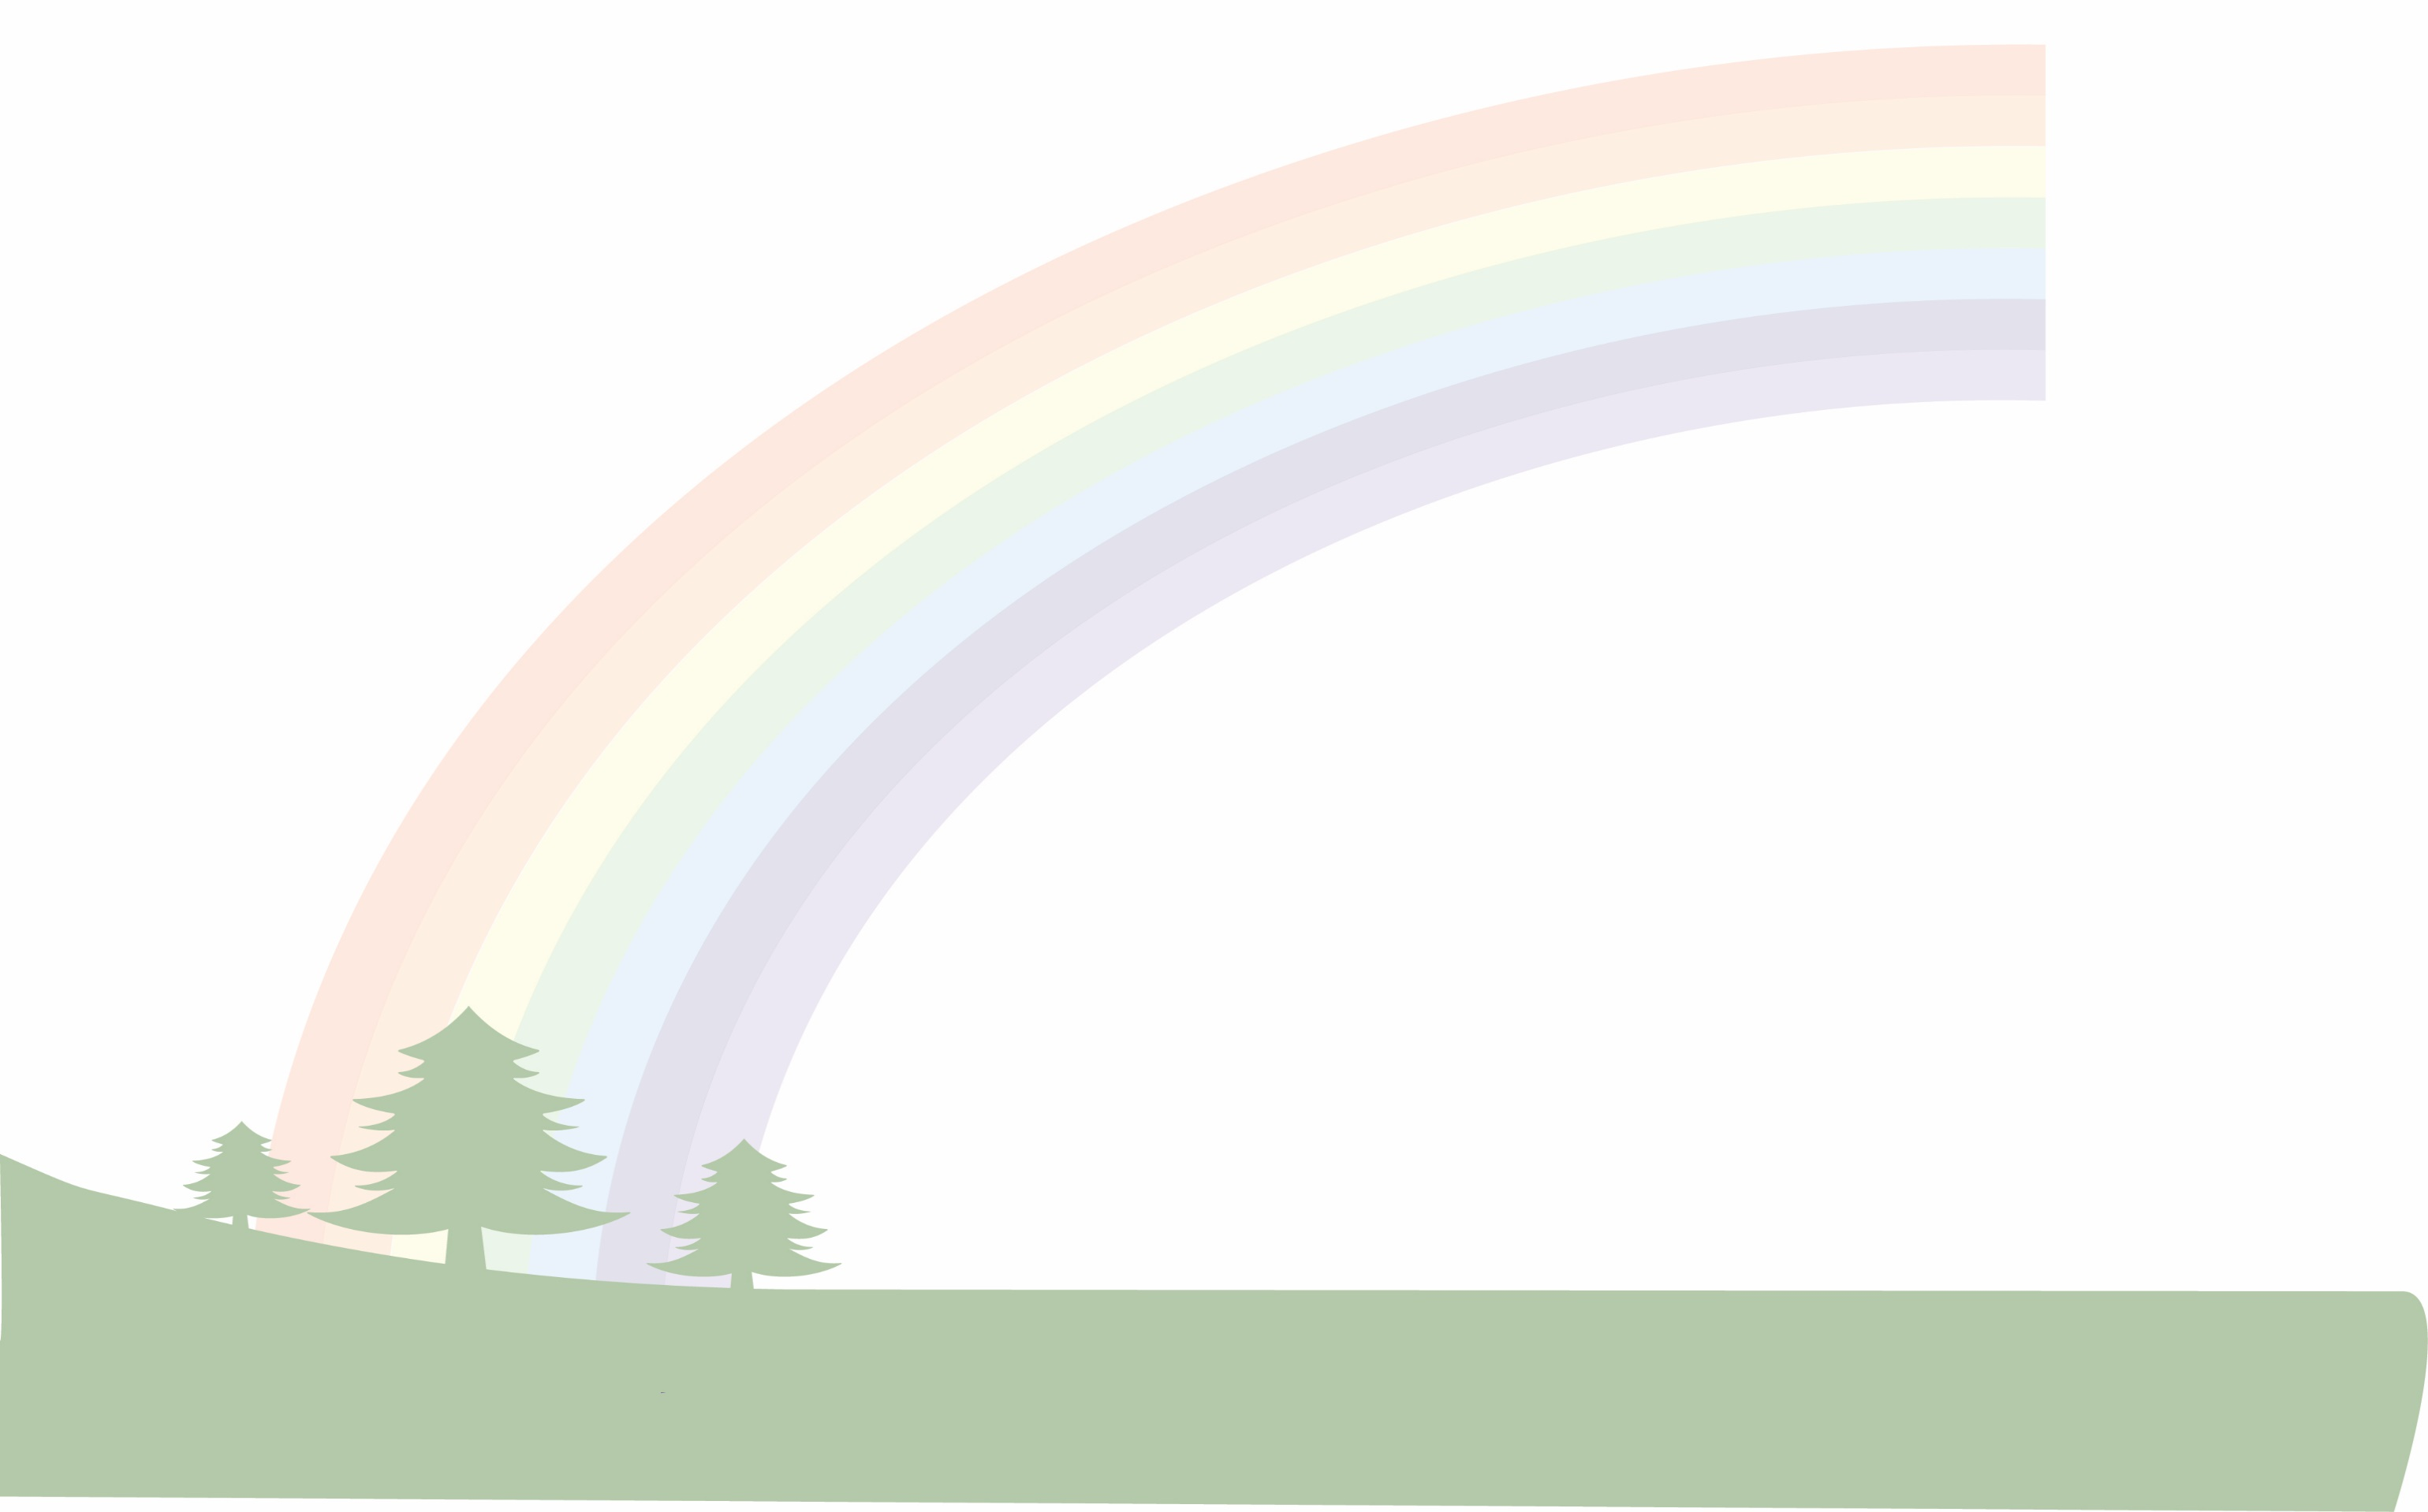
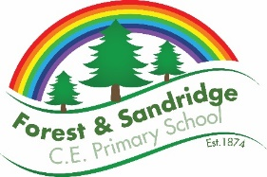
Design and Technology – Whole school overview

