|  |  |  |  |  |  |  |
| --- | --- | --- | --- | --- | --- | --- |
|  | Unit 1 | Unit 2 | | Unit 3 | | |
| **EYFS FS1** | Children will be exploring how to create using a variety of joining skills with materials such as wood, fabric and hardboard. Children will use tools such as hammers, screw drivers, hand drill and sand paper. Children will be taught how to use these tools and materials safely. | | | | | |
| **EYFS FS2** | Children will be learn how to use different types of wood to create desired outcome. For example balsa and pine. Children will use palm drills, hammers, screw fixers, small pull saws. Children will be taught how to use these tools and materials safely.  For further information please see our Woodwork progression. | | | | | |
| Year 1/2 Year A | Mechanisms  Moving Parts | Structures  Windmill | | Cooking and Nutrition: Wraps | | |
| Year 1/2 Year B | Textiles Pouches/Bunting | Structures  Baby Bear’s Chair | | Mechanisms  Wheels and Axels | |
| Year 3 | Digital World  Wearable Technology | Structures  Pavilions | | Cooking and nutrition  Adapting a Recipe | |
| Year 4 | Textiles: Ancient Egypt | Mechanisms  Making a slingshot car | | Electrical Systems  Torches |
| Year 5 | Structures  Bridges | Digital World  Monitoring Devices | Cooking and nutrition  Come Dine with Me | | | |
| Year 6  24-25 | Cooking and nutrition  Come Dine with Me | Digital World  Monitoring Devices | Structures  Bridges | | | |
| Year 6 | Textiles  Stuffed Toys | Mechanisms  Automata Toys | | Electrical Systems  Steady Hand Game | | |

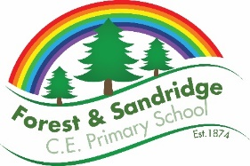 Design and Technology – Whole school overview