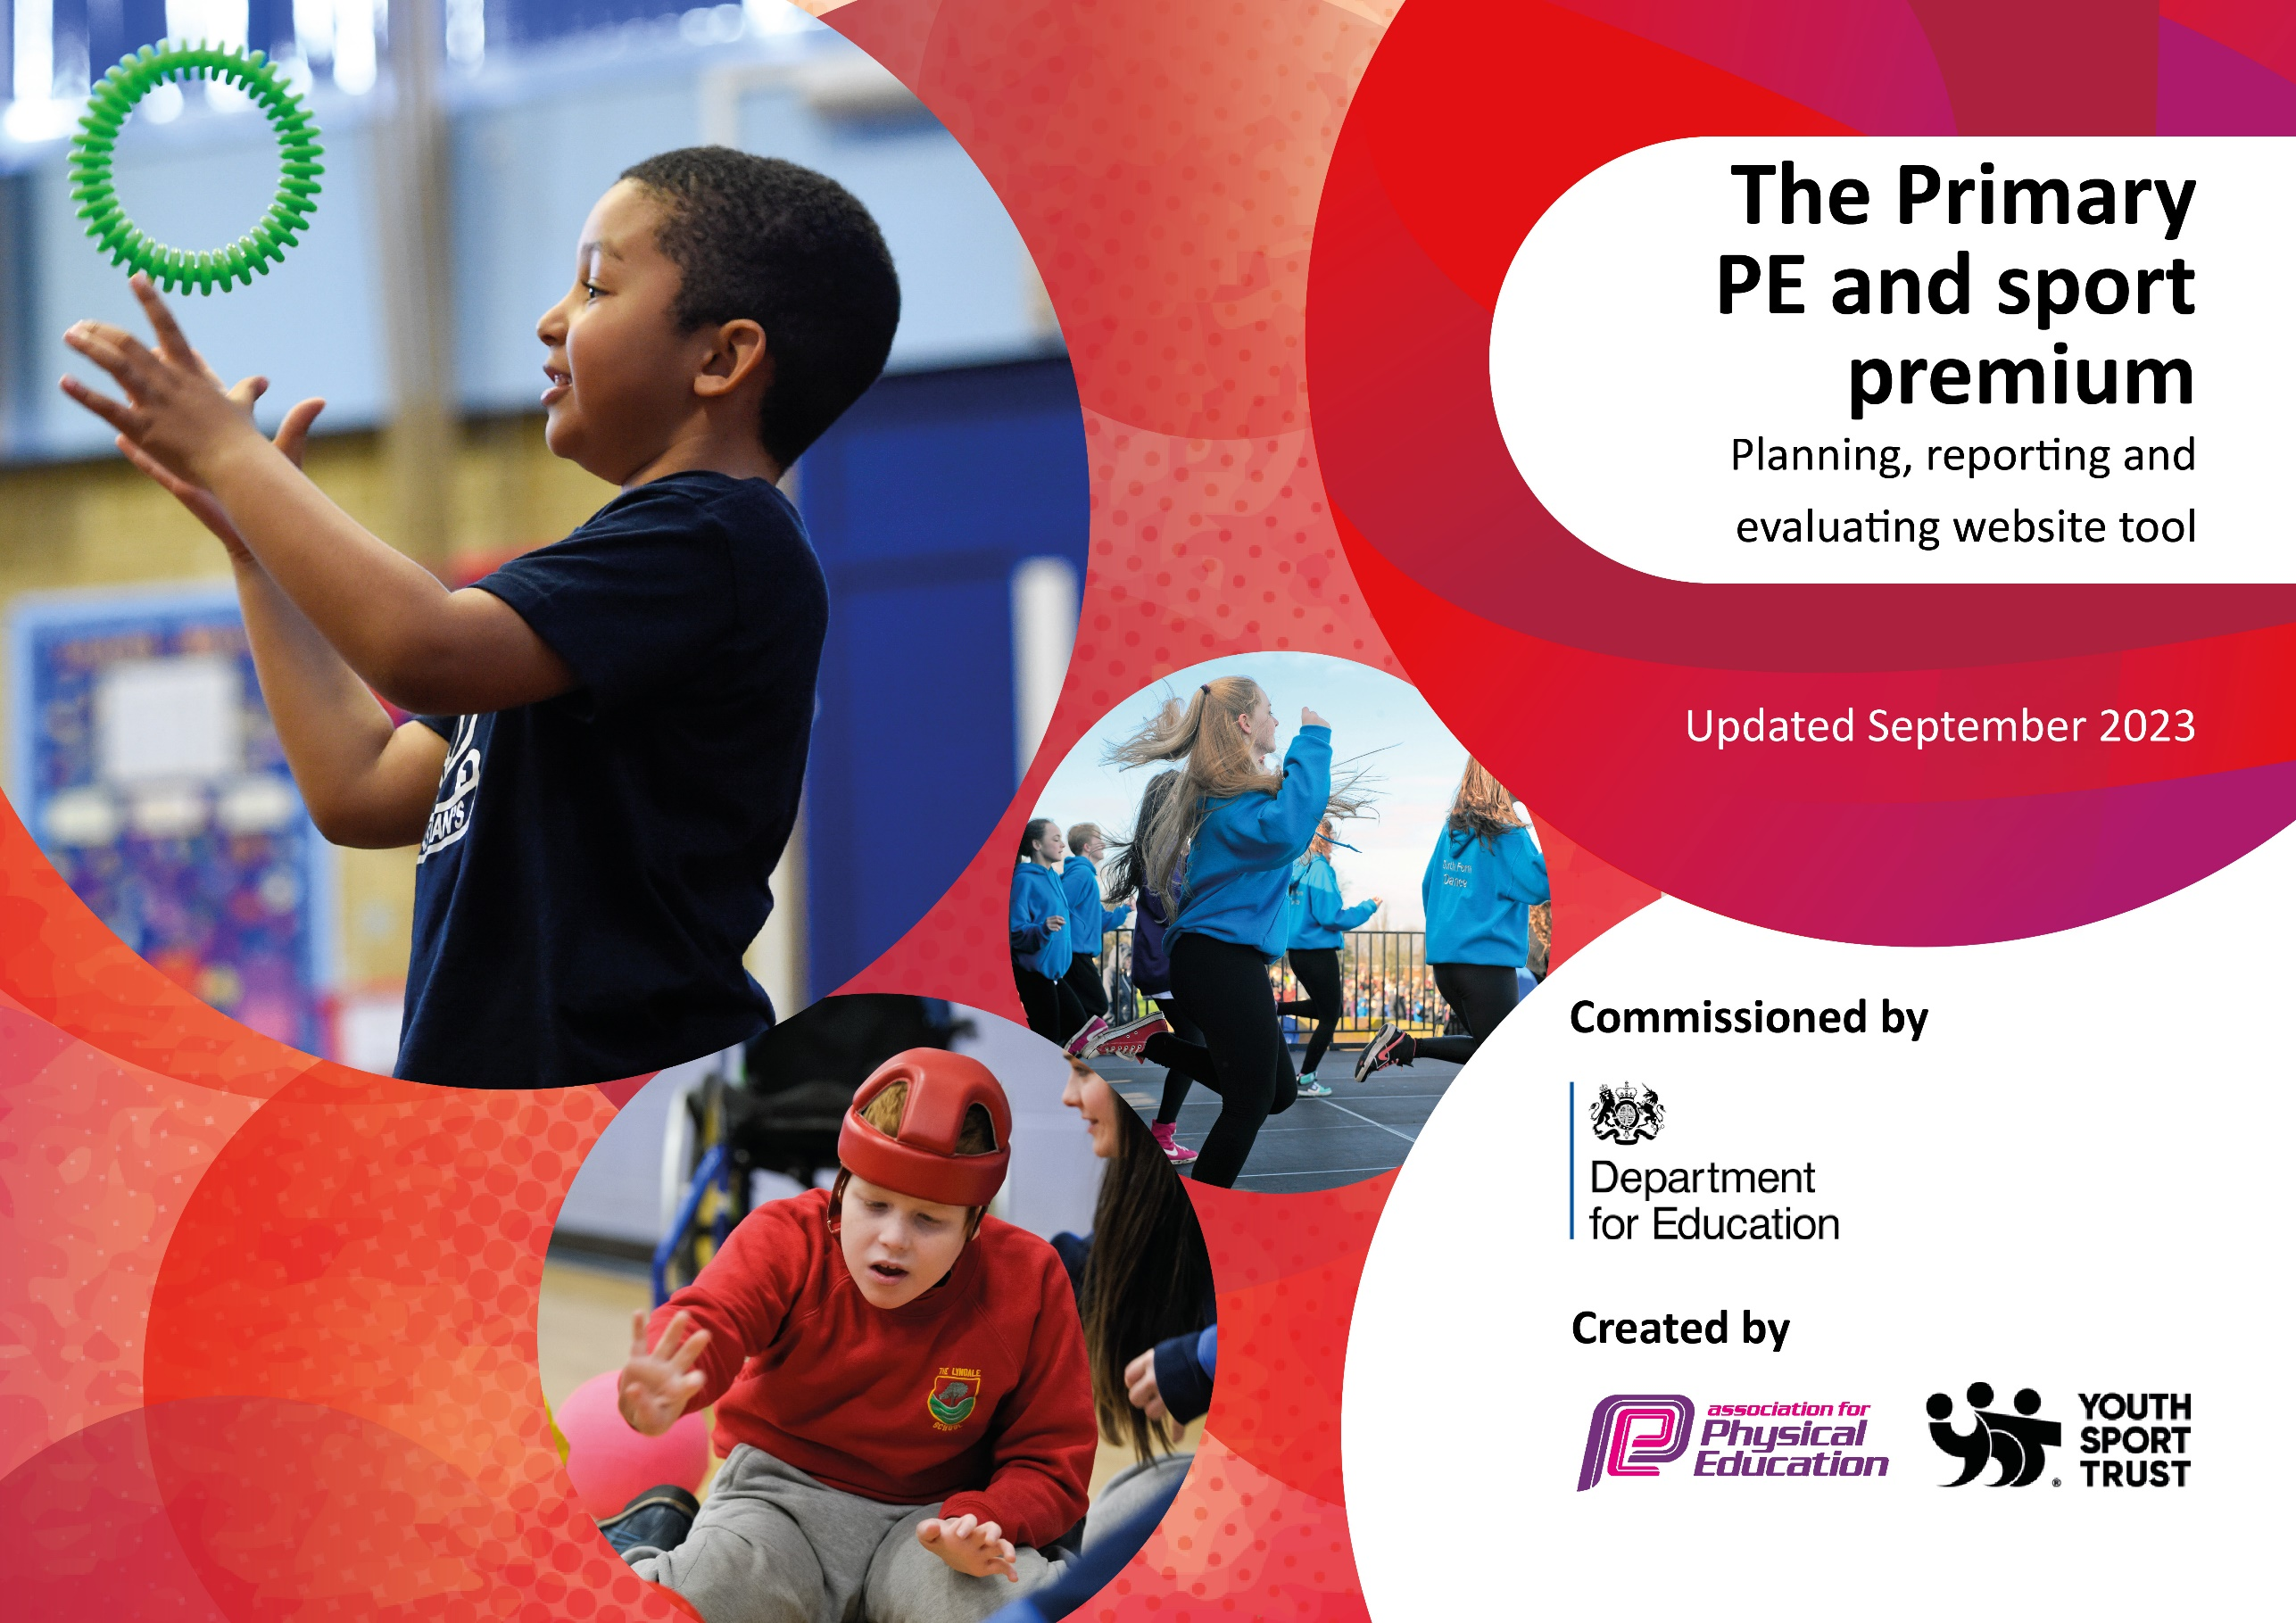

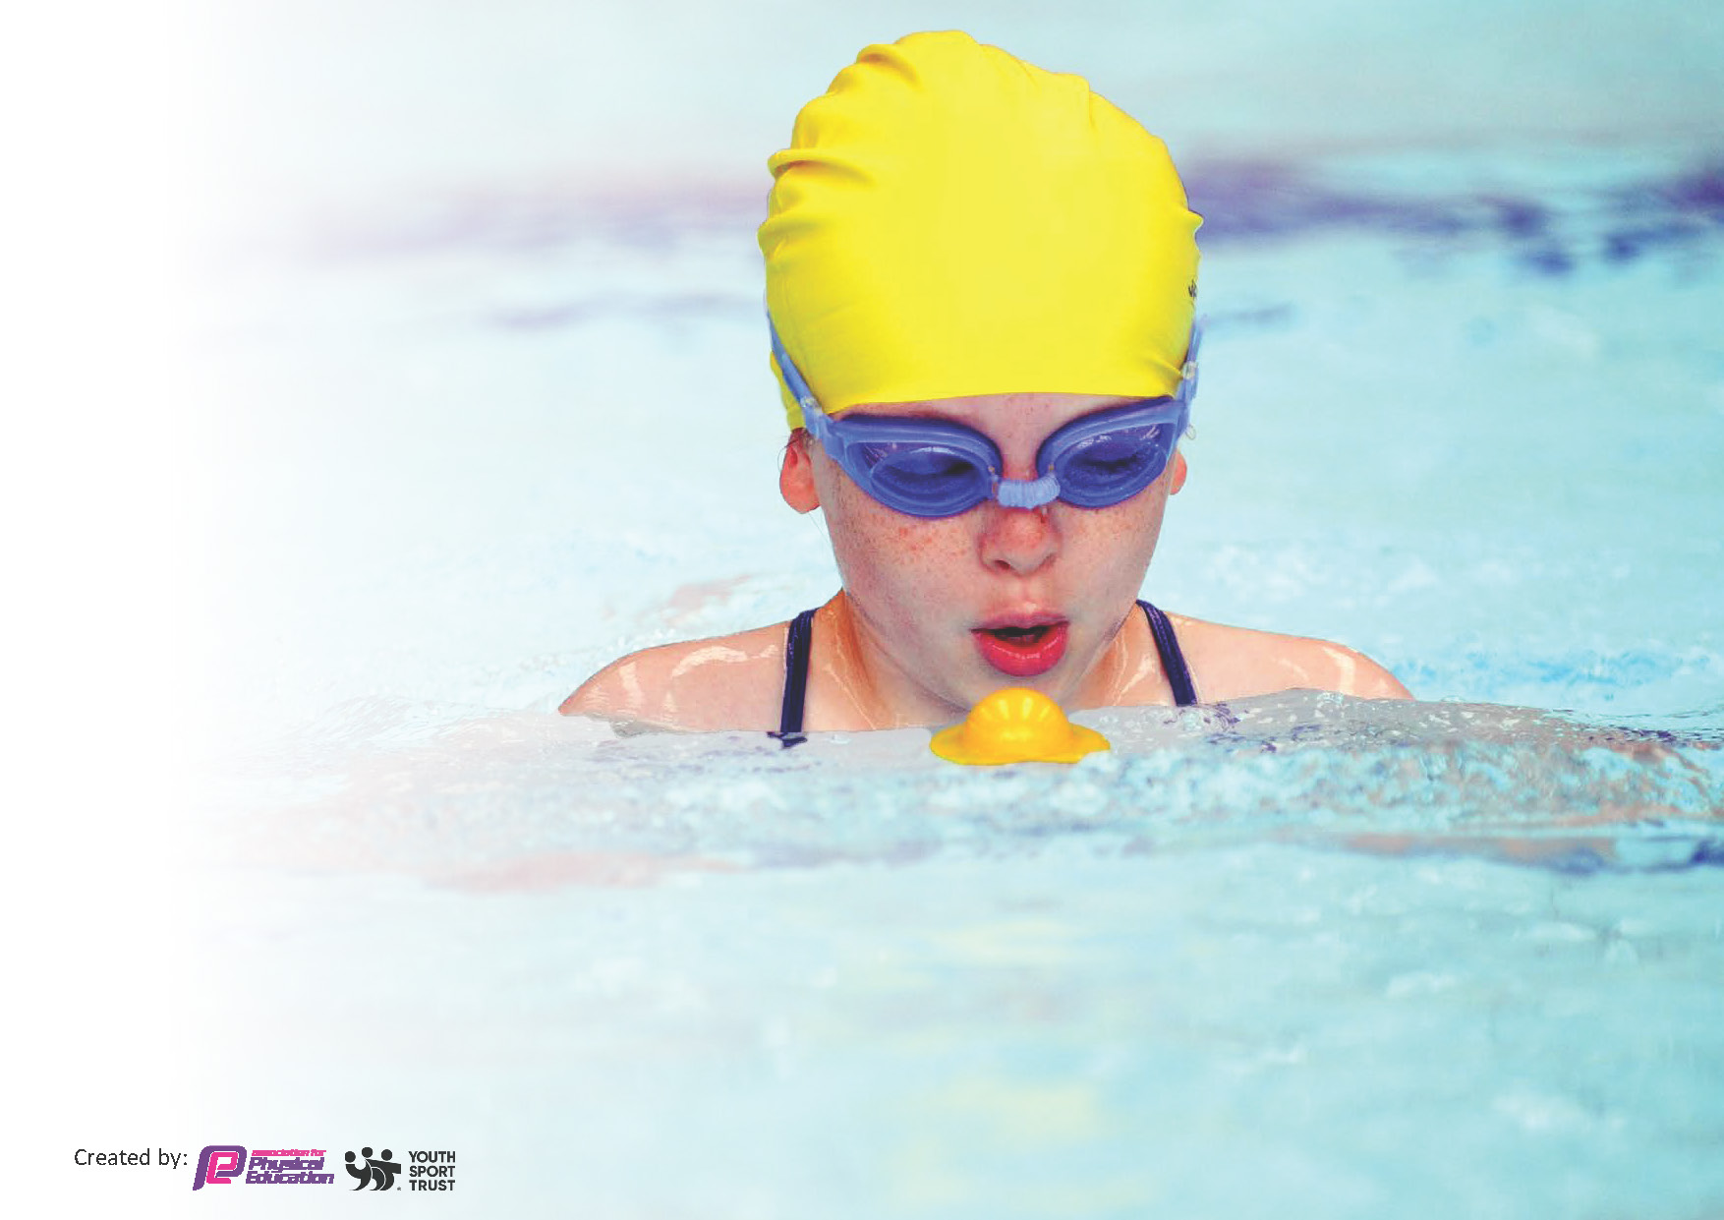
This template can be used for multiple purposes:
by:
- It enables schools to effectively plan their use of the Primary PE and sport premium
- It helps schools to meet the requirements (as set out in guidance) to publish information on their Primary PE and sport premium
- It will be an effective document to support Ofsted inspections enabling schools to evidence progress in Physical Education (PE) and evidence swimming attainment, which forms part of the PE National Curriculum. We would recommend schools consider
the Intent, Implementation and Impact of any spend, as examined within the Education Inspection Framework.

It is important that your grant is used effectively and based on school need.

Schools must use the funding to make additional and sustainable
improvements to the quality of the PE, School Sport and Physical Activity (PESSPA)
they offer. This means that you should use the Primary PE and sport premium to:

- Build capacity and capability within the school to ensure that improvements made now will benefit pupils joining the school in future years
- Develop or add to the PESSPA activities that your school already offers.

The Primary PE and sport premium should not be used to fund capital spend projects; the school’s core budget should fund these. Further detail on capital expenditure can be found in the updated Primary PE and sport premium guidance.

The Primary PE and sport premium guidance, outlines 5 key priorities that funding should be used towards. It is not

necessary that spending has to meet all the key priorities, you should select the priorities that you aim to use any funding towards.

Although completing this template is not a requirement for schools, schools are required to publish details of how they spend this funding. Schools must also outline what the impact this funding has had on pupils’ PE and sport participation and attainment and how any spending will be sustainable in the future. All funding must be spent by 31st July 2024.

The Department for Education has worked closely with the Association for Physical Education (afPE) and the Youth Sport Trust (YST) to develop this template and encourages schools to use it. This template is an effective way of meeting the reporting requirements of the Primary PE and sport premium.

Key priorities and Planning 2024 - 2025
This planning template will allow schools to accurately plan their spending.

Action – what are you planning to do | Who does this action impact? | Key indicator to meet | Impacts and how sustainability will be achieved? | Cost linked to the action
Ensure engagement with targeted competitive sport and festivals to encourage participation for all groups of children including SEND and PP. Time to practice in lead up to competition / festival through a club. E.g SEND dance workshop  Buying equipment to enable the school to offer a wider range of sports within the curriculum and in extra-curricular sessions. E.g. Boccia, Basketball  Subscription to Primary Planning and associated CPD on how to use effectively  Teachers to be supported by specialist Sports Coaches within lessons to create opportunity for CPD  Lunchtime sports provision led by an adult  Enhancement of after school sports club provision with two additional clubs offered from external provider – PH Sports  Children in EYFS to all be able to ride a bike by participation in weekly ‘Balance Ability’ lessons. Maintenance of helmets and bikes.  School Games Subscription and attendance of annual PE conference with Sports Ambassador training for 4 children.  Participation in competitive Sport events with time and clubs for children to practice before the event  Additional capacity of resources to support the new 3G pitch being installed. E.g. goal posts, sports equipment  Increased swimming provision for all pupil above and beyond the national curriculum requirements – swimming offered Year 3 – 6 as identified as a key life skill and promote lifelong physical activity | Pupils, teachers and specialist PE teachers  Pupils, Teachers  Pupils, Teachers  .  Pupils, teachers, sports coaches  Pupils, Teachers, Sports Coaches  Pupils, sports coaches  Pupils, instructor, EYFS teaching team  Sports Leaders, Teachers and Pupils  Pupils, KB  Pupils  Pupils, teachers | Key Indicator 2: Engagement of all pupils in regular physical activity  Key indicator 4: Broader experience of a range of sports and activities offered to all pupils.  Key Indicator 1 and 4: Increased confidence, knowledge and skills of all staff in teaching PE and sport / Broader experience of a range of sports and activities offered to all pupils.  Key Indicator 1: Increased confidence, knowledge and skills of all staff in teaching PE and sport  Key Indicator 1: Increased confidence, knowledge and skills of all staff in teaching PE and sport  Key indicator 4 and 5: Broader experience of a range of sports and activities offered to all pupils and increased participation in competitive sport  Key indicator 2: Engagement of all pupils in regular physical activity  Key indicator 3: The profile of PE and sport is raised across the school as a tool for whole school improvement  Key Indicator 5: Increased Participation in competitive sport  Key indicator 2: Engagement of all pupils in regular physical activity  Key indicator 2: Engagement of all pupils in regular physical activity  Key indicator 4: Broader experience of a range of sports and activities offered to all pupils. | A wider range of pupils participate in competitive sport and festivals  More pupils meeting daily activity goal with wider range and more pupils encouraged to take part in PE and Sport Activities  Teachers become more confident in teaching PE with high quality and detailed planning.  Teachers become more confident and skilled in teaching PE which they can then use in their teaching moving forward.  More pupils meeting their daily physical activity goal, more pupils encouraged to take part in PE and Sport Activities.  More pupils meeting their daily physical activity goal, more pupils encouraged to take part in PE and Sport Activities.  A wider range of sports offered as extra-curricular activities with more pupils being able to participate.  More pupils meeting their daily physical activity goal, more pupils encouraged to take part in PE and Sport Activities.  All pupils can ride a bike by the end of reception promoting lifelong physical activity.  Pupil leadership if PE and sport is encouraged as well as CPD for PE leaders  Pupils are confident to take part in competitive sport and festivals.  More pupils meeting their daily physical activity goal, more pupils encouraged to take part in PE and Sport Activities.  More pupils meeting their daily physical activity goal, more pupils encouraged to take part in PE and Sport Activities.  All children feel water confident and more likely to participate in lifelong physical activity. | £1000.00  £2250.00  £425.00  £3259.64  £1425.00  £3259.64 (nominal charge for commitment)  £1000 (subsidy)  £200.00  £1500.00  £4000.00  £1200.00

Key achievements 2023-2024
This template will be completed at the end of the academic year and will showcase the key achievements schools have made with their Primary PE and sport premium spending.

Activity/Action | Impact | Comments
Subscription to Primary PE and CPD within lessons for teachers | Teachers report a higher confidence in teaching PE lessons. | Continue next year to develop opportunities further and with a wider range of staff
Additional lunchtime provision, enhancement of after school club provision. | More pupils participated in physical activity than in the previous year and more children took part in competitive sport – partnership with FoF supported this. | With FoF partnership ending, explore ways to support competitive sport in the local area by using the new 3G pitch (due spring 2025) to host events.
Number of Pupils participating in competitive sport | More children participating in competitive sport. | Making links with Christ Church school to organise competitive sport for a wider range of children.  Links with FoF to allow access to Melksham wide football tournament – nearly 100 pupils participated over the two events.
Swimming opportunity for all children in KS2 | Although figures in our swimming data has dropped this year, this is due to lower starting point. They had no Year 3 swimming which meant non-swimmers had bigger barriers in year 4. | Continue to monitor data throughout this year.
Balanceability – cycling provision for all reception children | Every child could confidently ride a balance bike by the end of Reception with over 50% being able to ride a pedal bike. | Continue.

Swimming Data
Meeting National Curriculum requirements for swimming and water safety.
Priority should always be given to ensuring that pupils can perform safe self-rescue even if they do not fully meet the first two requirements of the National Curriculum programme of study

Question | Stats: | Further context  Relative to local challenges
What percentage of your current Year 6 cohort can swim competently, confidently and proficiently over a distance of at least 25 metres? | 65% | This has fallen year on year – these children did not participate in swimming during the Year 3 and 4. There was an increase in non-swimmers and non-confident in water pupils at the start of the year who made excellent progress however fell short of this standard.
What percentage of your current Year 6 cohort can use a range of strokes effectively [for example, front crawl, backstroke, and breaststroke]? | 47% | This has fallen year on year – these children did not participate in swimming during the Year 3 and 4. There was an increase in non-swimmers and non-confident in water pupils at the start of the year who made excellent progress however fell short of this standard.

What percentage of your current Year 6 cohort are able to perform safe self-rescue in different water-based situations? | 77% | Use this text box to give further context behind the percentage.
If your schools swimming data is below national expectation, you can choose to use the Primary PE and sport premium to provide additional top-up sessions for those pupils that did not meet National Curriculum  requirements after the completion of core lessons. Have you done this? | Yes/No | Pupils who are identified as non-swimmers participate in a double session to build water confidence and swimming skills to enable them to progress in to the main pool.
Have you provided CPD to improve the knowledge and confidence of staff to be able to teach swimming and water safety? | Yes/No | KB attended CPD ‘Teaching School Swimming’ to enable her to work with a group. This sports in decreased group numbers and the ability to offer more specialist small group teaching for pupils.

Signed off by:

Head Teacher: | Scott James
Subject Leader or the individual responsible for the Primary PE and sport premium: | Liz Bell
Governor: | Simon Lawrence
Date: | 23/07/2024

