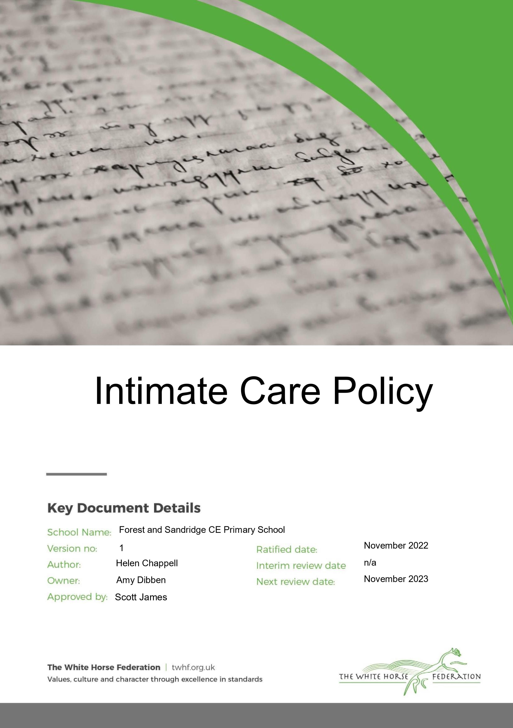

Author: James Mead Approver: Scott James

Owner: Scott James Version No: 2

Date: September 2025 Next review: July 2027

Ratified: July 2024

**Intimate Care Policy**

# Introduction

It is our intention to develop independence in each child, however there will be occasions when help is required. Intimate care is any care which involves washing, touching or carrying out an invasive procedure (such as cleaning up a child after they have soiled themselves) to intimate personal areas. In most cases such care will involve cleaning for hygiene purposes as part of a staff member’s duty of care.

The issue of intimate care is a sensitive one and will require staff to be respectful of a child’s needs and any child protection issues. A child’s dignity should always be preserved with a high level of privacy, choice and control. Staff behaviour must be open to scrutiny and staff must work in partnership with parents/carers to provide continuity of care to children wherever possible.

Forest and Sandridge CE Primary School is committed to ensuring that all staff responsible for the intimate care of children will undertake their duties in a professional manner at all times. Our school recognises that there is a need to treat all children with respect when intimate care is given. No child should be attended to in a way that causes distress or pain.

**What Is Intimate Care In Our School?**

Intimate care may be defined as an activity required to meet the personal care needs of each individual child in partnership with the parent, carer and the child. In school this may occur on a regular basis or during a one-off incident. All children are always encouraged to be independent, therefore the child should be encouraged to do as much cleaning and removal of clothes as is practical. If a child needs intimate care, parental permission must be obtained and an agreement signed (appendix 1). The pupil’s dignity must always be considered and where contact of a more intimate nature is required (eg assisting with toileting or the removal of wet/soiled clothing), another member of staff should be in the vicinity and should be made aware of the task being undertaken. This must be recorded in the intimate care log (appendix 1).

Intimate care is any care which involves one of the following:

1. Assisting a child to change his/her clothes
2. Changing or washing a child who has soiled him/herself
3. Supervising a child involved in intimate self-care
4. Providing comfort to an upset or distressed child and limited touch
5. Swimming
6. Residential trips
7. Menstrual cycle
8. Positive handling
9. Providing first aid assistance.
10. Assisting a child who requires a specific medical procedure and who is not able to carry this out unaided*

*In the case of a specific procedure, only a person suitably trained and assessed as competent should undertake the procedure. Parents have the responsibility to advise the school of any known intimate care needs relating to their child.

## 1. Assisting A Child To Change His/Her Clothes

On occasions an individual child may require some assistance with changing if, for example, they get wet outside, or has vomit on his/her clothes etc, this should be recorded on CPOMS. Staff will always encourage children to attempt undressing and dressing unaided. However, if assistance is required this will be given. Staff will always ensure that they have a colleague in attendance when supporting dressing/undressing and will always give the children the opportunity to change in private, unless the child is in such distress that it is not possible to do so. If staff are concerned in any way, parents will be contacted and asked to assist their child.

## 2. Changing A Child Who Has Soiled Him/Herself

If a child soils him/herself in school a professional judgement has to be made whether it is appropriate to change the child in school or request the parent/carer collect the child for changing. In either circumstance, the child’s needs are paramount and he/she should be comforted and reassured throughout. The following guidelines outline our procedures but we will also seek to make age appropriate responses.

* The child will be given the opportunity to change his/her underwear in private and carry out this process themselves
* School will have a supply of clean underwear and spare uniform for this purpose.
* If a child is not able to complete this task unaided, school staff will contact the emergency contact to inform them of the situation.
* If the emergency contact is able to come to school within an appropriate time frame, the child will be accompanied and supported by a staff member until they arrive. This avoids any further distress and preserves dignity
* If the emergency contact cannot attend, school will seek verbal permission for staff to change the child. If none of the contacts can be reached the Principal is to be consulted and the decision taken on the basis of loco-parentis and our duty of care to meet the needs of the child
* The intimate care log must be completed if a child has been supported or observed (appendix 1).

## 3. Supervising A Child Involved In Intimate Self-Care

Some children with additional needs may still be supervised whilst using the toilet. Children are encouraged to toilet themselves independently, however at times they may need assistance. Parental support must have already been obtained as part of the child’s existing Intimate Care Plan. The intimate care log must be completed (appendix 1).

## 4. Providing Comfort To An Upset Or Distressed Child And Limited Touch

All staff engaged in the care and education of children and young people need to exercise caution in the use of physical contact. The expectation is that staff will work in ‘limited touch’ cultures and that when physical contact is made with pupils this will be in response to the pupil’s needs at the time, will be of limited duration and will be appropriate given their age, stage of development and background.

Staff should be aware that even well intentioned physical contact might be misconstrued directly by the child, an observer or by anyone the action is describe to. Staff must therefore always be prepared to justify actions and accept that all physical contact be open to scrutiny. Children with special/additional needs may require more physical contact to assist their everyday learning. The general culture of ‘limited touch’ will be adapted where appropriate to the individual requirements of each child. The arrangements must be understood and agreed by all concerned, justified in terms of the child’s need, consistently applied and open to scrutiny. Any deviation and the justification for it should be documented and reported on CPOMS.

There may be occasions when a distressed pupil needs comfort and reassurance that may include physical touch such as a caring parent would give. Staff must remain self-aware at all times to ensure that their contact is not threatening or intrusive and not subject to misinterpretation. Judgements will need to take account of the circumstances of a pupil’s distress, their age, the extent and cause of the distress. Particular care must be taken in instances which involve the same pupil over a period of time.

Extra caution may be required where a child has suffered previous abuse or neglect. In the child’s view, physical contact might be associated with such experiences and lead to staff being vulnerable to allegations of abuse. Ensuring that a witness is present will help to protect staff from such allegations.

## 5. Swimming

Our key stage two children participate in a swimming programme. Children are entitled to respect and privacy when changing their clothes, however, there must be the required level of supervision to safeguard young people with regard to health and safety considerations and ensure that unacceptable behaviour does not occur. Staff must offer effective and discrete supervision. Where a child needs additional support for changing, parental permission must be given in an individual care plan which will be drawn up as to maintain dignity but increase independence.

## 6. Residential Trips

Residential educational visits are an important part of our school experience. Staff should take particular care when supervising children in the less formal atmosphere of a residential setting or after school activity. As with extra-curricular activities, although more informal relationships in such circumstances tend to be usual, staff are still guided by our Child Protection procedures.

Some specific intimate care issues may arise in a residential context – if they do then seek advice from the Principal.

## 7. Menstrual Cycle

Some children will develop periods during their Primary education. They should be supported and encouraged to keep their own supply of sanitary protection without having to request it from staff. A central supply of sanitary protection is stored in the first aid room. However, it should be recognised that some children will not know how to deal with menstruation and they will need guidance and support to manage their periods appropriately. This should be provided by female staff in a positive manner and is taught through the PHSE curriculum. There should also be adequate provision for the private disposal of used sanitary protection. If a child needs further assistance, seek advice from the Principal.

## 8. Positive Handling

There may be occasions where it is necessary for staff to use Team Teach techniques to prevent a child from inflicting damage to either themselves, others or property. In such cases it will be carried out by those staff holding up to date Team Teach training certificates and logged on CPOMS.

## 9. Providing First Aid

Staff who administer first aid should ensure, wherever possible, that another adult or other child are present, e.g. on the playground or the first aid area where there are others in view. The pupil’s dignity must always be considered and where contact of a more intimate nature is required (e.g. assisting with the removal of wet/soiled clothing), another member of staff should be in the vicinity and should be aware of the task being undertaken.

## 10. Assisting A Child Who Requires A Specific Medical Procedure

Parental permission must be given before any medication is dispensed in school and a care plan in place for regular medication. If required, the school staff will receive appropriate training.

# Individual Health Care Plan

Individual Health Care Plans will be drawn up for children requiring ongoing intimate care to suit their individual circumstances. It is vital that these plans are prepared prior to admission and, where possible, opportunities are made for the child and family to meet the staff who will be providing intimate care. The plan should be signed by all who contribute and reviewed on a regular basis.

When writing the plan, whole school and classroom management considerations should be taken into account, for example:

* The importance of working towards independence
* School visits, swimming etc
* Designated substitutes in case of staff absence
* Strategies for dealing with bullying/harassment if, for example, the child has an odour
* A system to leave the classroom with minimum disruption
* Awareness of discomfort that may disrupt learning

Any plan should be clearly recorded to ensure clarity of roles, responsibilities and expectations. A procedure should be included to explain how concerns arising from the intimate care process will be dealt with. These will be reviewed and discussed with the parents/carers.

# Responsibility of Staff

The management of all children with intimate care needs will be carefully planned. Staff will be supported to adapt their practice in relation to the needs of individual children. The child will be supported to achieve the highest level of independence that is possible given their age and abilities. Staff will encourage each child to do as much for themselves as they can. Any member of staff may provide intimate care, provided it does not require unusual procedures or techniques (eg lifting). Volunteers are not to provide intimate care, but they may be used as a witness. Staff will be supported to adapt their practice in relation to the needs of individual children taking into account developmental changes such as the onset of puberty and menstruation.

Wherever possible, the same child will not be cared for by the same adult on a regular basis; ideally there will be a rota of carers known to the child, who will take turns in providing care.

Wherever possible, staff should only care intimately for an individual of the same sex. However, this principle may need to be waived where failure to provide appropriate care would result in negligence.

Some staff are likely to come into physical contact with pupils from time to time in the course of their duties when participating in games, demonstrating an exercise of the use of equipment. Staff should be aware of the limits within which such contact should properly take place and of the possibility of misinterpretation. Where it is anticipated that a pupil might be prone to misinterpret any such contact, alternatives should be considered, perhaps involving another member of staff or a less vulnerable pupil in the demonstration.

# Resources

The dignity and privacy of the child is of paramount concern. An area must be made private when a child is to be changed. Staff should always wear gloves when dealing with a child who is bleeding or soiled. Any soiled waste should be placed in a waste disposal bag which should then be place in the designated bin in the medical room/disabled toilet. Staff should be aware of the school’s Health and Safety policy.

# The Protection of Children

If a member of staff has any concerns about physical changes in a child’s presentation, e.g. marks, bruises etc, they will immediately report concerns to the DSL/DDSL. If a child becomes distressed or unhappy about being cared for by a particular member of staff, the matter will be looked into and outcomes recorded.

## Consent form for the delivery of intimate care

Name:

DOB:

Address:

Telephone:

|  |  |
| --- | --- |
| Emergency Contact | 1. |
| Class Teacher/TA |  |
| Completed by    Date completed  Date to be reviewed |  |
| Storage and accessibility of equipment | * It is the parent/carers responsibility to ensure the correct equipment is provided * The equipment will be stored in the classroom |
| Type of intimate care    Please give details of care to be given |  |
| Words used by the child for intimate body parts |  |
| Words used by practitioners for intimate body parts |  |
| Name of practitioners to deliver care. All staff should be experienced with DBS checks |  |
| Emergency | In case of any concerns, notes should be made, recorded and the safeguarding lead and parent informed |
| Record keeping | When staff within the school carry out intimate care they will record and file in child’s file |

I/we the undersigned have read the policy for intimate care and give permission for staff at Forest and Sandridge CE Primary School to carry out the intimate care of my/our child.

Signed by person with parental responsibility.....................................................

Relationship to child ..............................................................Date.....................

# Record sheet for the delivery of Intimate Care

|  |  |  |  |  |  |
| --- | --- | --- | --- | --- | --- |
| Date | Time | Name of Child | Procedure | Staff sign | Second  staff sign |
|  |  |  |  |  |  |
|  |  |  |  |  |  |
|  |  |  |  |  |  |
|  |  |  |  |  |  |
|  |  |  |  |  |  |
|  |  |  |  |  |  |
|  |  |  |  |  |  |
|  |  |  |  |  |  |
|  |  |  |  |  |  |
|  |  |  |  |  |  |
|  |  |  |  |  |  |
|  |  |  |  |  |  |
|  |  |  |  |  |  |
|  |  |  |  |  |  |
|  |  |  |  |  |  |
|  |  |  |  |  |  |
|  |  |  |  |  |  |
|  |  |  |  |  |  |
|  |  |  |  |  |  |
|  |  |  |  |  |  |
|  |  |  |  |  |  |
|  |  |  |  |  |  |
|  |  |  |  |  |  |
|  |  |  |  |  |  |
|  |  |  |  |  |  |
|  |  |  |  |  |  |
|  |  |  |  |  |  |
|  |  |  |  |  |  |
|  |  |  |  |  |  |
|  |  |  |  |  |  |
|  |  |  |  |  |  |
|  |  |  |  |  |  |
|  |  |  |  |  |  |
|  |  |  |  |  |  |